

Managing Purchase Requisitions
Role: requisition preparer jr

The following guide provides users with the steps necessary to manage the Requisition process. This guide includes procedures on how to enter different requisition types and manage requisitions (search, edit, and cancel a requisition). Please note that this Study Guide is based on Oracle Fusion Cloud Procurement Version 20C and 20D. The software is updated on a quarterly basis and therefore may change from time to time.

Contents
Requisitions: 6
Purpose of Requisitions 6
Requisitioning Process 6
Create a Goods 3-Way Requisition Line for an Inventory Item Using Enter Requisition Line: 9
Business Procedure Description: 9
Prerequisites: 9
Output/Next Steps: 9
Tips/Additional Information: 9
Create a Goods 3-Way Requisition Line for an Inventory Item Using Enter Requisition Line With a Blanket Purchase Agreement Listed: 27
Business Procedure Description: 27
Prerequisites: 27
Output/Next Steps: 27
Tips/Additional Information: 27
Create a Goods 3-Way Requisition Line for an Inventory Item For a Project Using Enter Requisition Line: 44
Business Procedure Description: 44
Prerequisites: 44
Output/Next Steps: 44
Tips/Additional Information: 44
Create a Goods 3-Way Requisition Line For an Expense Item Not In The Item Master Using Enter Requisition Line: 66
Business Procedure Description: 66
Prerequisites: 66
Output/Next Steps: 66
Tips/Additional Information: 66
Create a Labor 3-Way Requisition Line For a Contract Services Item In The Item Master Using Enter Requisition Line: 81
Business Procedure Description: 81
Prerequisites: 81
Output/Next Steps: 81
Tips/Additional Information: 81
Create a Services 2-Way Requisition Line For a Service Using Enter Requisition Line: 100
Business Procedure Description: 100
Prerequisites: 100
Output/Next Steps: 100
Tips/Additional Information: 100
Create a Goods 3-Way Requisition Line Via Enter New Requisition Line for An Item in Item master – As a Preparer: 115
Business Procedure Description: 115
Prerequisites: 115
Output/Next Steps: 115
Tips/Additional Information: 115
Self Service Procurement: 132
What is Self Service Procurement 132
Types of Catalog Based Buying 132
Catalog Based Buying – Create a Requisition from a Shopping List: 133
Business Procedure Description: 133
Prerequisites: 133
Output/Next Steps: 133
Tips/Additional Information: 133
Catalog Based Buying - Create a Requisition via a Punchout Catalog: 144
Business Procedure Description: 144
Prerequisites: 144
Output/Next Steps: 144
Tips/Additional Information: 144
Create a Requisition Line via Shop by Category or Search: 153
Business Procedure Description: 153
Prerequisites: 153
Output/Next Steps: 153
Tips/Additional Information: 153
Create a New Requisition Via Duplicate: 160
Business Procedure Description: 160
Prerequisites: 160
Output/Next Steps: 160
Tips/Additional Information: 160
Search for a Requisition: 167
Business Procedure Description: 167
Prerequisites: 167
Output/Next Steps: 167
Tips/Additional Information: 167
Requisition Management - Edit a Requisition in Incomplete or Withdrawn Status: 175
Business Procedure Description: 175
Prerequisites: 175
Output/Next Steps: 175
Tips/Additional Information: 175
Requisition Management – Edit Requisition in Pending Approval or Approved Status but With Out A Purchase Order Assigned to A Line 184
Business Procedure Description: 184
Prerequisites: 184
Output/Next Steps: 184
Tips/Additional Information: 184
Requisition Management – Methods for Starting Requester Initiated Change Orders. 195
Business Procedure Description: 195
Prerequisites: 195
Output/Next Steps: 195
Tips/Additional Information: 195
Create a Change Order 203
Business Procedure Description: 203
Prerequisites: 203
Output/Next Steps: 203
Tips/Additional Information: 203
Cancel a Requisition in Pending Approval or Approved Status without An Order Assigned to The Requisition Lines: 214
Business Procedure Description: 214
Prerequisites: 214
Output/Next Steps: 214
Tips/Additional Information: 214
Cancel a Requisition in an Approved Status with a PO Created: 220
Business Procedure Description: 220
Prerequisites: 220
Output/Next Steps: 220
Tips/Additional Information: 220
Create a Private Shopping List: 228
Business Procedure Description: 228
Prerequisites: 228
Output/Next Steps: 228
Tips/Additional Information: 228
Approvals: 235
Purpose of Approvals 235
Approval Types 235
Adding Approvers 236
Approving Combined Requisitions 236

Requisitions:

Purpose of Requisitions
Requisitions are the most important part of the purchasing process as they provide all the necessary features and information to allow a user to request goods or services needed to perform or sustain their work activities, and allows procurement to process the request with the most appropriate supplier. A requisition will allow to the user to:
- Create and edit requisition lines on-line and enter a suggested supplier to order from if known to the user.
- Add special notes or requests, including attachments such as quotations to each requisition line
- Submit the requisition for approval and to route to others for information purposes
- Automatically set the correct charge account based on company specified criteria.
- Add a requested delivery date (which supplier will have to confirm)
- Automatically include tax information as part of the requisition value.
- Create single requisitions for a specific project that include multiple requisition lines for multiple items and suppliers
- Allow for the review and approval of the requisitions by the respective approvers based on the use and purposes of the requisition (such as inventory material, inventory material for a project, etc.)
- Track the status of all requisitions and print the requisitions as needed.
- Automatically source requisitions from active blanket purchase agreements or when approved, assigned the requisition amount to a contract purchase agreement.

Requisitioning Process
The Requisitioning process is broken down into five steps. The First four steps (1) Create requisition lines, (2) Review Requisition, (3) Submit Requisition and (4) Approve Requisition refer solely to the creation of a requisition. The step (5) Requisition Lifecycle Management, deals with editing and updating the requisition at various stages in the lifecycle. Oracle provides specific tools to support each step to ensure complete control and compliance to design rules.
- Create Requisition Lines
There are two basic types of requisition line creation methods that provide different advantages to the user. The most basic and flexible method is the “Enter Requisition Line” task. This method requires the user to manually enter almost all the information required for a requisition line prior to adding the requisition line to the Shopping Cart. The second method is the Shop-by-Catalog method. This method consists of several individual approaches that are all based on internal or external catalogs, public or private shopping lists, and form-based buying. This method allows for the user to quickly create requisition lines by selecting the items to add to the shopping cart.

Requisition Line Types
Each requisition line has a specific characteristic that defines certain process requirements. Each requisition line requires the user to enter a Line Type characteristic. Line types let you distinguish between quantity and amount based line items. You use quantity-based line items when you know the quantity and price of the line you are ordering. For example, you might buy a dozen pens for $10 each. You use amount-based line items when you are ordering a service for which you do not know the quantity or may not have a breakdown of the price per the unit of measure. For example, you might order $5,000 of consulting services over the next year but will get invoices of different amounts during the life of the order. For Cable One, there will be 3 initial Line Types
- Goods 3-Way
- Labor 3-Way
- Services 2-Way

- Review Requisition
This process entails the user’s final review to ensure that all the required fields in each requisition line are properly completed, gives the user the opportunity to remove items or correct items (depending on how the lines were created), add project related information which may not have been added during the process of creating the lines, and to provide the requisition with a custom description (example, “Requisition for Project IH-203HJ”). The review process also allows the user to add (not to bypass) approvers either as FYI or as part of the actual approval process).
- Submit Requisition
This process entails saving the requisition and submitting it for approval. The approval process has been pre-built and cannot be bypassed. Until this stage, every requisition is in Incomplete status even though a requisition number has already been assigned. The submission process moves to process responsibility to another person and changes the status to Pending Approval.
- Approve Requisition
This process entails the review by the approver(s) of the submitted requisition. An approver has several options included but not limited to Approving the requisition, Rejecting the requisition, requesting more information, and in some case, modifying the requisition. The approver can also re-assign and re-route an approval request,
- Requisition Lifecycle Management
This step entails the ability of a requester to track the status of a requisition at all stages of the lifecycle and modify a requisition line or an entire requisition in the manner most appropriate for the requisition line. The possible statuses and their descriptions are listed in the Table below.
Requisition Status | Description
Approved | A requisition is approved if on initial submission for approval it was approved.  The requisition retains the status of approved unless all the active lines on the requisition have a different status. Then, the new status is rolled up to the requisition header.  Note: An approved requisition can contain lines with other statuses such as returned, withdrawn, rejected, and so on. For example, a requisition with multiple lines is approved, so both the header and the lines are approved. If a buyer returns a line, the header and line remain approved with the exception of the returned line, which will have the status of returned. If a line from the approved requisition is withdrawn, the status remains the same for the other lines and header.
Canceled | A requisition is canceled if all the lines on the requisition except for those with a status of split or replaced have a status of canceled.
Pending Approval | A requisition line that's submitted but hasn't yet gone through the approval process is pending approval. A requisition is pending approval if all the active lines on the requisition are pending approval.
Incomplete | A requisition is incomplete when it not submitted for approval or when all the active lines have a status of incomplete.
Rejected | A requisition is rejected if all the active lines on the requisition have a status of rejected (all the active lines were rejected during the approval process).
Returned | A requisition is returned if all the active lines on the requisition have a status of returned (all the active lines on the requisition have been returned by the buyer).
Withdrawn | A requisition can be withdrawn after submission for approval if, for example, modifications to the requisition are required. This gives the requisition withdrawn status.

An attempt to modify a requisition line has different implications and process steps depending on whether the requisition is in Incomplete, Pending Approval status, or approve status. The last stage triggers a controlled change order if there is a purchase order that has been created against the Requisition line.

Create a Goods 3-Way Requisition Line for an Inventory Item Using Enter Requisition Line:

Business Procedure Description:
Use this process to create a requisition for an inventory item in the item master using the Enter Requisition Line task.

Prerequisites:
Procurement setups should be completed
Item number should be purchasable
Supplier must be available and spend authorized
Item field must be populated with parts Not starting with CS, IM, or IS

Output/Next Steps:
Requisition is created and forwarded to the Requisition Approver for review and approval

Tips/Additional Information:

- Login into Oracle

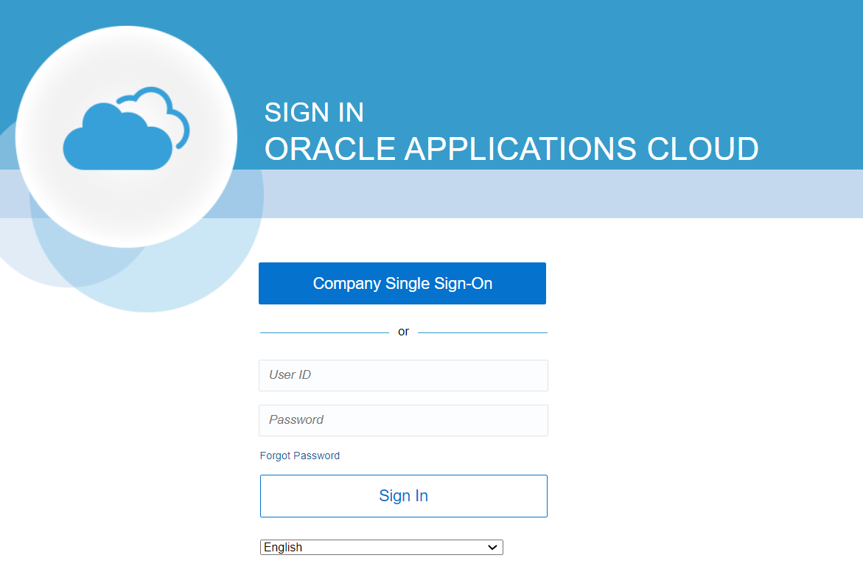

Once logged in, the Oracle Springboard should appear.

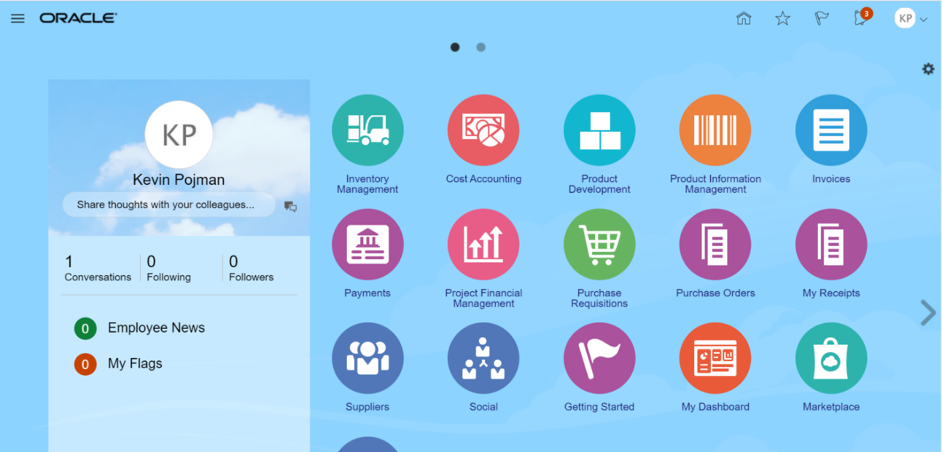


- Click on the Purchase Requisitions icon. The Requisition page listed below should open and should display different information on recent requisitions and purchases and other tasks available to the user.
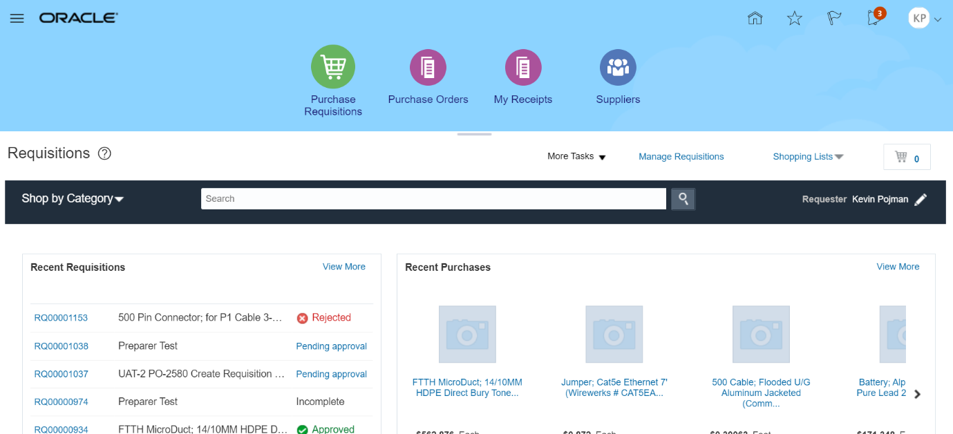

- Click the More Tasks drop-down arrow to see a list of tasks available to the user.

- Upon clicking on More Tasks drop down, the task list should be visible

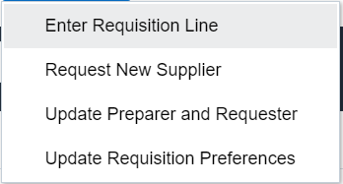

- Select the Enter Requisition Line task to go to the Enter Requisition Line screen.

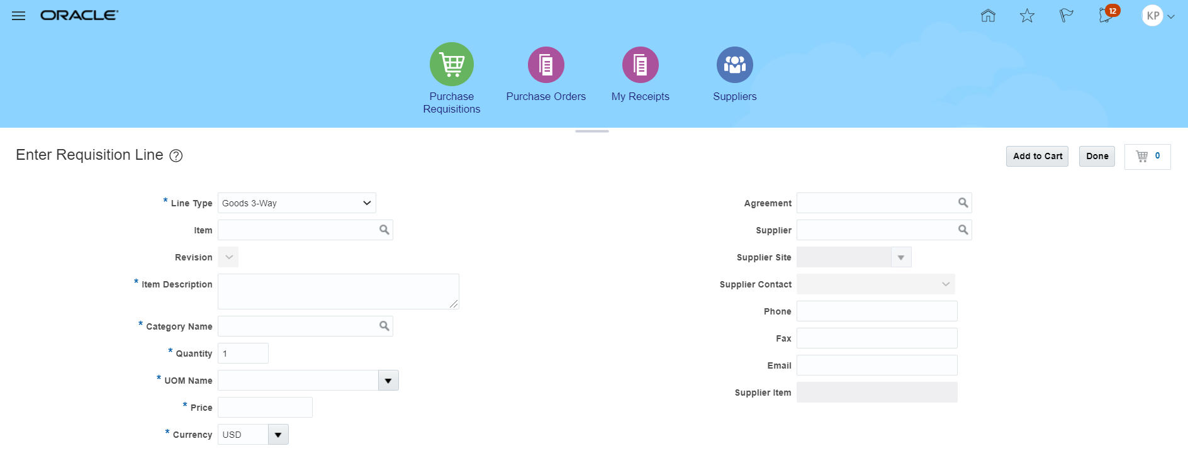

- Please note that any field listed with an Asterix (*) next to it, is a required field. The first available field is the Line Type field. When first opening Enter Requisition Line, this field should be defaulted to Goods 3-Way. Click on the Line Type field drop down.

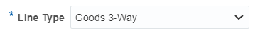

- A listing of Line Types should be visible.

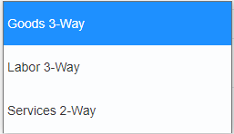

- For this exercise we will keep Goods 3-Way line type to select the appropriate Line Type for a physical good that will have a quantity and listed price.



- Upon selecting the Goods 3-Way Line Type option certain fields below it should be visible and available for the required data entry

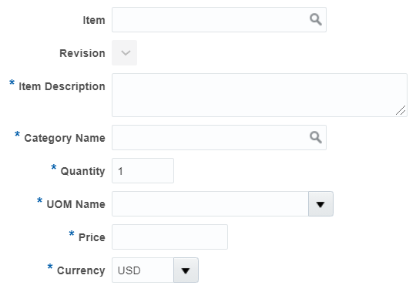

- Click inside the Item field

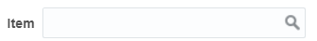

- In the Item field you will enter an Item number which can be done by entering the item number itself (or the starting portion of the number) or by searching for the item

  - Find an Item by typing the starting portion of the item number
In the Item field, type the first few characters of the part number. As you type, the system should show a listing of matching items. Please note that you will need at least 3 characters to activate the item listing.

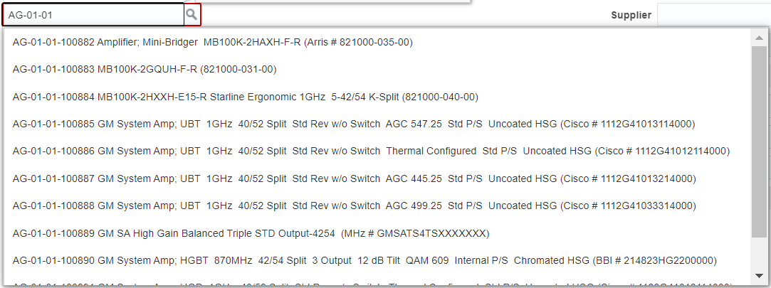

Once the list is visible click on the item number AG-01-01-100882. The selected item number should populate the Item field
  - Finding an Item by searching for the item
Click on the magnifying glass icon to search for an item. The Search and Select: Item window should open and will allow you to search by either Item number or by Description.

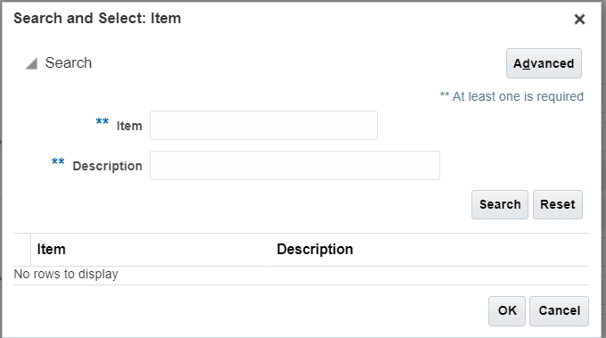
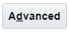
Click on the Advance Button to open the advance search setting.
Note that between both field names (Item and Description) and the data entry area, you will see the “Start With” Item operator.

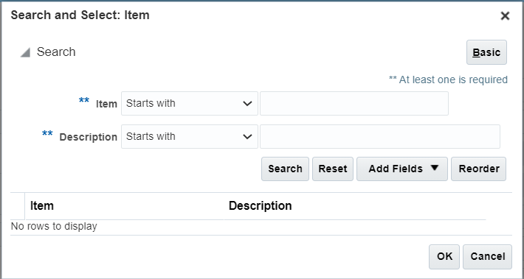


Enter the starting characters of the part number or the description and keep the item operators as Starts with. Press the Search button to process the search. The Search and Select: Item window should update and provide the search results based on your selected criteria.

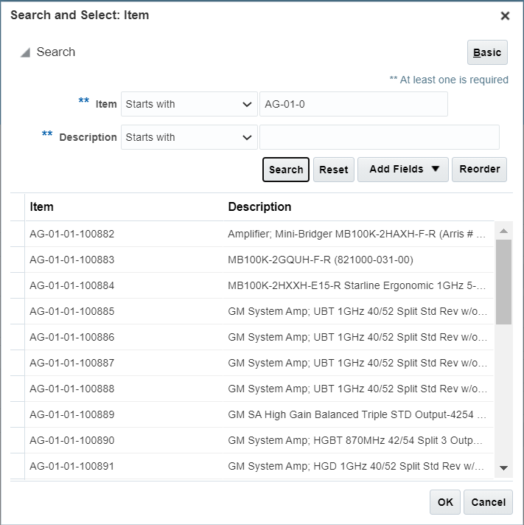

Using the mouse, click on the row for item number AG-01-01-100882 to highlight the entire row.

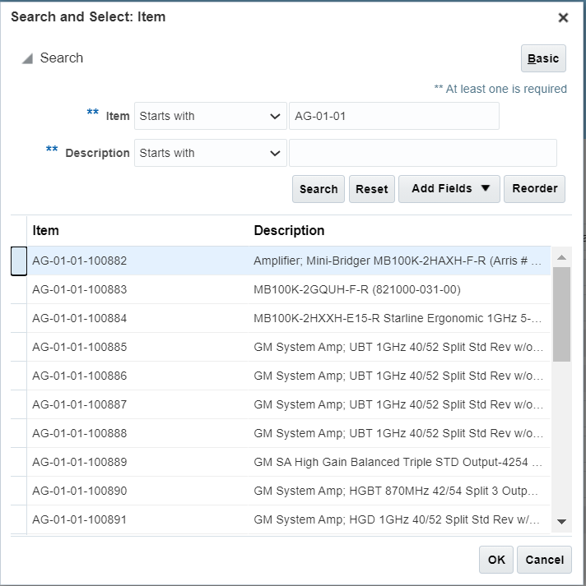
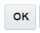
Once the desired row is highlighted, click on the OK button and the selected item will populate the Item field.

- Once the Item number is populated, the system will auto populate the Item Description, Category Name, Quantity, Unit of Measure (UOM Name) and Price fields. The Price field is only an estimated value and should be updated by the user or by procurement unless a supplier agreement is listed

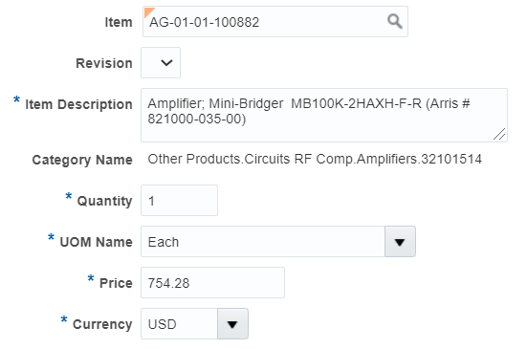

- In the Quantity field change the default value to 10. There should be no issue with the value being changes

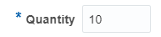

- In the Price field, change the default price to 700.00

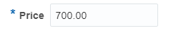

- The Currency field should be defaulted to USD

- In the Agreement Type, the Contract Purchase Agreement option should be the default value. Click on the drop-down arrow and select the Blanket Purchase Agreement option by clicking on that option

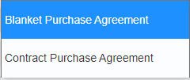

The Agreement Line field which was not visible should now appear below the Agreement field.
- Click on the Search Icon (the magnifying glass icon) to bring up the Search and Select: Agreement window

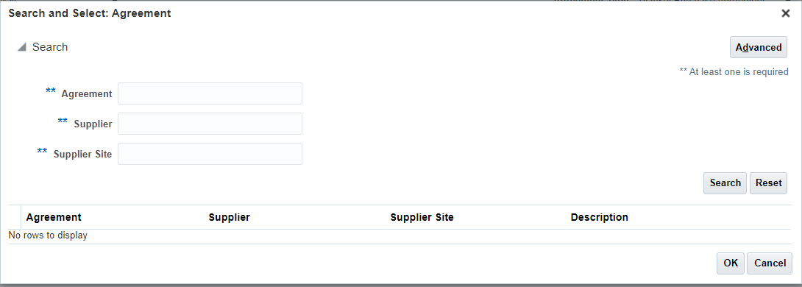
- Click on the Advance Button to bring up the agreement, supplier and supplier site operators. The default operator for each field should be “Starts with”

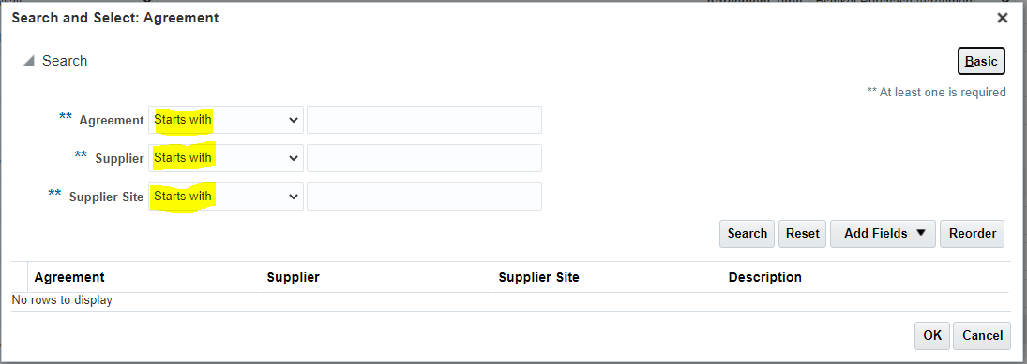

- Click on the agreement operator drop drown menu to see a list of search operators.

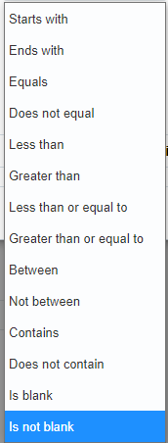

- Select the Is Not Blank option by clicking on it, The Agreement operator should now be populated with the value Is Not Blank

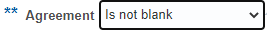

- Repeat the same process for the Supplier operators and the Supplier Site operators. All three operators for the fields should have the value Is Not Blank. Please note that the data entry field should not be available

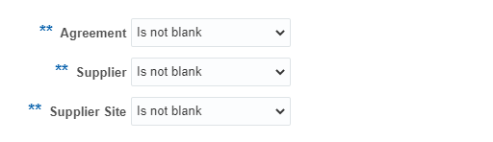
- Click on the Search Button. If there are any Supplier Agreements that are active and include the item listed in the Item field, then such information should be returned in the search result.

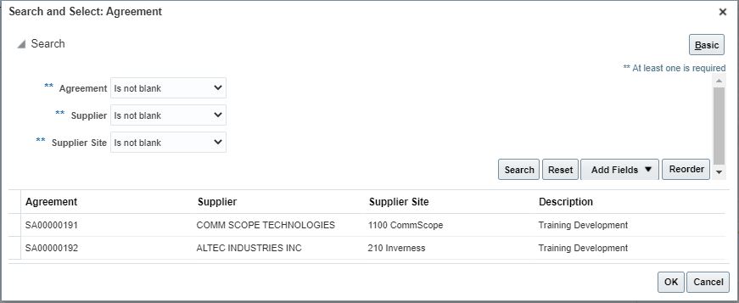

- If your desired supplier does not have a listed Supplier Agreement, then press the Cancel button and leave the Supplier Agreement field empty. For this exercise please leave the Agreement field blank by clicking Cancel.

- In the Supplier field you will enter the name of the supplier to purchase the item from. You can enter the supplier name by typing the first few characters of the name or by searching for the supplier through search. For this exercise we will use TECHNETIX INC.

  - Find the Supplier Name by typing the starting portion of the name
In the Supplier field, type the first few characters of the supplier name. In this example, start typing TECH. As you type, the system should show a listing of matching names. Please note that you will need at least 3 characters to activate the item listing.

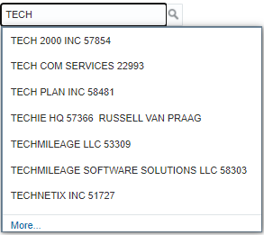

Once the list is visible click on the Supplier name TECHNETIX INC 51727. The selected supplier should populate the Supplier field
  - You can also find a supplier by searching for the Name, Number or Alternate Name
Click on the magnifying glass icon to search for a Supplier. The Search and Select: Supplier window should open and will allow you to search by either Supplier, Supplier Number or Alternate Name
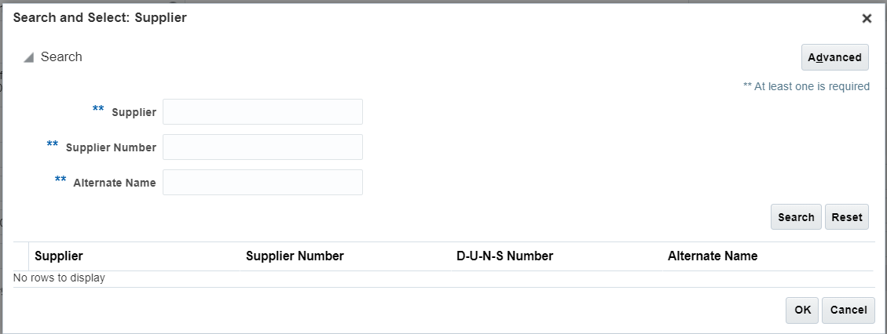

Click on the Advance Button to open the advance search setting.
Note that between all field names (Supplier, Supplier Number and Alternate Name) and the data entry area, you will see the “Start with” supplier operator.

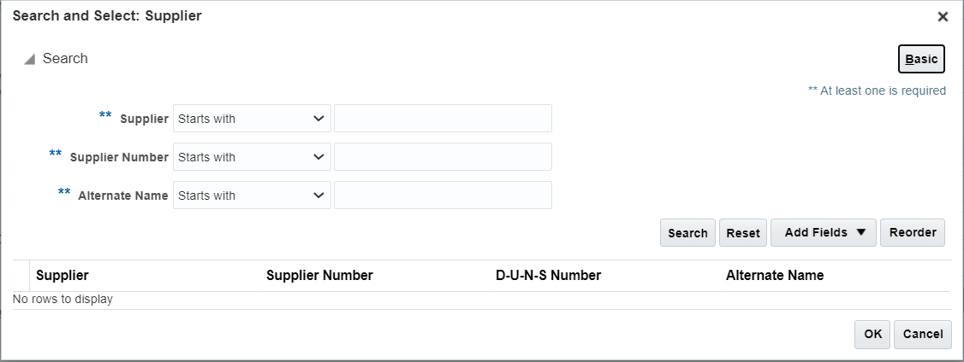

In the Supplier Number field enter the number 51727.
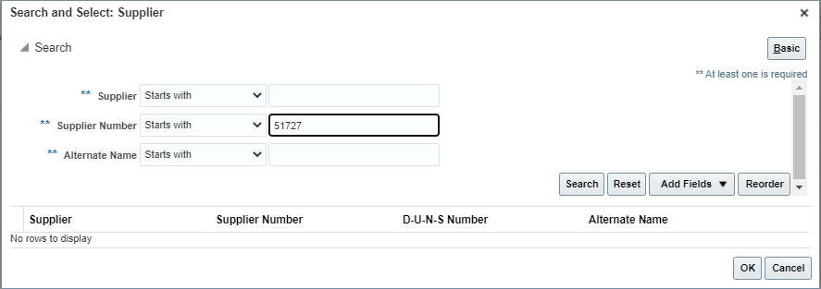
Click on the Search button to conduct the number search. The supplier record matching the entered supplier number (or portion of the number) should list in the search results.

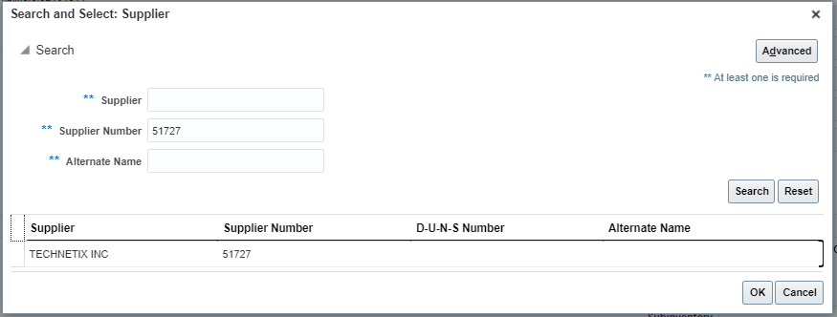

Using the mouse, click on the row for Supplier Name TECHNETIX INC to highlight the entire row.

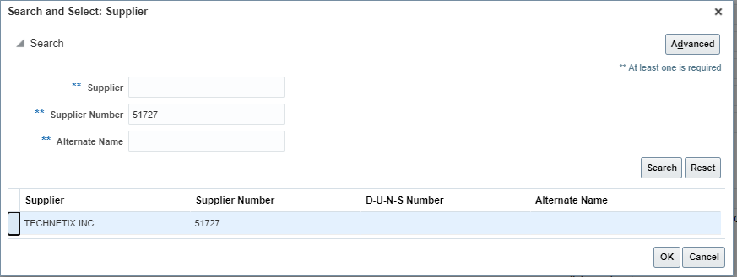
Once the desired row is highlighted, click on the OK button and the selected Supplier will populate the Supplier field. Please note that the Supplier Site, which prior to populating the Supplier field name was locked, now should be available for data entry or populated.

- Leave the Supplier Site as is. If the Supplier Site is listed, leave it listed. If the Supplier Site is not automatically listed leave it as is (this means that there are multiple Supplier Sites). Most of our suppliers received orders to 1 site only.

- Leave the Supplier Contact Field blank or select an option from the drop down.
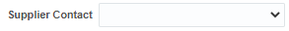
- If the Phone field is blank you have the option to provide a contact number so long as you have not selected a Supplier Contact

- Leave the Fax field blank. Procurement will not send out purchase orders via fax.

- If the email site is blank, you may provide an email address where to send the purchase order. However, if an email has been populated by the system or you have selected a Supplier Agreement, this field cannot be changed.

- In the Supplier Item field Enter AMP1-Q. If a Supplier Agreement had been selected, this field would have been populated and should not be changed.

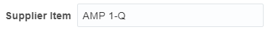

- In the delivery Section of the Enter Requisition Line screen, Click on the Requested Delivery Date field and type the requested delivery date in mm/dd/yy format, click on the date Icon and select the desired date or leave the contents of the field as is.

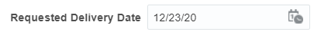 | 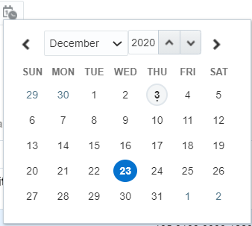

- Select CORP-HQ in the Delivery to Location or leave as defaulted



- Click on the Destination Type drop down arrow and select the Inventory option

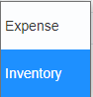

- Click on the Subinventory field drop down and select the _MAIN option. The first 4 characters of the Subinventory should match your inventory organization

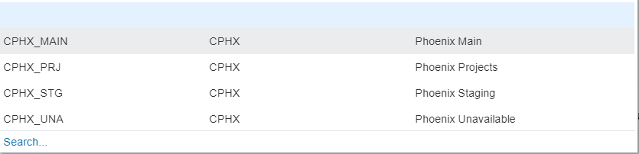

- In the Billing section of the Enter Requisition Line page, there should be a charge account that has been automatically added for you. Under no circumstances should this charge account be modified. The Charge Account is composed on several segments. The First Segment is the company segment and should be listed as 105. The second segment is the Location and should list 0102 for Corp-HQ. If you have changed the Deliver-to Location, the location segment will also change. The third segment is the Department segment and for all inventory purchases if should be listed as 0000. The fourth segment is the Account Segment and for inventory purchases is should be 16605
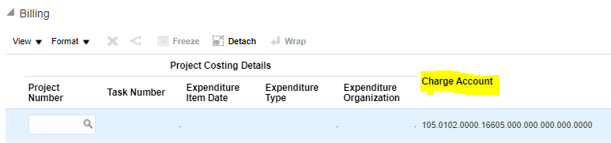

- In the same lines as the Charge Account, you will also see a few fields listed as Percentage, Quantity and Amount. These fields let the system know that 100% of the value of the requisition will be charged to the charge account listed previously. All Inventory lines must be 100% charged to the same Charge Account.
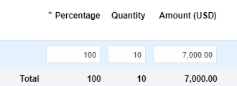

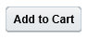
- Click the Add to Cart button to continue. An information message should appear briefly to let you know that the content has been added to the cart and the cart value should increase by 1
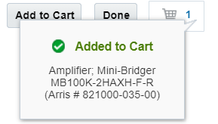

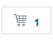
- Click the Shopping Cart icon to display the contents of cart.


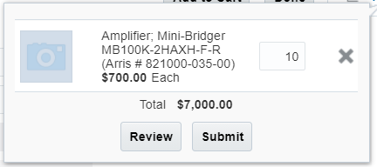
- Click the Review button to review the requisition for edits and to add a name to your requisition prior to submitting for approval. Upon clicking Review, the Edit Requisition page should open

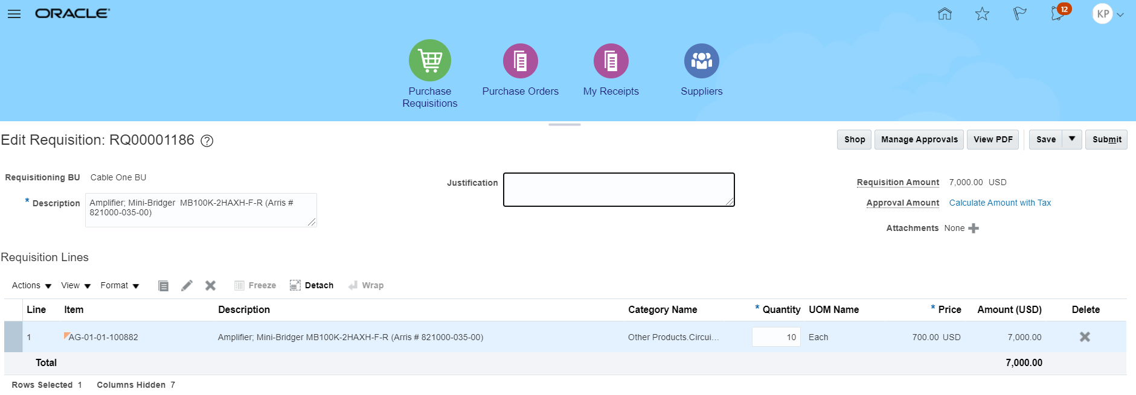

- Click on the Description field and replace the existing text (which by default will be the description of the first item added to your cart) with the text “My First Requisition”

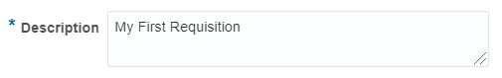

- Make any additional changes if needed.
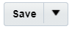
- Click on the Save button. A date and time stamp should appear near the save button.



- If you have forgotten an item, you can always continue shopping by clicking on the Shop button. The shop button returns the item to the cart (but the requisition number remains assigned). If you must continue shopping, always remember to click save. For this exercise this will be our only item.

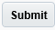
- Click the Submit button to submit your requisition. A confirmation message appears, Requisition XXXX was submitted , with the requisition number listed. The Edit Requisition page should close, and Oracle should return you back to the requisition page.

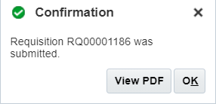

- Click on the PDF Button if you would like to see an electronic copy of the requisition. Click on the OK Button to close the confirmation message.

- The newly created requisition should be listed under the Recent Requisitions section of the Requisitions page. The status of the Requisition should also be listed and most likely will be listed as Pending Approval. User may return to check the status of the Requisition

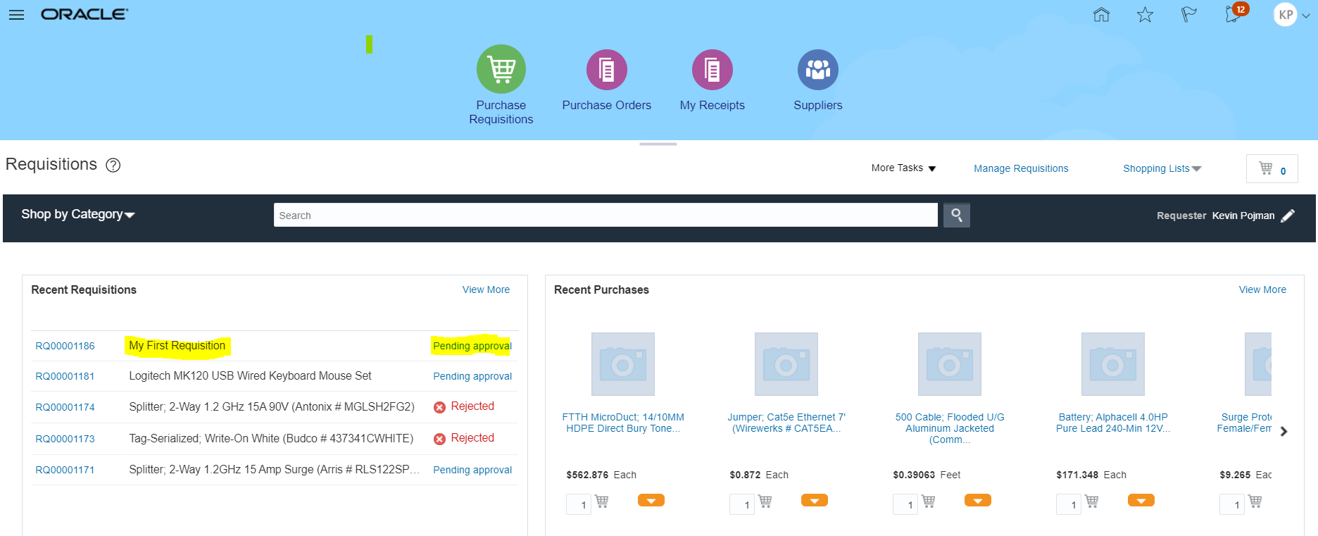

- You have completed the requisition. Return to this screen or to Manage Requisitions to follow up on your requisition status.

Create a Goods 3-Way Requisition Line for an Inventory Item Using Enter Requisition Line With a Blanket Purchase Agreement Listed:

Business Procedure Description:
Use this process to create a requisition for an inventory item in the item master using the Enter Requisition Line task. The requisitioner will also select a Blanket Purchase Agreement to review the impact that agreements have on purchase order lines

Prerequisites:
Procurement setups should be completed
Item number should be purchasable
Supplier must be available and spend authorized
Supplier Agreements must be available for specified item(s)
Item field must be populated with parts Not starting with CS, IM, or IS

Output/Next Steps:
Requisition is created and forwarded to the Requisition Approver for review and approval

Tips/Additional Information:

- Login into Oracle

Once logged in, the Oracle Springboard should appear.

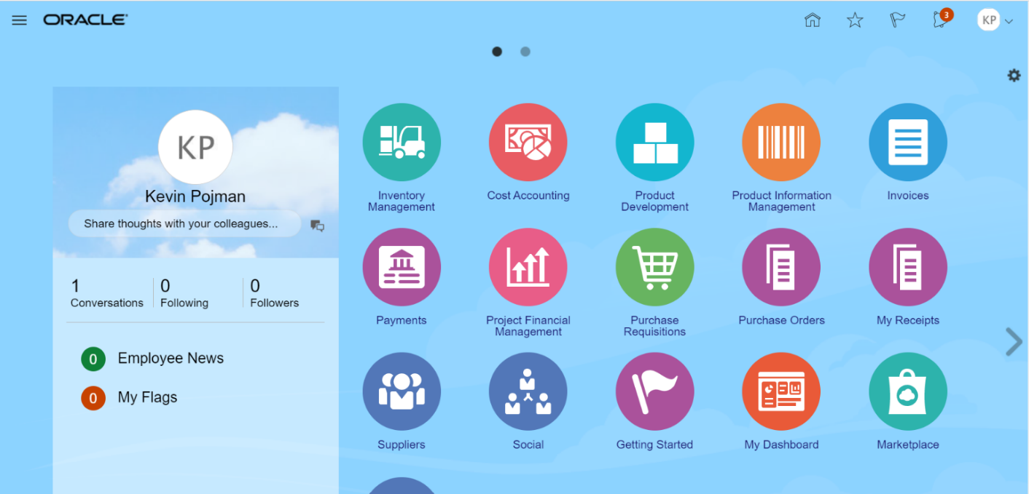


- Click on the Purchase Requisitions icon. The Requisition page listed below should open and should display different information on recent requisitions and purchases and other tasks available to the user.
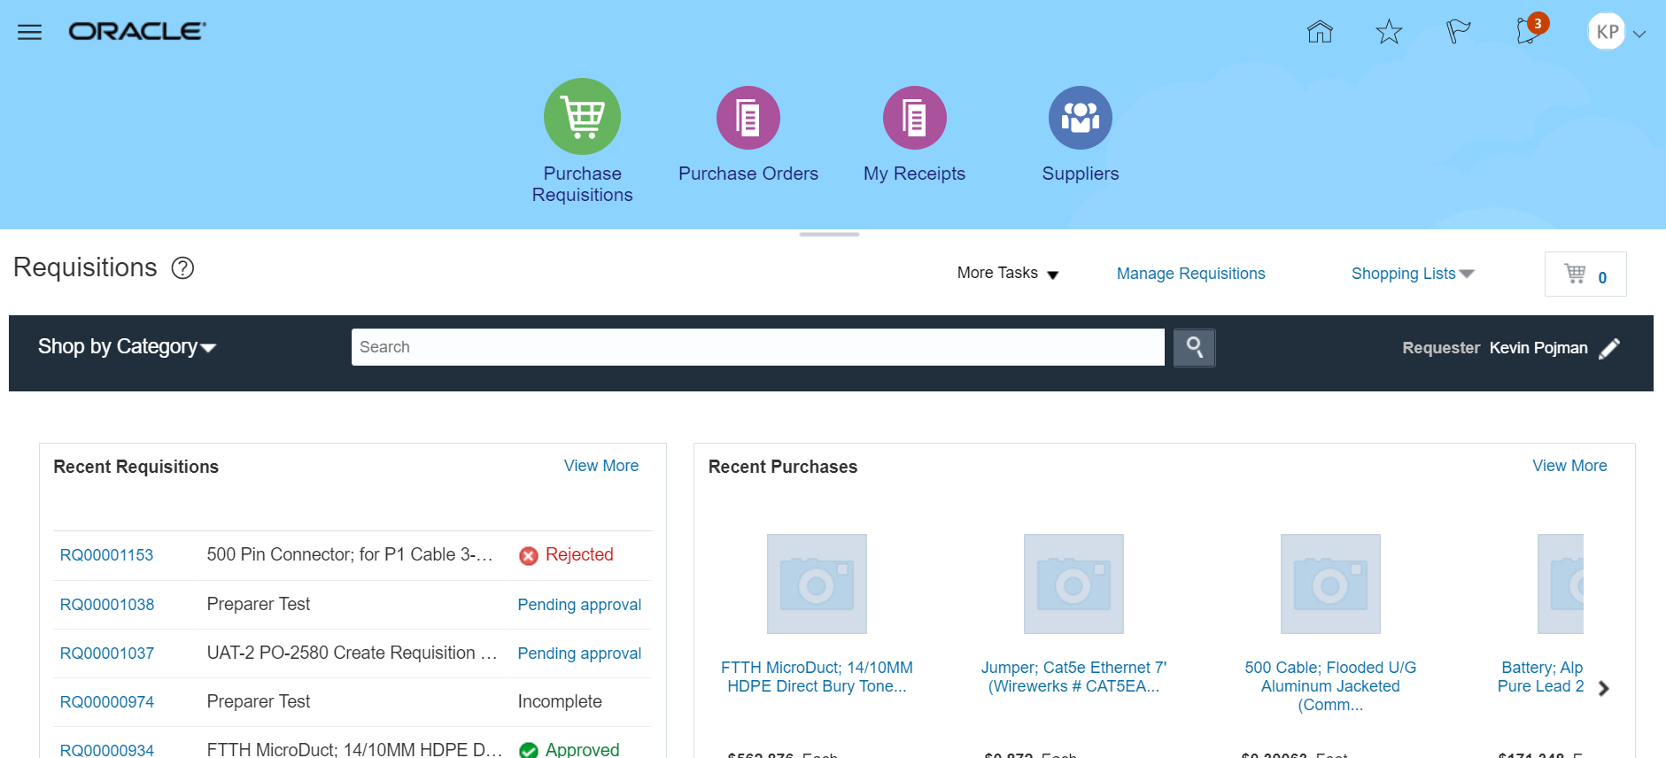

- Click the More Tasks drop-down arrow to see a list of tasks available to the user.

Upon clicking on More Tasks drop down, the task list should be visible

- Select the Enter Requisition Line task to go to the Enter Requisition Line screen.

- The first available field is the Line Type field. When first opening Enter Requisition Line, this field should be defaulted to Goods 3-Way. Click on the Line Type field drop down.

A listing of Line Types should be visible.

- For this exercise we will keep Goods 3-Way line type to select the appropriate Line Type for a physical good that will have a quantity and listed price.

Upon selecting the Goods 3-Way Line Type option certain fields below it should be visible and available for the required data entry

- Click inside the Item field

- In the Item field you will enter an Item number which can be done by entering the item number itself (or the starting portion of the number) or by searching for the item

  - Find an Item by typing the starting portion of the item number
In the Item field, type the first few characters of the part number. As you type, the system should show a listing of matching items. Please note that you will need at least 3 characters to activate the item listing.

Once the list is visible click on the item number AG-01-01-100882. The selected item number should populate the Item field
  - Finding an Item by searching for the item
Click on the magnifying glass icon to search for an item. The Search and Select: Item window should open and will allow you to search by either Item number or by Description.

Click on the Advance Button to open the advance search setting.
Note that between both field names (Item and Description) and the data entry area, you will see the “Start With” Item operator.

Enter the starting characters of the part number or the description and keep the item operators as Starts with. Press the Search button to process the search. The Search and Select: Item window should update and provide the search results based on your selected criteria.

Using the mouse, click on the row for item number AG-01-01-100882 to highlight the entire row.

Once the desired row is highlighted, click on the OK button and the selected item will populate the Item field.

- Once the Item number is populated, the system will auto populate the Item Description, Category Name, Quantity, Unit of Measure (UOM Name) and Price fields. The Price field is only an estimated value and should be updated by the user or by procurement unless a supplier agreement is listed

- In the Quantity field change the default value to 10. There should be no issue with the value being changes

- In the Price field, change the default price to 700.00

- The Currency field should be defaulted to USD

- In the Agreement Type, the Contract Purchase Agreement option should be the default value. Click on the drop-down arrow and select the Blanket Purchase Agreement option by clicking on that option

The Agreement Line field which was not visible should now appear below the Agreement field.
- Click on the Search Icon (the magnifying glass icon) to bring up the Search and Select: Agreement window

- Click on the Advance Button to bring up the agreement, supplier and supplier site operators. The default operator for each field should be “Starts with”

- Click on the agreement operator drop drown menu to see a list of search operators.

- Select the Is Not Blank option by clicking on it, The Agreement operator should now be populated with the value Is Not Blank

- Repeat the same process for the Supplier operators and the Supplier Site operators. All three operators for the fields should have the value Is Not Blank. Please note that the data entry field should not be available

- Click on the Search Button. If there are any Supplier Agreements that are active and include the item listed in the Item field, then such information should be returned in the search result.

- If your desired Supplier has a listed Supplier Agreement, select it by clicking on the desired row to highlight it and them press the OK button . For this exercise we will use Agreement Number SA00000191.

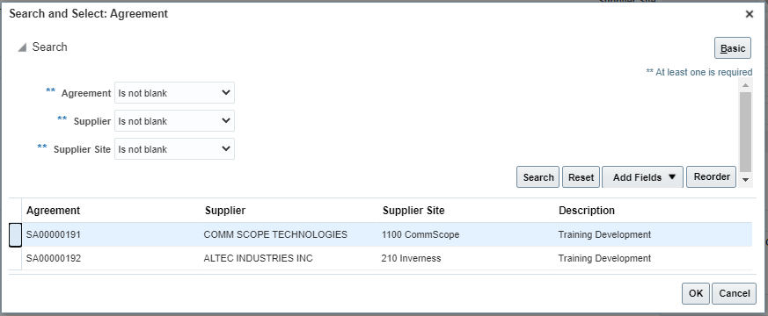

- The Agreement field will populate with the Agreement number and the Agreement Line will also auto populate based on which agreement line matches. Based on the information in the Supplier Agreement the Supplier Site, Supplier Contact, Phone, Fax, Email and Supplier Item will auto-populate. Of these fields, only Supplier Item is unlocked. Do not change the Item number unless told to do so.

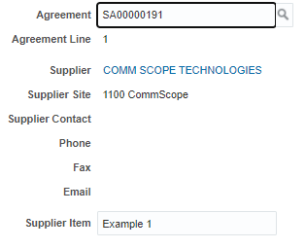
- Also note that upon selection of the supplier Agreement, another set of fields will change. The Item Description, Category Name, UOM Name, Price and Currency fields on the left side of the Enter Requisition Line page are now locked. In addition, the Price field has been updated from the 700.00 value you entered previously to 750.00. Blanket Purchase Agreements are meant to ensure that the correct pricing and information matching an item and a supplier is listed in the requisition and purchase order.

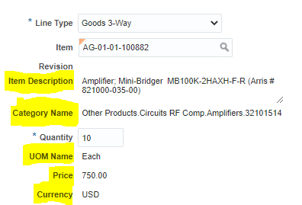

- In the delivery Section of the Enter Requisition Line screen, click on the Requested Delivery Date field and type the requested delivery date in mm/dd/yy format. A second option is to click on the date Icon and select the desired date from the date choose box. You may also leave the field as is.

- Select CORP-HQ in the Delivery to Location or leave as defaulted. The address should be listed below it.

- Click on the Destination Type drop down arrow and select the Inventory option

- Click on the Subinventory field drop down and select the _MAIN option. The first 4 characters of the Subinventory should match your inventory organization

- In the Billing section of the Enter Requisition Line page, there should be a charge account that has been automatically added for you. Under no circumstances should this charge account be modified. The Charge Account is composed on several segments. The First Segment is the company segment and should be listed as 105. The second segment is the Location and should list 0102 for Corp-HQ. If you have changed the Deliver-to Location, the location segment will also change. The third segment is the Department segment and for all inventory purchases if should be listed as 0000. The fourth segment is the Account Segment and for inventory purchases is should be 16605

- In the same lines as the Charge Account, you will also see a few fields listed as Percentage, Quantity and Amount. These fields let the system know that 100% of the value of the requisition will be charged to the charge account listed previously. All Inventory lines must be 100% charged to the same Charge Account.
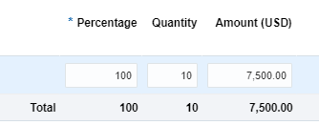
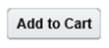
- Click the Add to Cart button to continue. An information message should appear briefly to let you know that the content has been added to the cart and the cart value should increase by 1

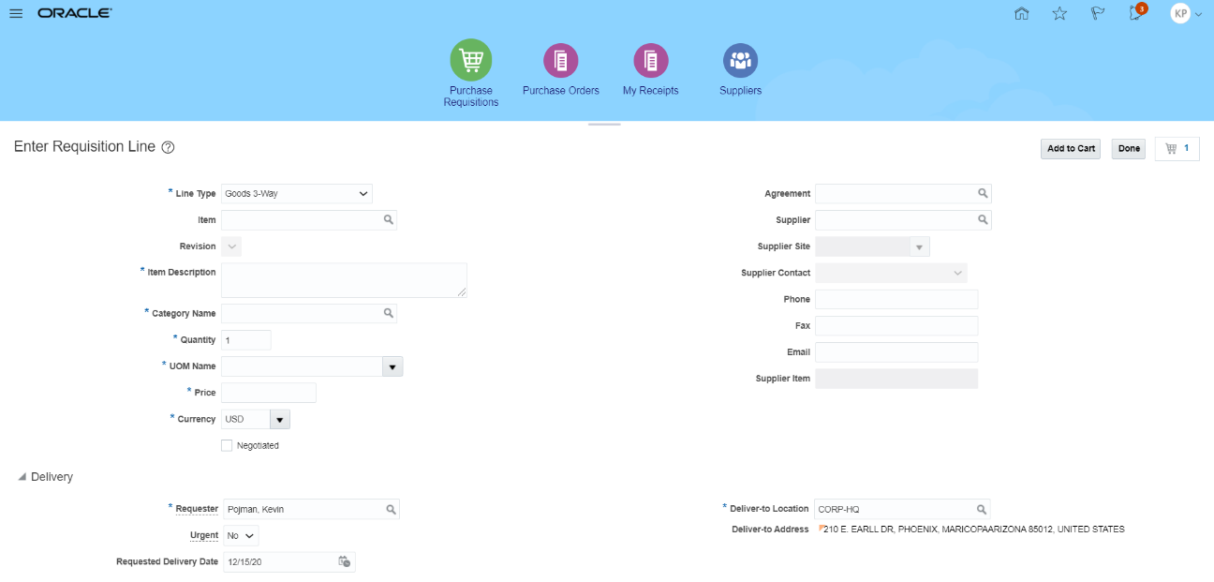
- Click the Shopping Cart icon to display the contents of cart.
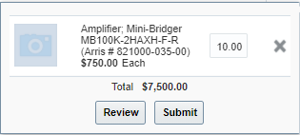
- Click the Review button to review the requisition for edits and to add a name to your requisition prior to submitting for approval. Upon clicking Review, the Edit Requisition page should open

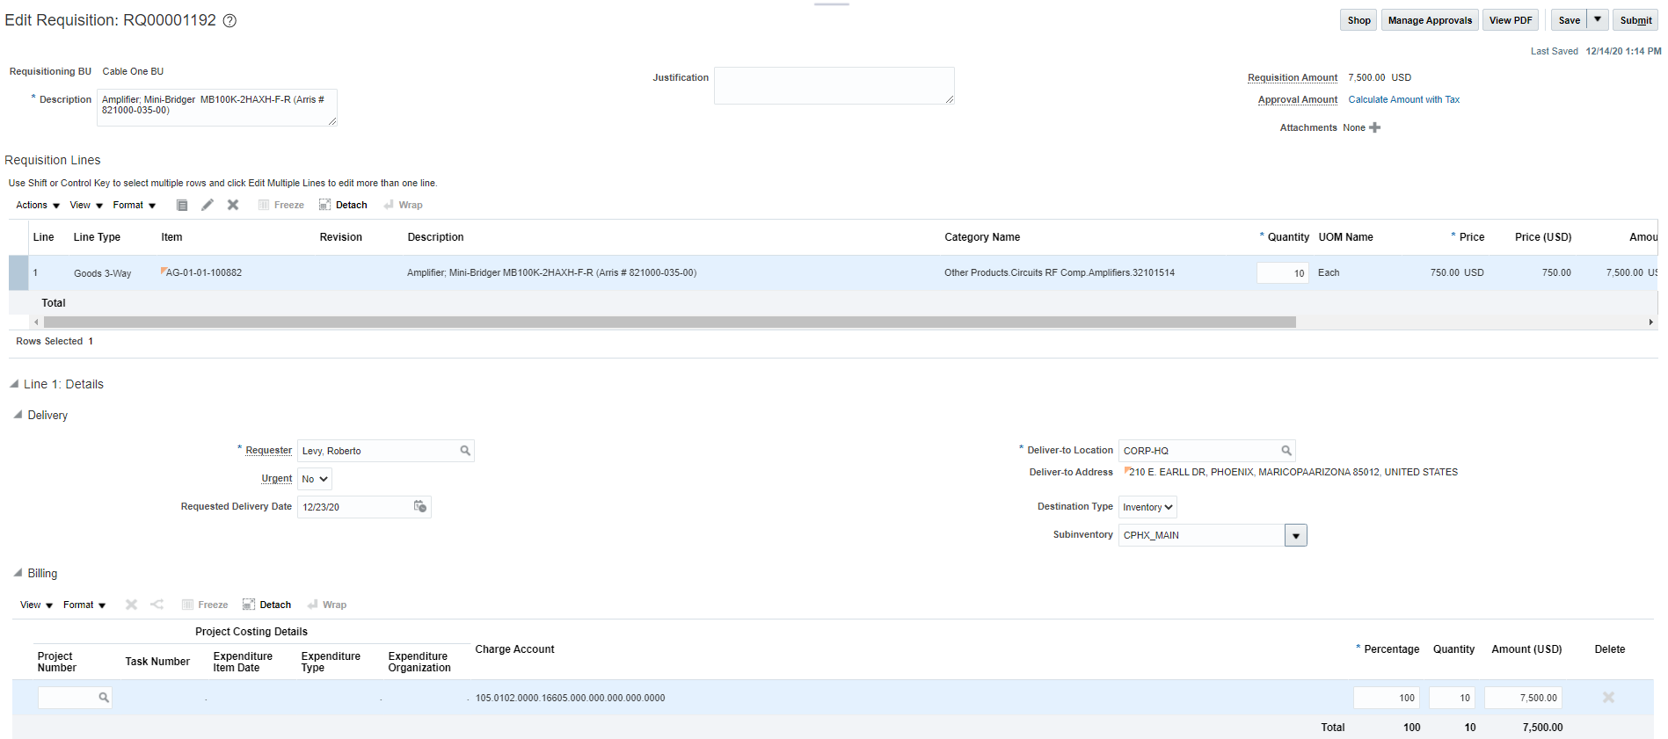

- Click on the Description field and replace the existing text (which by default will be the description of the first item added to your cart) with the text “My Second Requisition”

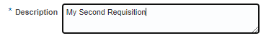

- Make any additional changes if needed.
- Click on the Save button. A date and time stamp should appear near the save button.

- If you have forgotten an item, you can always continue shopping by clicking on the Shop button. The shop button returns the item to the cart (but the requisition number remains assigned). If you must continue shopping, always remember to click save. For this exercise this will be our only item.
- Click the Submit button to submit your requisition. A confirmation message appears, Requisition XXXX was submitted , with the requisition number listed. The Edit Requisition page should close, and Oracle should return you back to the requisition page.

- Click on the PDF Button if you would like to see an electronic copy of the requisition. Click on the OK Button to close the confirmation message.

- The newly created requisition should be listed under the Recent Requisitions section of the Requisitions page. The status of the Requisition should also be listed and most likely will be listed as Pending Approval. User may return to check the status of the Requisition

- You have completed this transaction. To follow up on requisitions pending approval you must return to the Requisitions page or to Manage Requisitions.

Create a Goods 3-Way Requisition Line for an Inventory Item For a Project Using Enter Requisition Line:

Business Procedure Description:
Use this process to create a Goods 3-Way requisition for an Inventory item in the item master for a project. These steps utilize the Enter Line Item requisition process.

Prerequisites:
Procurement setups should be done
Project number for an open project, a purchasable item number and spend-authorized supplier should be available.
User must have access to roles that allow this requisition’s creation
User’s deliver to location will be listed in the Deliver-to Location Field search. Prior to test, Edit User Preference may be used to change default Deliver-to Location not available through requisition process

Item field must be populated with parts Not starting with CS, IM, or IS

Output/Next Steps:
Requisition is created and forwarded to the Requisition Approver for review and approval

Tips/Additional Information:
It is recommended that you keep line items for the same requisition together and that you do not mix project and non project items in the same requisition. You may include items for different suppliers for the same project in the same requisition.

- Login into Oracle

Once logged in, the Oracle Springboard should appear.

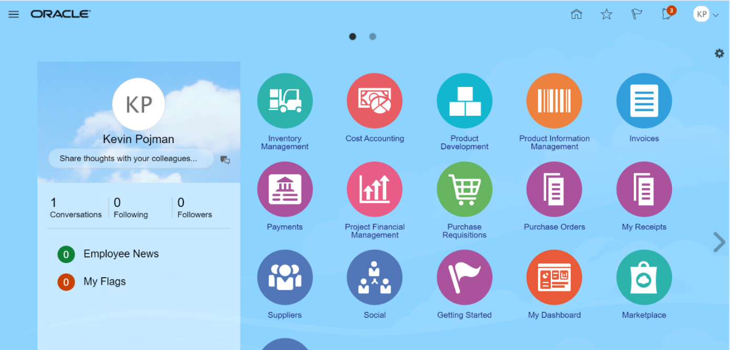

- Click on the Purchase Requisitions icon. The Requisition page listed below should open and should display different information on recent requisitions and purchases and other tasks available to the user.
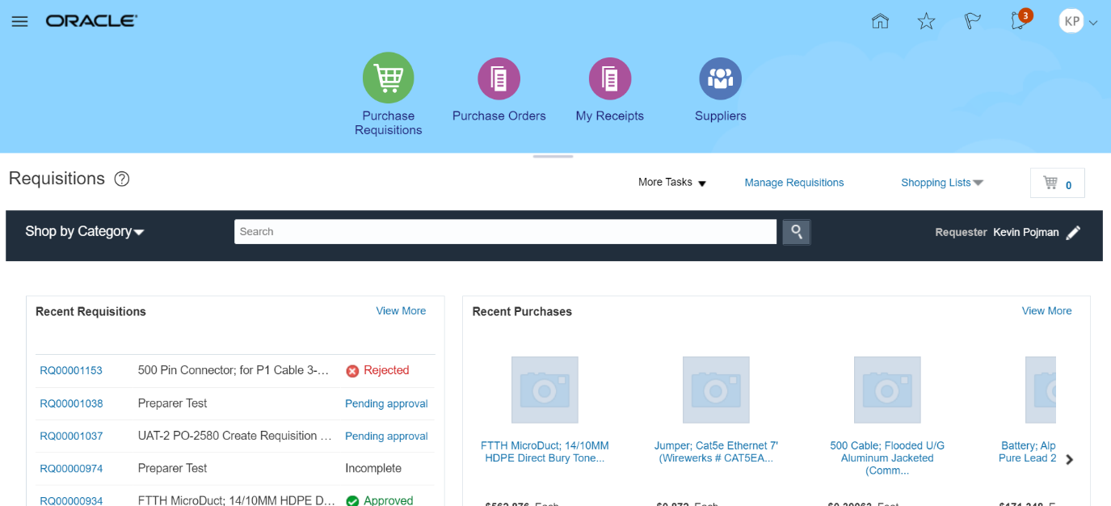

- Click the More Tasks drop-down arrow to see a list of tasks available to the user.

Upon clicking on More Tasks drop down, the task list should be visible

- Select the Enter Requisition Line task to go to the Enter Requisition Line screen. We recommended that you keep line items for the same project in the same requisition. You may include items for different suppliers for the same project in the same requisition.

- The first available field is the Line Type field. When first opening Enter Requisition Line, this field should be defaulted to Goods 3-Way. Click on the Line Type field drop down.

A listing of Line Types should be visible.

- For this exercise we will keep Goods 3-Way line type to select the appropriate Line Type for a physical good that will have a quantity and listed price.

Upon selecting the Goods 3-Way Line Type option certain fields below it should be visible and available for the required data entry

- Click inside the Item field

- In the Item field you will enter an Item number which can be done by entering the item number itself (or the starting portion of the number) or by searching for the item

  - Find an Item by typing the starting portion of the item number
In the Item field, type the first few characters of the part number. As you type, the system should show a listing of matching items. Please note that you will need at least 3 characters to activate the item listing.

Once the list is visible click on the item number AG-01-01-100883. The selected item number should populate the Item field
  - Finding an Item by searching for the item
Click on the magnifying glass icon to search for an item. The Search and Select: Item window should open and will allow you to search by either Item number or by Description.

Click on the Advance Button to open the advance search setting.
Note that between both field names (Item and Description) and the data entry area, you will see the “Start With” Item operator.

Enter the starting characters of the part number or the description and keep the item operators as Starts with. Press the Search button to process the search. The Search and Select: Item window should update and provide the search results based on your selected criteria.

Using the mouse, click on the row for item number AG-01-01-100883 to highlight the entire row.

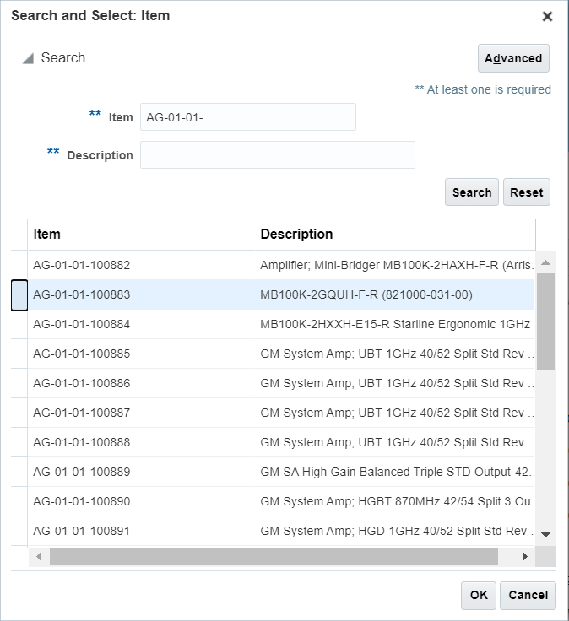
Once the desired row is highlighted, click on the OK button and the selected item will populate the Item field.

- Once the Item number is populated, the system will auto populate the Item Description, Category Name, Quantity, Unit of Measure (UOM Name) and Price fields. The Price field is only an estimated value and should be updated by the user or by procurement unless a supplier agreement is listed

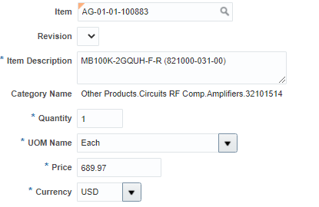

- In the Quantity field change the default value to 10. There should be no issue with the value being changes

- In the Price field, change the default price to 700.00

- The Currency field should be defaulted to USD

- In the Agreement Type, the Contract Purchase Agreement option should be the default value. Click on the drop-down arrow and select the Blanket Purchase Agreement option by clicking on that option

The Agreement Line field which was not visible should now appear below the Agreement field.
- Click on the Search Icon (the magnifying glass icon) to bring up the Search and Select: Agreement window

- Click on the Advance Button to bring up the agreement, supplier and supplier site operators. The default operator for each field should be “Starts with”

- Click on the agreement operator drop drown menu to see a list of search operators.

- Select the Is Not Blank option by clicking on it, The Agreement operator should now be populated with the value Is Not Blank

- Repeat the same process for the Supplier operators and the Supplier Site operators. All three operators for the fields should have the value Is Not Blank. Please note that the data entry field should not be available

- Click on the Search Button. If there are any Supplier Agreements that are active and include the item listed in the Item field, then such information should be returned in the search result.

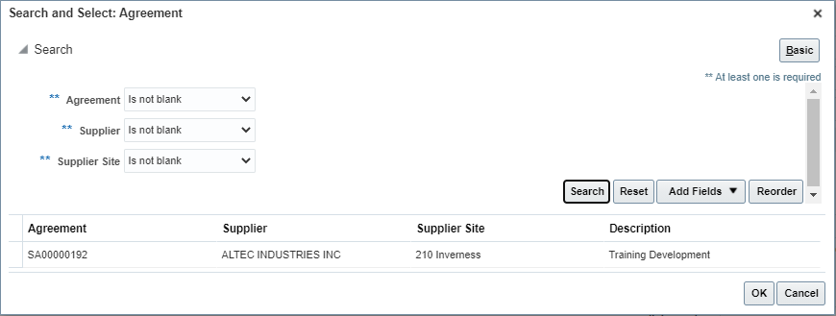

- If your desired supplier does not have a listed Supplier Agreement, then press the Cancel button and leave the Supplier Agreement field empty. For this exercise please leave the Agreement field blank by clicking cancel.

- In the Supplier field you will enter the name of the supplier to purchase the item from. You can enter the supplier name by typing the first few characters of the name or by searching for the supplier through search. For this exercise we will use TECHNETIX INC.

  - Find the Supplier Name by typing the starting portion of the name
In the Supplier field, type the first few characters of the supplier name. In this example, start typing TECH. As you type, the system should show a listing of matching names. Please note that you will need at least 3 characters to activate the item listing.

Once the list is visible click on the Supplier name TECHNETIX INC 51727. The selected supplier should populate the Supplier field
  - You can also find a supplier by searching for the Name, Number or Alternate Name
Click on the magnifying glass icon to search for a Supplier. The Search and Select: Supplier window should open and will allow you to search by either Supplier, Supplier Number or Alternate Name

Click on the Advance Button to open the advance search setting.
Note that between all field names (Supplier, Supplier Number and Alternate Name) and the data entry area, you will see the “Start with” supplier operator.

In the Supplier Number field enter the number 51727.
Click on the Search button to conduct the number search. The supplier record matching the entered supplier number (or portion of the number) should list in the search results.

Using the mouse, click on the row for Supplier Name TECHNETIX INC to highlight the entire row.

Once the desired row is highlighted, click on the OK button and the selected Supplier will populate the Supplier field. Please note that the Supplier Site, which prior to populating the Supplier field name was locked, now should be available for data entry or populated.

- Leave the Supplier Site as is. If the Supplier Site is listed, leave it listed. If the Supplier Site is not automatically listed leave it as is (this means that there are multiple Supplier Sites). Most of our suppliers received orders to 1 site only.
- Leave the Supplier Contact Field blank or select an option from the drop down.
- If the Phone field is blank you have the option to provide a contact number so long as you have not selected a Supplier Contact

- Leave the Fax field blank. Procurement will not send out purchase orders via fax.

- If the email site is blank, you may provide an email address where to send the purchase order. However, if an email has been populated by the system or you have selected a Supplier Agreement, this field cannot be changed.

- In the Supplier Item field Enter AMP1-Q. If a Supplier Agreement had been selected, this field would have been populated and should not be changed.

- In the delivery Section of the Enter Requisition Line screen, Click on the Requested Delivery Date field and type the requested delivery date in mm/dd/yy format, click on the date Icon and select the desired date or leave the contents of the field as is. For Projects you should consider entering a date that best aligns with your project start date and not order to early.

- Select CORP-HQ in the Delivery to Location or leave as defaulted

- Click on the Destination Type drop down arrow and select the Inventory option

- Click on the Subinventory field drop down.

- Select the _PRJ (Project ) option. The first 4 characters of the Subinventory should match your inventory organization

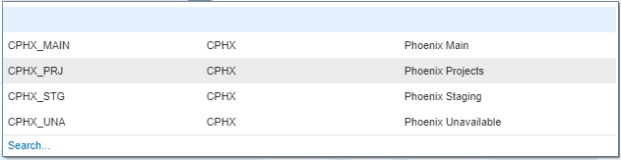

- In the Billing section of the Enter Requisition Line page you should see the Project Number field on the left side of the Project Costing Detail group. Please note that the remaining fields Task Number, Expenditure Item Date, Expenditure Item, Expenditure Type, and Expenditure Organization are not available for data entry.
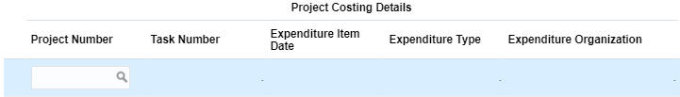

- Click inside the Project Number field and enter the project number 102-HD105. When done, press the tab or the enter key.
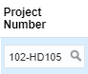

- The Project Costing Details field that were locked should now be available for data entry. The Expenditure Item Date should default to whatever value you have entered in the Requested Delivery Date.
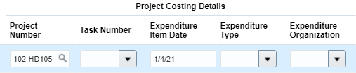
- Click on the Task Number dropdown arrow to see a list of available Tasks
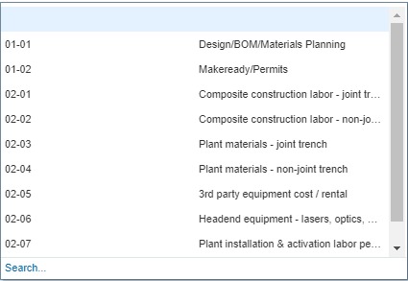

- Select the 02-06 (Headend Equipment – Lasers, optics, ) task number option by clicking on that row of the option list. The Task Number should populate the field
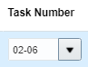

- Leave the Expenditure Item Date field as is. It is recommended that you always use the Requested Delivery Date to provide an indication of how early or how late you will want the products to be delivered.
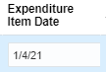
- Click on the Expenditure Type field drop down arrow to see a list of all available options for the expenditure types.
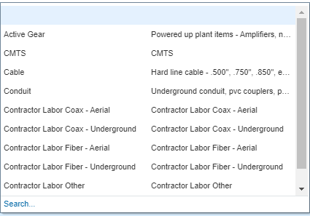
- Select the Active Gear expenditure type option by clicking on the row
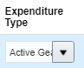

- Click on the Expenditure Organization field drop down to see or search for the available options
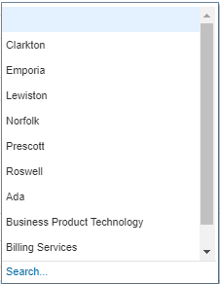
- Use the Corporate Office organization. If you see your Expenditure Organization, select it by clicking on the row. If you do not see your Expenditure Organization, then click on the search link to open the Search and Select: Expenditure Organization window.
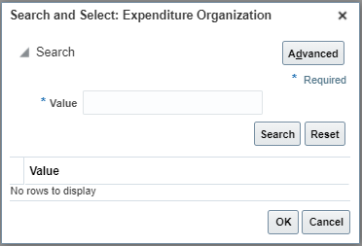
- In the Value field enter the text Corporate and then press the Search button to display the possible results. Please note that Expenditure Organizations are different than Deliver-to or Inventory Organizations.
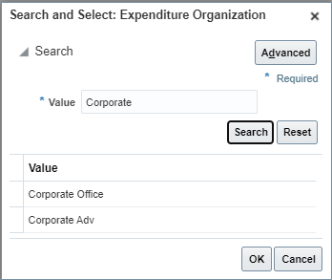

- Select the Corporate Office option by double-clicking on the selection or by clicking one to select the row and the pressing the OK button
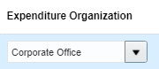

Please note the charge account currently listed in the Charge Account field. This is the incorrect charge account for a project. Continue to the next steps and don’t worry about the charge account for now.

- In the same lines as the Charge Account, you will also see a few fields listed as Percentage, Quantity and Amount. These fields let the system know that 100% of the value of the requisition will be charged to the charge account listed previously. All Inventory lines must be 100% charged to the same Charge Account.

- Click the Add to Cart button to continue. An information message should appear briefly to let you know that the content has been added to the cart and the cart value should increase by 1
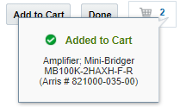
- Click the Shopping Cart icon to display the contents of cart.

- Click the Review button to review the requisition for edits and to add a name to your requisition prior to submitting for approval. Upon clicking Review, the Edit Requisition page should open

- Click on the Description field and replace the existing text (which by default will be the description of the first item added to your cart) with the text “My First Project Requisition”

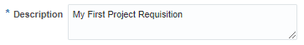

- Make any additional changes if needed.
- Click on the Save button. A date and time stamp should appear near the save button.

- If you have forgotten an item, you can always continue shopping by clicking on the Shop button. The shop button returns the item to the cart (but the requisition number remains assigned). If you must continue shopping, always remember to click save. For this exercise this will be our only item.

- Click the Submit button to submit your requisition. A confirmation message should appear, Requisition XXXX was submitted, with the requisition number listed. The Edit Requisition page should close, and Oracle should return you back to the requisition page.

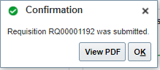
- If you do not get a confirmation message but you get an error Saying “Expenditure Item Date is Outside of Project Dates, your project start and end dates are outside no longer valid. You should review project information and correct the Expenditure Item Date and then Resubmit the requisition.

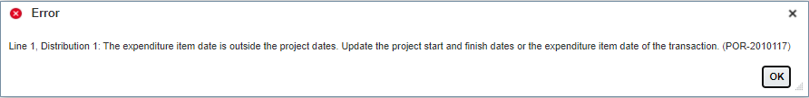
- Click on the PDF Button if you would like to see an electronic copy of the requisition. Click on the OK Button to close the confirmation message.

- The newly created requisition should be listed under the Recent Requisitions section of the Requisitions page. The status of the Requisition should also be listed and most likely will be listed as Pending Approval. User may return to check the status of the Requisition

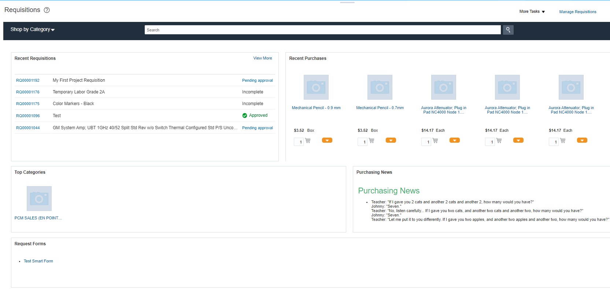

- You have completed the requisition. Return to this screen or to Manage Requisitions to follow up on your requisition status.

Create a Goods 3-Way Requisition Line For an Expense Item Not In The Item Master Using Enter Requisition Line:

Business Procedure Description:
This Activity describes the process of placing a requisition for an expense item that does not have an Item Master number. This activity explains the primary differences between an Expense item and a regular inventory item.

Prerequisites:
The Item field should not be populated
If a supplier agreement is used, it must be active.

Output/Next Steps:
Requisition is created and forwarded to the Requisition Approver for review and approval

Tips/Additional Information:

- Login into Oracle

Once logged in, the Oracle Springboard should appear.

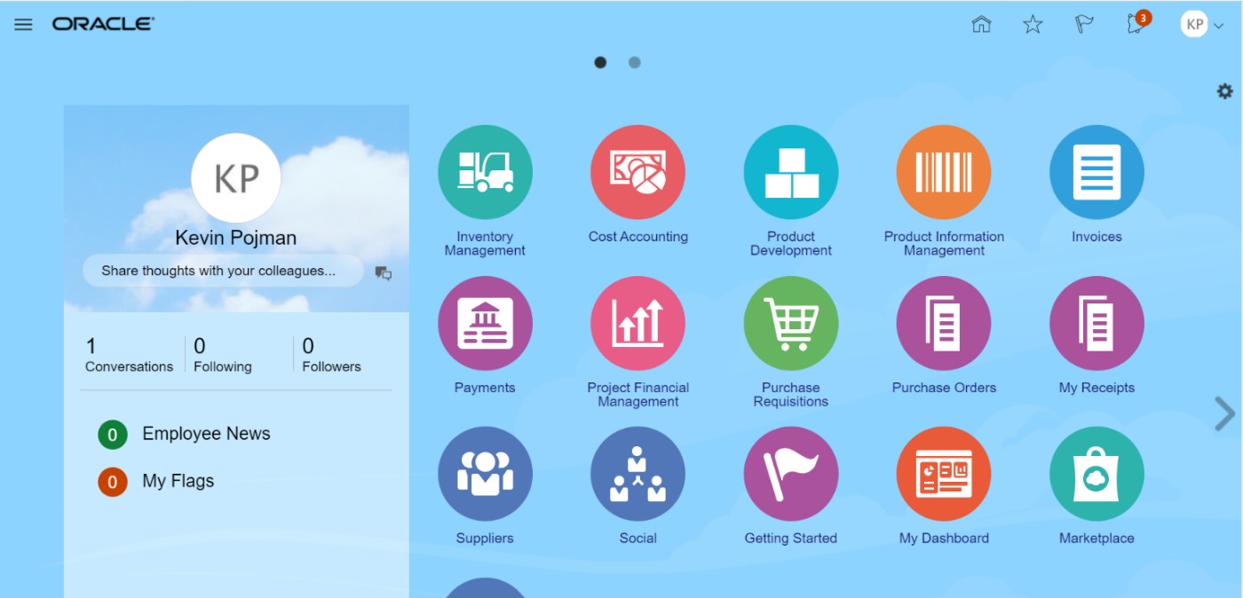

- Click on the Purchase Requisitions icon. The Requisition page listed below should open and should display different information on recent requisitions and purchases and other tasks available to the user.
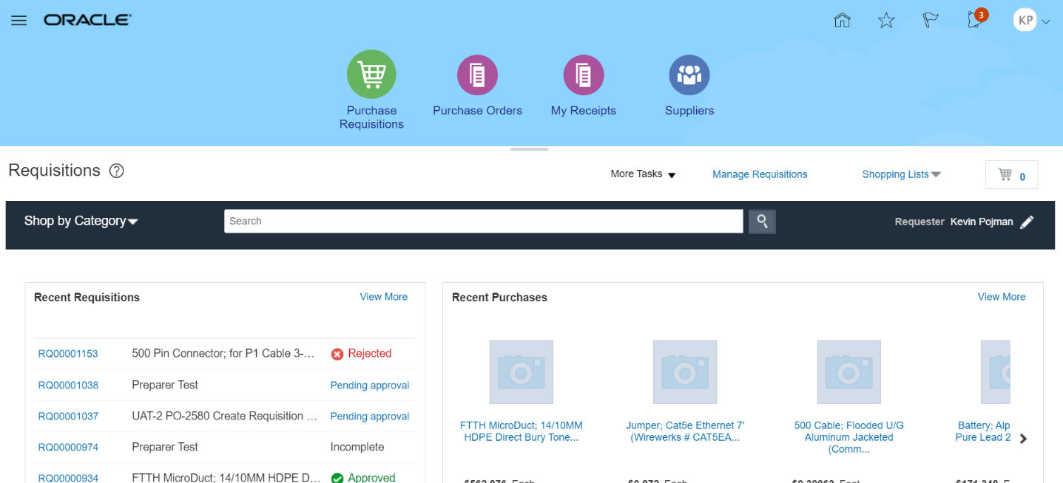

- Click the More Tasks drop-down arrow to see a list of tasks available to the user.

Upon clicking on More Tasks drop down, the task list should be visible

- Select the Enter Requisition Line task to go to the Enter Requisition Line screen.

- The first available field is the Line Type field. When first opening Enter Requisition Line, this field should be defaulted to Goods 3-Way. Click on the Line Type field drop down.

A listing of Line Types should be visible.

- For this exercise we will keep Goods 3-Way line type to select the appropriate Line Type for a physical good that will have a quantity and listed price.

Upon selecting the Goods 3-Way Line Type option certain fields below it should be visible and available for the required data entry

- Leave the Item Field Blank

- In the Item Description, enter the following text: Microsoft Surface Tablet For Student 1

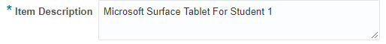

- In the Category Name field press the search Icon (The Magnifying glass Icon) . The Search and Select: Category Name window should open.

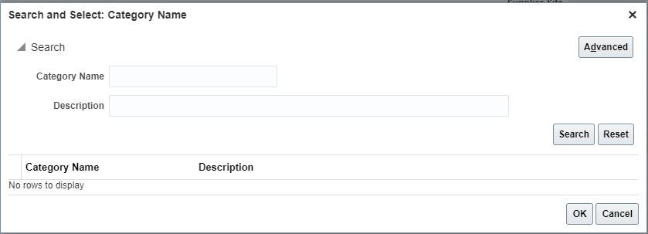

- Click inside the Description field of the Search and Select window and then type the text Notebook.

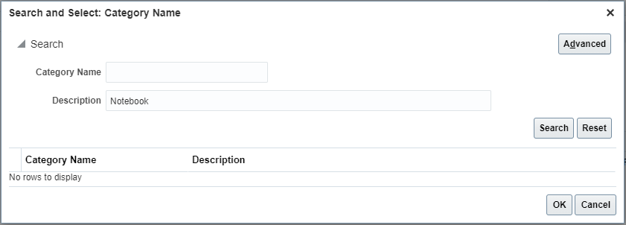


- Click on the Search button to conduct the search for the matching Category Name

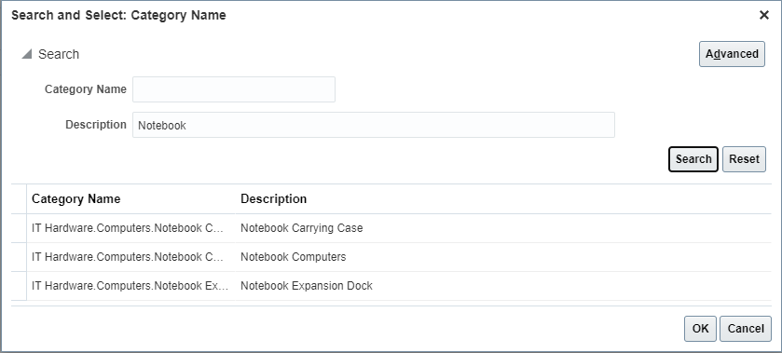

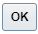
Click on the row with the Description listed as Notebook Computers. The row should be highlighted. The click on the OK button to select the Category Name. User can also double click on the selected row and the Category Name will populate.

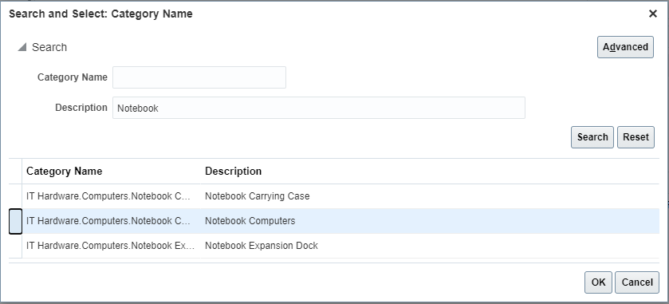

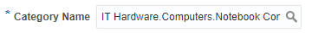

- In the Quantity field change the default value to 10. There should be no issue with the value being changes

- Click on the UOM Name field drop-down or type the name of the measure in the field.

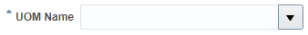

- If you clicked on the drop down arrow, you should see a listing of valid Units of Measure.

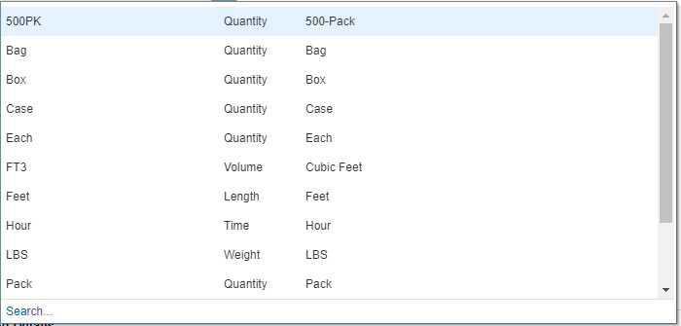

- Click on the Each row to select the Each unit of measure

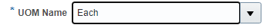

- In the Price field, change the default price to 1200.00

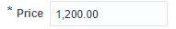

- The Currency field should be defaulted to USD

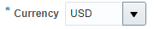

- The Agreement field should be blank

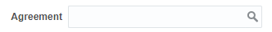

- In the Supplier field you will enter the name of the supplier to purchase the item from. You can enter the supplier name by typing the first few characters of the name or by searching for the supplier through search. For this exercise we will use TECHNETIX INC.

  - Find the Supplier Name by typing the starting portion of the name
In the Supplier field, type the first few characters of the supplier name. In this example, start typing TECH. As you type, the system should show a listing of matching names. Please note that you will need at least 3 characters to activate the item listing.

Once the list is visible click on the Supplier name TECHNETIX INC 51727. The selected supplier should populate the Supplier field
  - You can also find a supplier by searching for the Name, Number or Alternate Name
Click on the magnifying glass icon to search for a Supplier. The Search and Select: Supplier window should open and will allow you to search by either Supplier, Supplier Number or Alternate Name

Click on the Advance Button to open the advance search setting.
Note that between all field names (Supplier, Supplier Number and Alternate Name) and the data entry area, you will see the “Start with” supplier operator.

In the Supplier Number field enter the number 51727.
Click on the Search button to conduct the number search. The supplier record matching the entered supplier number (or portion of the number) should list in the search results.

Using the mouse, click on the row for Supplier Name TECHNETIX INC to highlight the entire row.

- Once the desired row is highlighted, click on the OK button and the selected Supplier will populate the Supplier field. Please note that the Supplier Site, which prior to populating the Supplier field name was locked, now should be available for data entry or populated.

- Leave the Supplier Site as is. If the Supplier Site is listed, leave it listed. If the Supplier Site is not automatically listed leave it as is (this means that there are multiple Supplier Sites). Most of our suppliers received orders to 1 site only.

- Leave the Supplier Contact Field blank or select an option from the drop down.

- If the Phone field is blank you have the option to provide a contact number so long as you have not selected a Supplier Contact

- Leave the Fax field blank. Procurement will not send out purchase orders via fax.

- If the email site is blank, you may provide an email address where to send the purchase order. However, if an email has been populated by the system or you have selected a Supplier Agreement, this field cannot be changed.

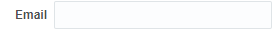

- In the Supplier Item field Enter Laptop Surface If a Supplier Agreement had been selected, this field would have been populated and should not be changed.

- In the delivery Section of the Enter Requisition Line screen, Click on the Requested Delivery Date field and type the requested delivery date in mm/dd/yy format, click on the date Icon and select the desired date or leave the contents of the field as is.

- Select CORP-HQ in the Delivery to Location or leave as defaulted

- Please note that the destination type that was available when creating a requisition for an Inventory Item is not visible. When the Item field is blank or the Part number starts with CS, IS or IM, the Destination Type will not appear but will be defaulted to Expense.

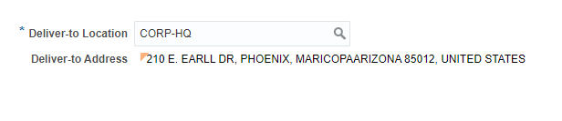

- In the Billing section of the Enter Requisition Line page, there should be a charge account that has been automatically added for you. Under no circumstances should this charge account be modified. The Charge Account is composed on several segments. The First Segment is the company segment and should be listed as 105. The second segment is the Location and should list 0102 for Corp-HQ. If you have changed the Deliver-to Location, the location segment will also change. The third segment is the Department segment and for all inventory purchases if should be listed as 0000. The fourth segment is the Account Segment and for expense purchases it will default based on the Category Name. The best place to review the correct Charge Account number is upon Requisition Review to ensure charge account is correctly processed
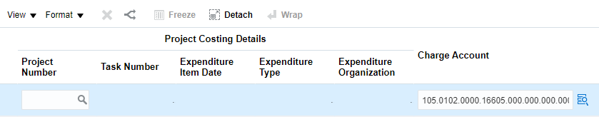

- In the same lines as the Charge Account, you will also see a few fields listed as Percentage, Quantity and Amount. These fields let the system know that 100% of the value of the requisition will be charged to the charge account listed previously. All Inventory lines must be 100% charged to the same Charge Account.

- Click the Add to Cart button to continue. An information message should appear briefly to let you know that the content has been added to the cart and the cart value should increase by 1. Keep in mind that this information message may not appear if you have cleared the cart contents once before.

- Click the Shopping Cart icon to display the contents of cart.

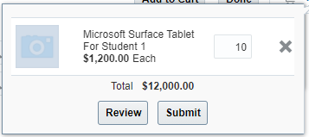

- Click the Review button to review the requisition for edits and to add a name to your requisition prior to submitting for approval. Upon clicking Review, the Edit Requisition page should open

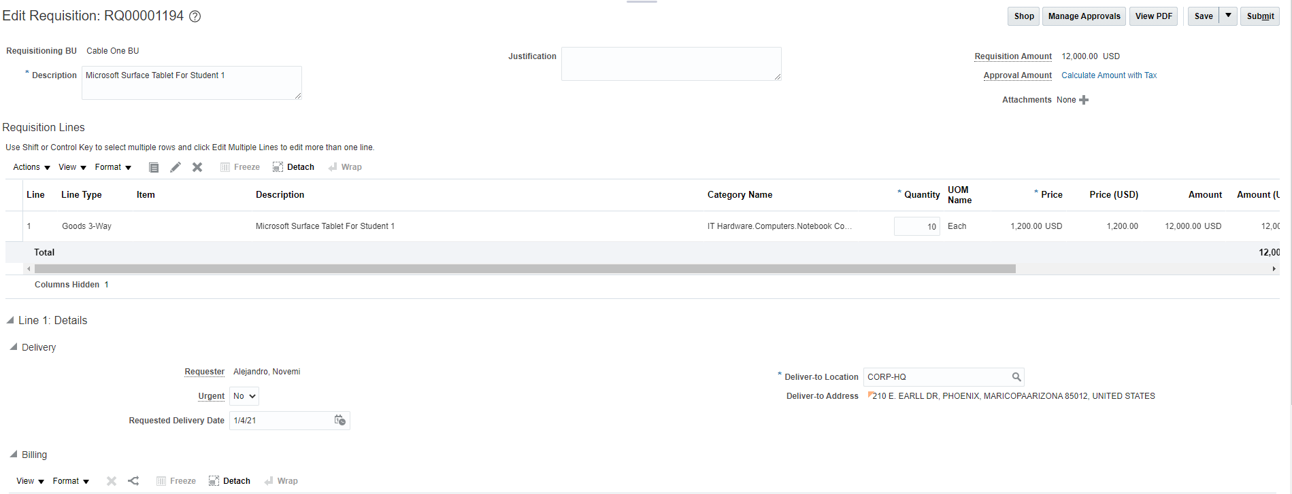

- Click on the Description field and replace the existing text (which by default will be the description of the first item added to your cart) with the text “My First Expense Requisition”

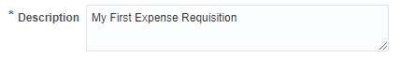

- Make any additional changes if needed.

- Review the charge account for the requested line and look at the changes that have occurred. The third and the fourth charge account segments should have changed from what you saw prior to adding the item to the cart. The department segment is now populated based on the department of the Requester and the Account segment is based on the account codes for Laptops/Notebooks.

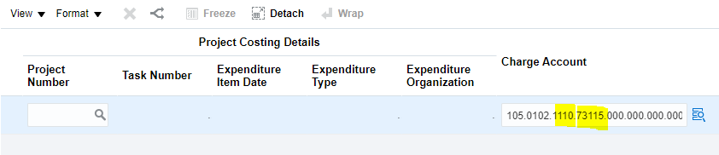
- Click on the Save button. A date and time stamp should appear near the save button.

- If you have forgotten an item, you can always continue shopping by clicking on the Shop button. The shop button returns the item to the cart (but the requisition number remains assigned). If you must continue shopping, always remember to click save. For this exercise this will be our only item.

- Click the Submit button to submit your requisition. A confirmation message appears, Requisition XXXX was submitted , with the requisition number listed. The Edit Requisition page should close, and Oracle should return you back to the requisition page.

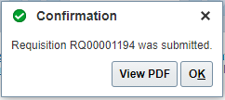
- The Requisition should be listed in the Recent Requisitions page and its status should be Pending Approval

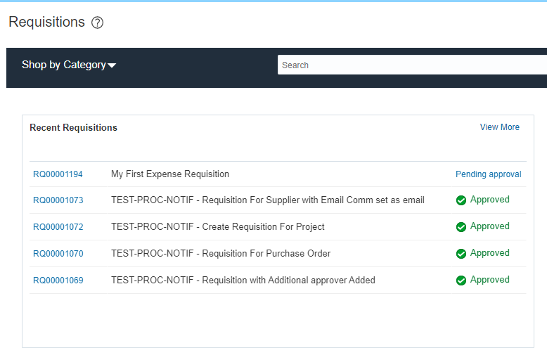

- You have completed the activity

Create a Labor 3-Way Requisition Line For a Contract Services Item In The Item Master Using Enter Requisition Line:

Business Procedure Description:
Use this process to create a requisition for a Contracted Services item that is listed in the Item Master using the Enter Requisition Line and the Labor 3-Way Line Type.

Prerequisites:
Item must be in the item master
Labor 3-Way Line Type Should be Setup and Active
Project must be active
User’s Requisition Preferences should be set as defaulted

Output/Next Steps:
Requisition is created and forwarded to the Requisition Approver for review and approval

Tips/Additional Information:

- Login into Oracle

Once logged in, the Oracle Springboard should appear.

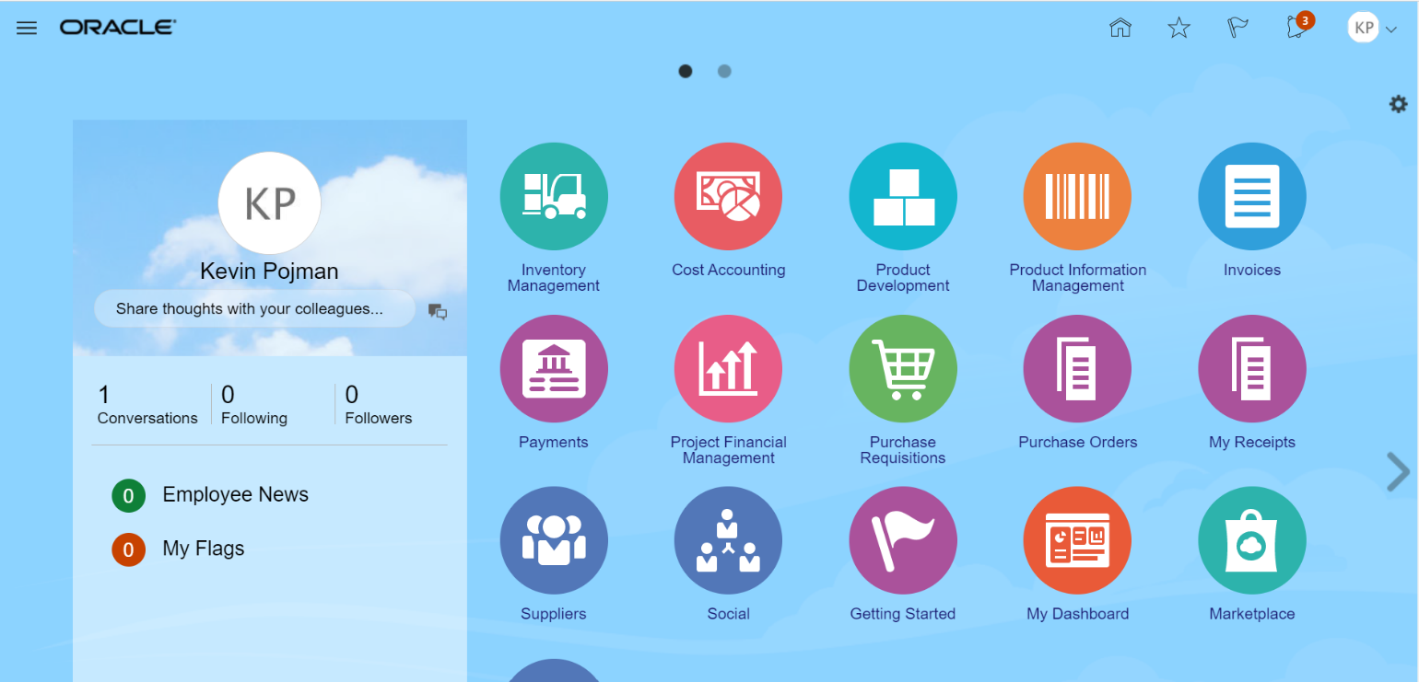

- Click on the Purchase Requisitions icon. The Requisition page listed below should open and should display different information on recent requisitions and purchases and other tasks available to the user.

- Click the More Tasks drop-down arrow to see a list of tasks available to the user.

- Upon clicking on More Tasks drop down, the task list should be visible

- Select the Enter Requisition Line task to go to the Enter Requisition Line screen.

- Please note that any field listed with an Asterix (*) next to it, is a required field. The first available field is the Line Type field. When first opening Enter Requisition Line, this field should be defaulted to Goods 3-Way. Click on the Line Type field drop down.

- A listing of Line Types should be visible.

- For this exercise we will Select Labor 3-Way line type. We will be ordering a contracted service by a define quantity and price per unit of measure.

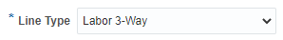

- Upon selecting the Goods 3-Way Line Type option certain fields below it should be visible and available for the required data entry

- Click inside the Item field

- In the Item field you will enter an Item number which can be done by entering the item number itself (or the starting portion of the number) or by searching for the item

  - Find an Item by typing the starting portion of the item number
In the Item field, type the first few characters of the part number. As you type, the system should show a listing of matching items. Please note that you will need at least 3 characters to activate the item listing.

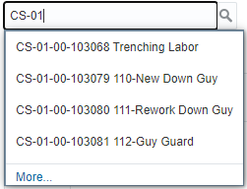

Once the list is visible click on the item number CS-01-00-103079. The selected item number should populate the Item field
  - Finding an Item by searching for the item
Click on the magnifying glass icon to search for an item. The Search and Select: Item window should open and will allow you to search by either Item number or by Description.

Click on the Advance Button to open the advance search setting.
Note that between both field names (Item and Description) and the data entry area, you will see the “Start With” Item operator.

Enter the starting characters of the part number or the description and keep the item operators as Starts with. Press the Search button to process the search. The Search and Select: Item window should update and provide the search results based on your selected criteria.

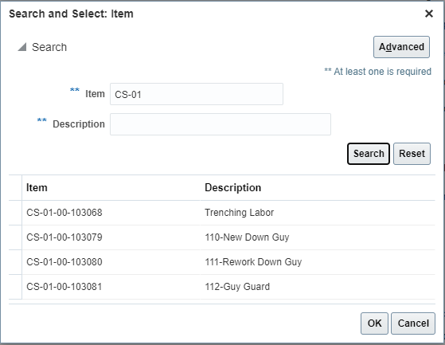

Using the mouse, click on the row for item number AG-01-01-100882 to highlight the entire row.

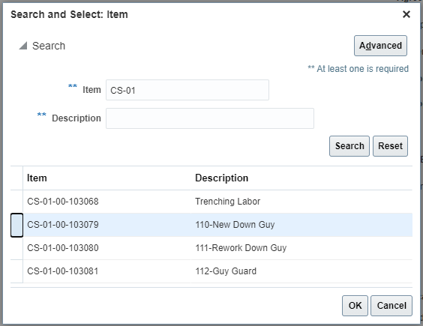
Once the desired row is highlighted, click on the OK button and the selected item will populate the Item field.
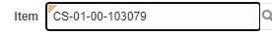

- Once the Item number is populated, the system will auto populate the Item Description, Category Name, Quantity, Unit of Measure (UOM Name) and Price fields. The Price field is only an estimated value and should be updated by the user or by procurement unless a supplier agreement is listed

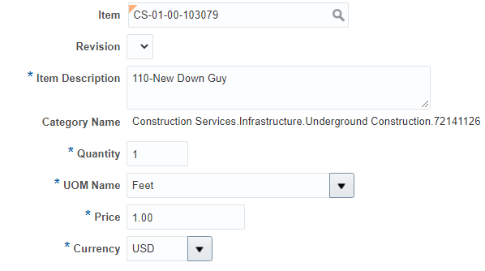

- In the Quantity field change the default value to 10000. There should be no issue with the value being changes

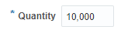

- In the Price field, change the default price to 2.30

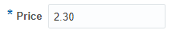

- The Currency field should be defaulted to USD

- In the Agreement Type, the Contract Purchase Agreement option should be the default value.

- In the Supplier field you will enter the name of the supplier to purchase the item from. You can enter the supplier name by typing the first few characters of the name or by searching for the supplier through search. For this exercise we will use KGPCO.

  - Find the Supplier Name by typing the starting portion of the name
In the Supplier field, type the first few characters of the supplier name. In this example, start typing KGP. As you type, the system should show a listing of matching names. Please note that you will need at least 3 characters to activate the item listing.

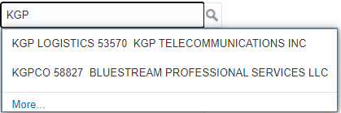

Once the list is visible click on the Supplier name KGPCO 58827. The selected supplier should populate the Supplier field
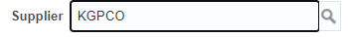
  - You can also find a supplier by searching for the Name, Number or Alternate Name
Click on the magnifying glass icon to search for a Supplier. The Search and Select: Supplier window should open and will allow you to search by either Supplier, Supplier Number or Alternate Name

  - Click on the Advance Button to open the advance search setting.
Note that between all field names (Supplier, Supplier Number and Alternate Name) and the data entry area, you will see the “Start with” supplier operator.

  - In the Supplier Number field enter the number 58827.

  - Click on the Search button to conduct the number search. The supplier record matching the entered supplier number (or portion of the number) should list in the search results.

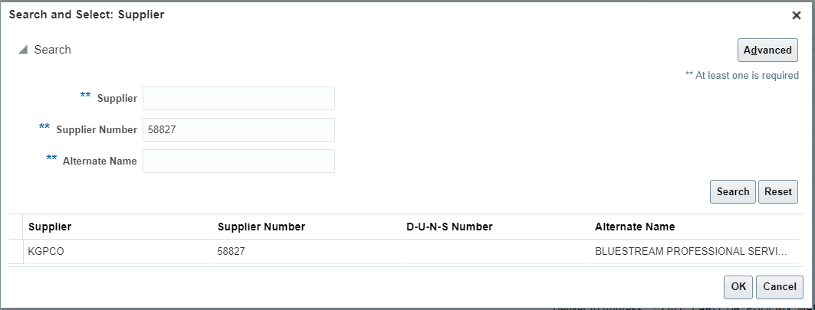

Using the mouse, click on the row for Supplier Name KGPCO to highlight the entire row.

  - Once the desired row is highlighted, click on the OK button and the selected Supplier will populate the Supplier field. Please note that the Supplier Site, which prior to populating the Supplier field name was locked, now should be available for data entry or populated.

- Leave the Supplier Site as is. If the Supplier Site is listed, leave it listed. If the Supplier Site is not automatically listed leave it as is (this means that there are multiple Supplier Sites). Most of our suppliers received orders to 1 site only.
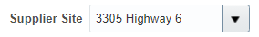
- Leave the Supplier Contact Field blank or select an option from the drop down.
- If the Phone field is blank you have the option to provide a contact number so long as you have not selected a Supplier Contact

- Leave the Fax field blank. Procurement will not send out purchase orders via fax.

- If the email site is blank, you may provide an email address where to send the purchase order. However, if an email has been populated by the system or you have selected a Supplier Agreement, this field cannot be changed.

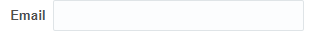

- In the Supplier Item field Enter Down Guy Work. If a Supplier Agreement had been selected, this field would have been populated and should not be changed.

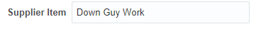

- In the delivery Section of the Enter Requisition Line screen, Click on the Requested Delivery Date field and type the requested delivery date in mm/dd/yy format, click on the date Icon and select the desired date or leave the contents of the field as is.

- Select CORP-HQ in the Delivery to Location or leave as defaulted

- In the Billing section of the Enter Requisition Line page you should see the Project Number field on the left side of the Project Costing Detail group. Please note that the remaining fields Task Number, Expenditure Item Date, Expenditure Item, Expenditure Type, and Expenditure Organization are not available for data entry.

- Click inside the Project Number field and enter the project number 102-HD105. When done, press the tab or the enter key.

- The Project Costing Details field that were locked should now be available for data entry. The Expenditure Item Date should default to whatever value you have entered in the Requested Delivery Date.
- Click on the Task Number dropdown arrow to see a list of available Tasks

- Select the 02-01 (Composite Construction Labor, ) task number option by clicking on that row of the option list. The Task Number should populate the field
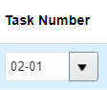
- Leave the Expenditure Item Date field as is. It is recommended that you always use the Requested Delivery Date to provide an indication of how early or how late you will want the products to be delivered.
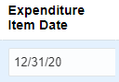
- Click on the Expenditure Type field drop down arrow to see a list of all available options for the expenditure types.
- Select the Contractor Labor Other expenditure type option by clicking on the row
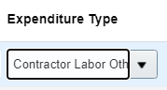
- Click on the Expenditure Organization field drop down to see or search for the available options
- Use the Corporate Office organization. If you see your Expenditure Organization, select it by clicking on the row. If you do not see your Expenditure Organization, then click on the search link to open the Search and Select: Expenditure Organization window.
- In the Value field enter the text Corporate and then press the Search button to display the possible results. Please note that Expenditure Organizations are different than Deliver-to or Inventory Organizations.

- Select the Corporate Office option by double-clicking on the selection or by clicking one to select the row and the pressing the OK button

- In the Billing section of the Enter Requisition Line page, there should be a charge account that has been automatically added for you. Under no circumstances should this charge account be modified. The Charge Account is composed on several segments. The First Segment is the company segment and should be listed as 105. The second segment is the Location and should list 0102 for Corp-HQ. If you have changed the Deliver-to Location, the location segment will also change. The third segment is the Department segment and for all inventory purchases if should be listed as 0000. The fourth segment is the Account Segment and for inventory purchases is should be 16605
- Please note the charge account currently listed in the Charge Account field. This is the incorrect charge account for a project. Continue to the next steps and don’t worry about the charge account for now.
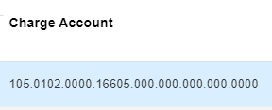

- In the same lines as the Charge Account, you will also see a few fields listed as Percentage, Quantity and Amount. These fields let the system know that 100% of the value of the requisition will be charged to the charge account listed previously. All Inventory lines must be 100% charged to the same Charge Account.

- Click the Add to Cart button to continue. An information message should appear briefly to let you know that the content has been added to the cart and the cart value should increase by 1
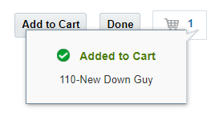
- Click the Shopping Cart icon to display the contents of cart.

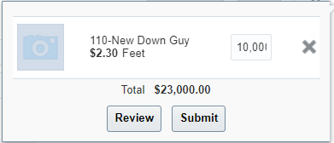
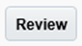
- Click the Review button to review the requisition for edits and to add a name to your requisition prior to submitting for approval. Upon clicking Review, the Edit Requisition page should open

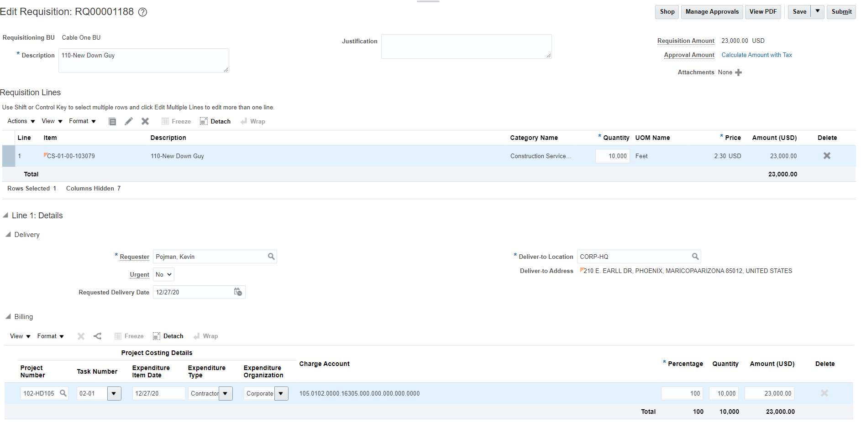

- Click on the Description field and replace the existing text (which by default will be the description of the first item added to your cart) with the text “My First Labor 3-Way Contract Services Requisition”

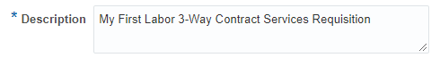

- Review the Charge Account and make sure that the account number now reflects project Charge account

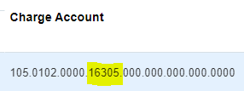
- Click on the Save button. A date and time stamp should appear near the save button.

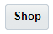
- If you have forgotten an item, you can always continue shopping by clicking on the Shop button. The shop button returns the item to the cart (but the requisition number remains assigned). If you must continue shopping, always remember to click save. For this exercise this will be our only item.

- Click the Submit button to submit your requisition. A confirmation message appears, Requisition XXXX was submitted , with the requisition number listed. The Edit Requisition page should close, and Oracle should return you back to the requisition page.

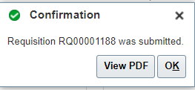
- Click on the PDF Button if you would like to see an electronic copy of the requisition. Click on the OK Button to close the confirmation message.

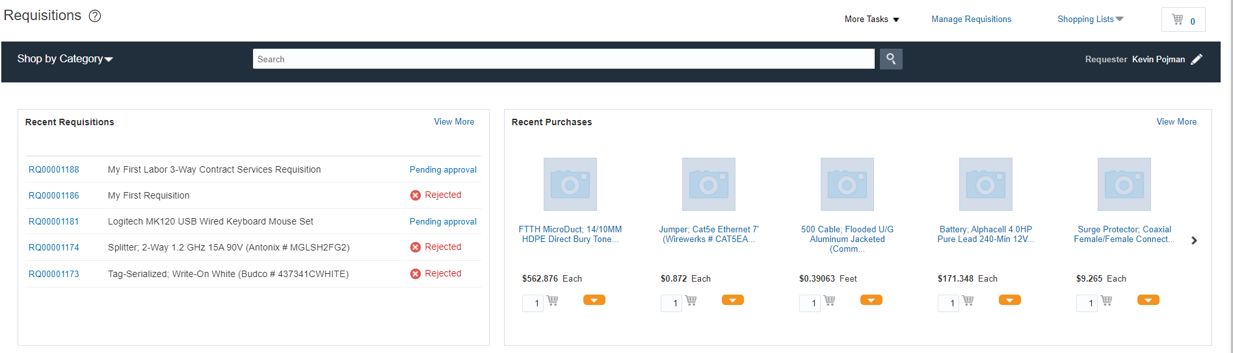

- The newly created requisition should be listed under the Recent Requisitions section of the Requisitions page. The status of the Requisition should also be listed and most likely will be listed as Pending Approval. User may return to check the status of the Requisition

- You have completed the requisition. Return to this screen or to Manage Requisitions to follow up on your requisition status.

Create a Services 2-Way Requisition Line For a Service Using Enter Requisition Line:

Business Procedure Description:
The activity describes the process for creating a service-related requisition line in which the service is being order based on the amount of the service or the total sum of the service. The user will use the Enter Requisition Line process to create the requisition and a line type Services 2-Way.

Prerequisites:
No Item from the item master can be used
Supplier Agreement must be in Open Status and must contain selected items
Supplier Agreement must be active (end date open or not reached)

Output/Next Steps:
Requisition is created and forwarded to the Requisition Approver for review and approval

Tips/Additional Information:

- Login into Oracle

Once logged in, the Oracle Springboard should appear.

- Click on the Purchase Requisitions icon. The Requisition page listed below should open and should display different information on recent requisitions and purchases and other tasks available to the user.
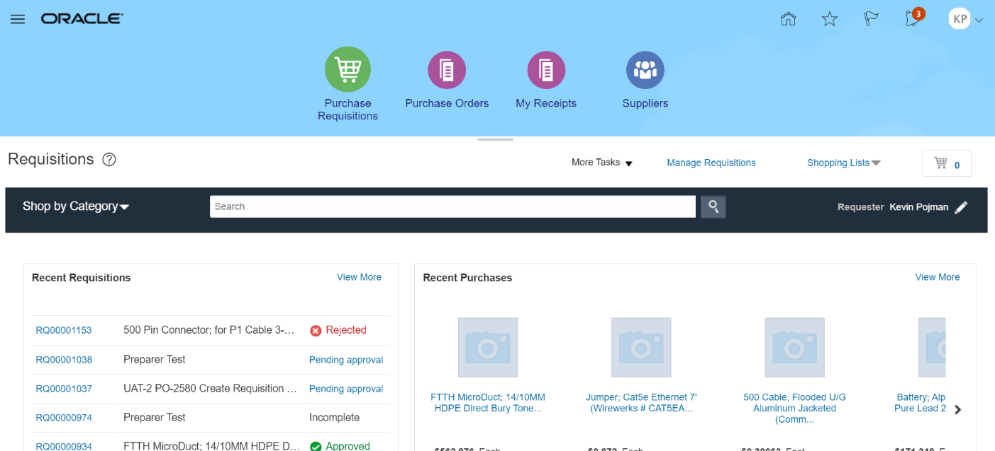

- Click the More Tasks drop-down arrow to see a list of tasks available to the user.

- Upon clicking on More Tasks drop down, the task list should be visible

- Select the Enter Requisition Line task to go to the Enter Requisition Line screen.

- The first available field is the Line Type field. When first opening Enter Requisition Line, this field should be defaulted to Goods 3-Way. Click on the Line Type field drop down.

A listing of Line Types should be visible.

- For this exercise we will use Services 2-Way line type to select the appropriate Line Type for a service that will not be received based on quantity and price per unit

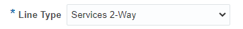

Upon selecting the Services 2-Way Line Type you will see certain fields will no longer be visible. Specifically, The Item, Revision, Quantity, UOM Name and Price Fields will no longer be visible and but Amount field will be visible

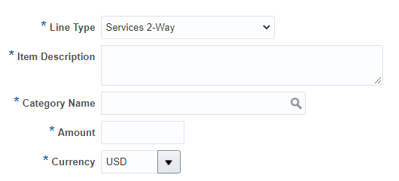

- In the Item Description, enter the following text: Building Janitorial Services

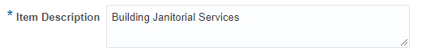
- In the Category Name field press the search Icon (The Magnifying glass Icon) . The Search and Select: Category Name window should open.

- Click inside the Description field of the Search and Select window and then type the text Janitorial

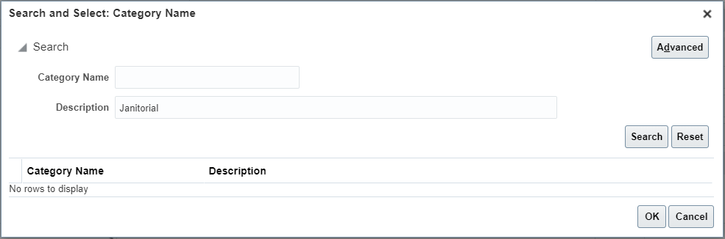

- Click on the Search button to conduct the search for the matching Category Name

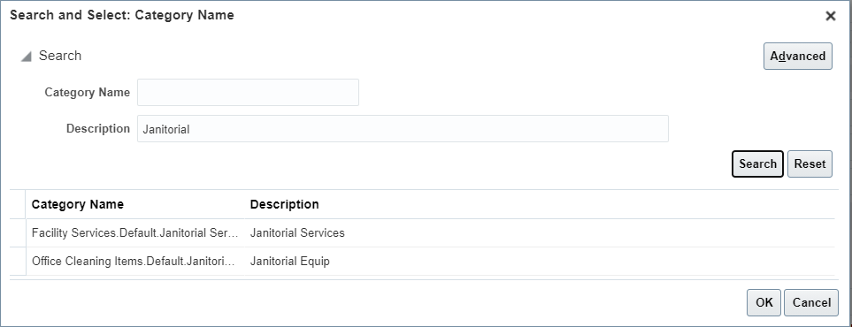

- Click on the row with the Description listed as Notebook Computers. The row should be highlighted. The click on the OK button to select the Category Name. User can also double click on the selected row and the Category Name will populate.

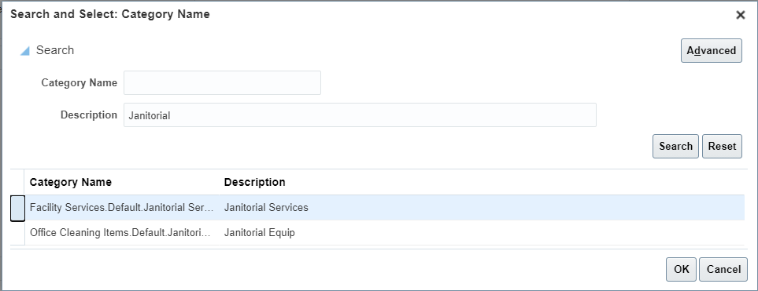

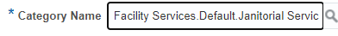

- In the Amount field enter 6600.00 field change the default value to 10. There should be no issue with the value being changes



- The Currency field should be defaulted to USD

- The Agreement field should be left blank

- In the Supplier field you will enter the name of the supplier to purchase the item from. You can enter the supplier name by typing the first few characters of the name or by searching for the supplier through search. For this exercise we will use JANI-KING OF SPRINGFIELD.

  - Find the Supplier Name by typing the starting portion of the name
In the Supplier field, type the first few characters of the supplier name. In this example, start typing JAN. As you type, the system should show a listing of matching names. Please note that you will need at least 3 characters to activate the item listing.

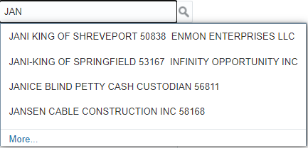

Once the list is visible click on the Supplier name JANI-KING OF SPRINGFIELD 53167. The selected supplier should populate the Supplier field

  - You can also find a supplier by searching for the Name, Number or Alternate Name
Click on the magnifying glass icon to search for a Supplier. The Search and Select: Supplier window should open and will allow you to search by either Supplier, Supplier Number or Alternate Name

Click on the Advance Button to open the advance search setting.
Note that between all field names (Supplier, Supplier Number and Alternate Name) and the data entry area, you will see the “Start with” supplier operator.

In the Supplier Number field enter the number 53167.
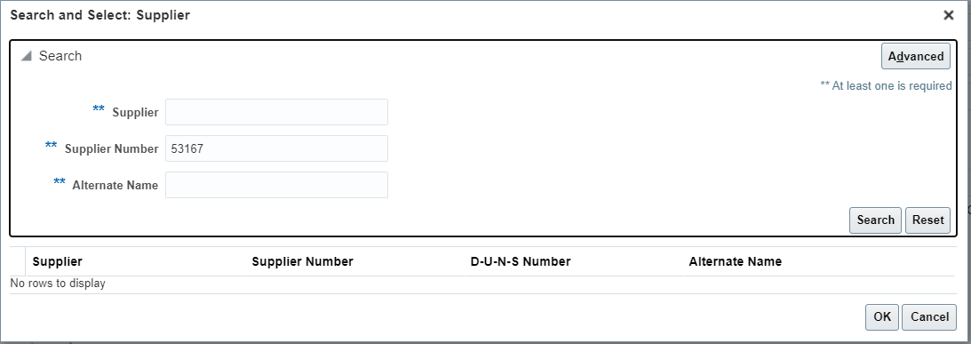
Click on the Search button to conduct the number search. The supplier record matching the entered supplier number (or portion of the number) should list in the search results.

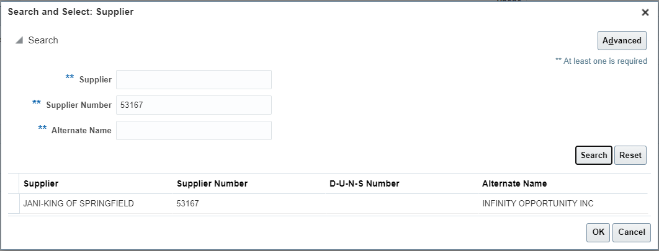

Using the mouse, click on the row for Supplier Name JANI-KING OF SPRINGFIELD to highlight the entire row.

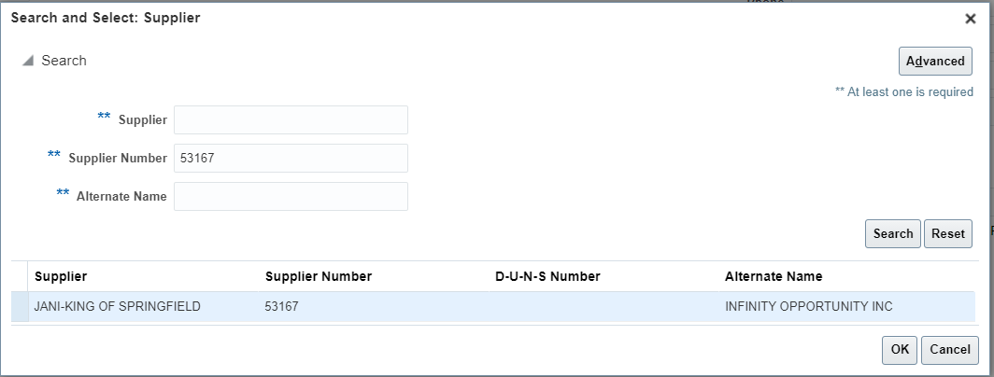
- Once the desired row is highlighted, click on the OK button and the selected Supplier will populate the Supplier field. Please note that the Supplier Site, which prior to populating the Supplier field name was locked, now should be available for data entry or should populated.

- Leave the Supplier Site as is. If the Supplier Site is listed, leave it listed. If the Supplier Site is not automatically listed, then leave it blank (this means that there are multiple Supplier Sites).

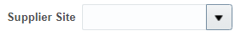

- Leave the Supplier Contact Field blank or select an option from the drop down.

- If the Phone field is blank you have the option to provide a contact number so long as you have not selected a Supplier Contact

- Leave the Fax field blank. Procurement will not send out purchase orders via fax.

- If the email site is blank, you may provide an email address where to send the purchase order. However, if an email has been populated by the system or you have selected a Supplier Agreement, this field cannot be changed.

- In the Supplier Item field Enter Laptop Surface If a Supplier Agreement had been selected, this field would have been populated and should not be changed.

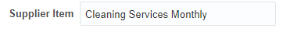

- In the delivery Section of the Enter Requisition Line screen, Click on the Requested Delivery Date field and type the requested delivery date in mm/dd/yy format, click on the date Icon and select the desired date or leave the contents of the field as is.

- Select CORP-HQ in the Delivery to Location or leave as defaulted

- Please note that the destination type that was available when creating a requisition for an Inventory Item is not visible. When the Item field is blank or the Part number starts with CS, IS or IM, the Destination Type will not appear but will be defaulted to Expense.

- In the Billing section of the Enter Requisition Line page, there should be a charge account that has been automatically added for you. Under no circumstances should this charge account be modified. The Charge Account is composed on several segments. The First Segment is the company segment and should be listed as 105. The second segment is the Location and should list 0102 for Corp-HQ. If you have changed the Deliver-to Location, the location segment will also change. The third segment is the Department segment and for all inventory purchases if should be listed as 0000. The fourth segment is the Account Segment and for expense purchases it will default based on the Category Name. The best place to review the correct Charge Account number is upon Requisition Review to ensure charge account is correctly processed

- In the same line as the Charge Account, you will also see a few fields listed as Percentage, Amount (USD). These fields let the system know that 100% of the value of the requisition will be charged to the charge account listed previously. Please note that the quantity field will not be listed for any 2-Way Line Type requisition line.
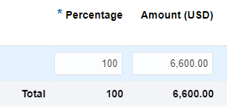

- Click the Add to Cart button to continue. An information message should appear briefly to let you know that the content has been added to the cart and the cart value should increase by 1. Keep in mind that this information message may not appear if you have cleared the cart contents once before.

- Click the Shopping Cart icon to display the contents of cart.

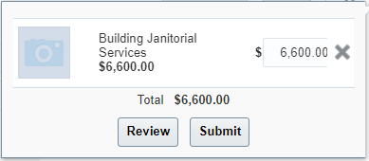
- Click the Review button to review the requisition for edits and to add a name to your requisition prior to submitting for approval. Upon clicking Review, the Edit Requisition page should open

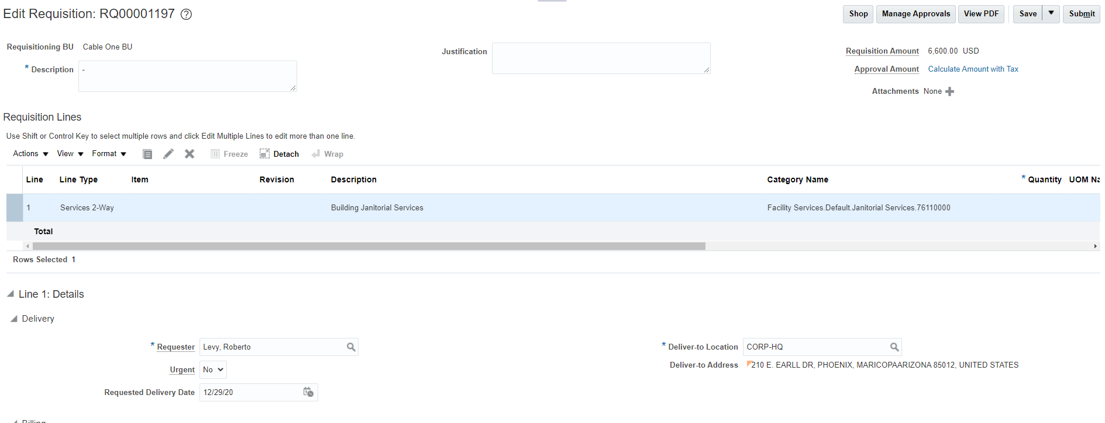

- Click on the Description field and replace the existing text (which by default will be the description of the first item added to your cart) with the text “My First Services 2-Way Requisition”

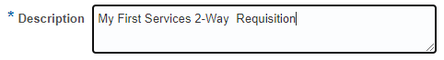

- Make any additional changes if needed.

- Review the charge account for the requested line and look at the changes that have occurred. The third and the fourth charge account segments should have changed from what you saw prior to adding the item to the cart. The department segment is now populated based on the department of the Requester and the Account segment is based on the account codes for the Category Janitorial Services

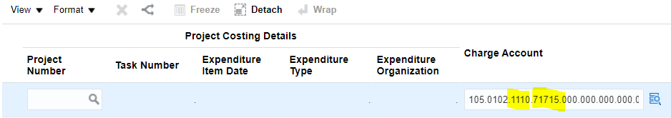
- Click on the Save button. A date and time stamp should appear near the save button.

- If you have forgotten an item, you can always continue shopping by clicking on the Shop button. The shop button returns the item to the cart (but the requisition number remains assigned). If you must continue shopping, always remember to click save. For this exercise this will be our only item.

- Click the Submit button to submit your requisition. A confirmation message appears, Requisition XXXX was submitted , with the requisition number listed. The Edit Requisition page should close, and Oracle should return you back to the requisition page.

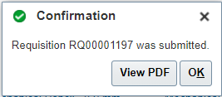
- The Requisition should be listed in the Recent Requisitions page and its status should be Pending Approval

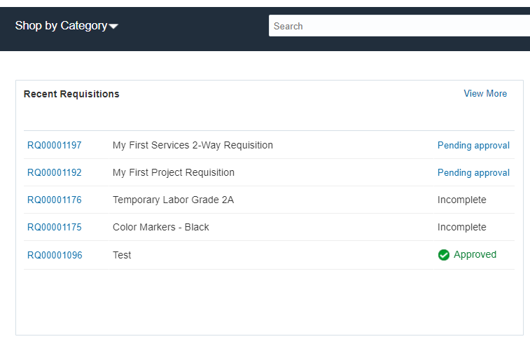

Create a Goods 3-Way Requisition Line Via Enter New Requisition Line for An Item in Item master – As a Preparer:

Business Procedure Description:
Use this process to create a requisition for an Expense Good not in the Item Master, Line Type Goods 3-Way , on behalf of a preparer.

Prerequisites:
Procurement setups must be complete
Supplier must be available and spend authorized
User must have preparer role

Output/Next Steps:
Requisition is created on behalf of another preparer and forwarded to the Approver for review and approval

Tips/Additional Information:

- Login into Oracle

Once logged in, the Oracle Springboard should appear.

- Click on the Purchase Requisitions icon. The Requisition page listed below should open and should display different information on recent requisitions and purchases and other tasks available to the user.

- Click the More Tasks drop-down arrow to see a list of tasks available to the user.

- Upon clicking on More Tasks drop down, the task list should be visible

- Click on the Update Requisition Preferences row to prepare the preferences for the actual requester. The Edit Requisition Preferences window should open

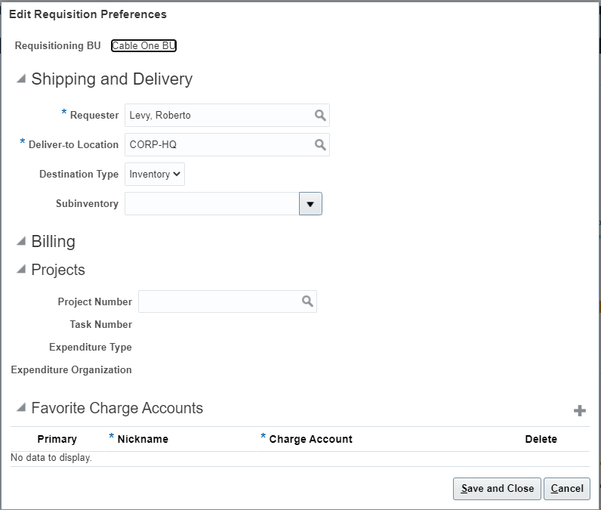

- In the Requester Name enter the name Alejandro, Novemi. You can type the name as shown or you can start typing the last name and the system should bring up all the matching options. You can also search for the user by pressing the magnifying Glass icon.

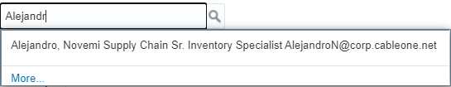

- Once typed or selected, the Requester field should update with the new information.

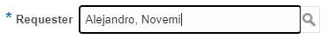

- In the Deliver-to Location field, you will type Cottonwood. The system should bring up the full Cottonwood location name.

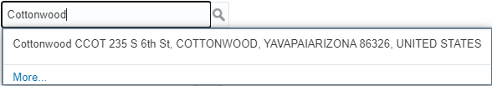

- Click on the Cottonwood option and it will populate in the field. Please note that for this the Requester’s home office is not Cottonwood but the product will be ship to the requester to that office location.

- Click on the Destination Type drop down arrow to see a list of option. Please note that unless the preparer is creating a Project related requisition, leaving the destination type as inventory will cause the future requisition to fail.

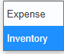

- Select the Expense option by clicking on the expense row. Upon selecting the Expense option, if the previous option listed was destination type Inventory, then the Subinventory field will no longer be visible.

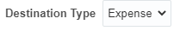
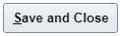
- Click on the Save and Close button to make the preference updates. After pressing the button, the Requisitions page should be visible.
- Click the More Tasks drop-down arrow again to see a list of tasks available

- Upon clicking on the More Tasks drop down, the task list should be visible

- Click on the Enter Requisition Line task to go to the Enter Requisition Line screen. Review the Enter Requisition Line and note that requester and the deliver to location now have been updated based on the preferences.

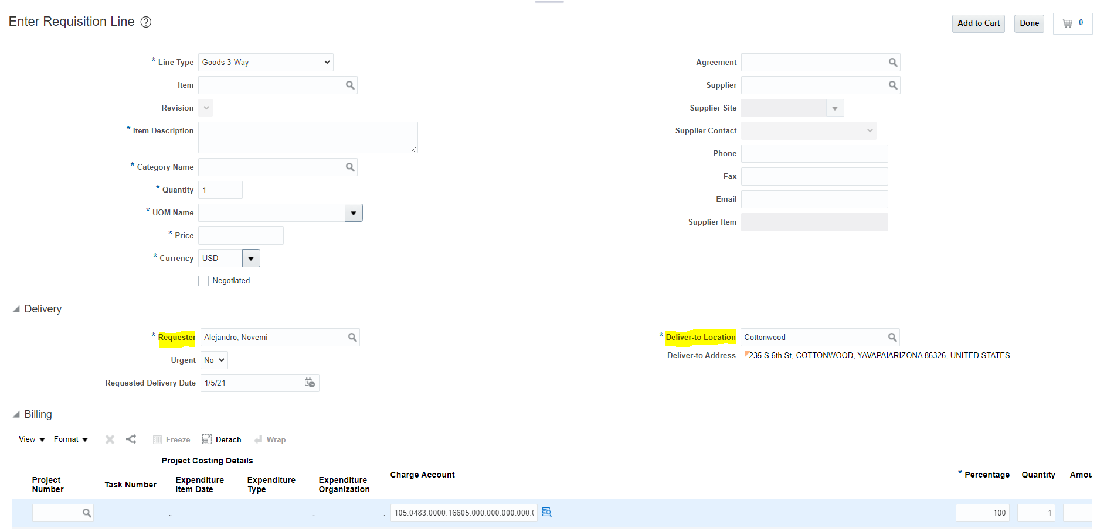

- Please note that any field listed with an Asterix (*) next to it, is a required field. The first available field is the Line Type field. When first opening Enter Requisition Line, this field should be defaulted to Goods 3-Way. Click on the Line Type field drop down.

- A listing of Line Types should be visible.

- For this exercise we will keep Goods 3-Way line type to select the appropriate Line Type for a physical good that will have a quantity and listed price.

- Upon selecting the Goods 3-Way Line Type option certain fields below it should be visible and available for the required data entry

- Leave the Item Field Blank

- In the Item Description, enter the following text: Dell XP Laptop For Student 1

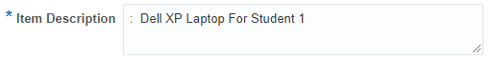
- In the Category Name field press the search Icon (The Magnifying glass Icon). The Search and Select: Category Name window should open.

- Click inside the Description field of the Search and Select window and then type the text Notebook.

- Click on the Search button to conduct the search for the matching Category Name

Click on the row with the Description listed as Notebook Computers. The row should be highlighted. The click on the OK button to select the Category Name. User can also double click on the selected row and the Category Name will populate.

- In the Quantity field change the default value to 10. There should be no issue with the value being changes

- Click on the UOM Name field drop-down or type the name of the measure in the field.

- If you clicked on the drop down arrow, you should see a listing of valid Units of Measure.

- Click on the Each row to select the Each unit of measure

- In the Price field, change the default price to 1100.00

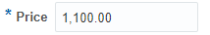

- The Currency field should be defaulted to USD

- The Agreement field should be blank

- In the Supplier field you will enter the name of the supplier to purchase the item from. You can enter the supplier name by typing the first few characters of the name or by searching for the supplier through search. For this exercise we will use TECHNETIX INC.

  - Find the Supplier Name by typing the starting portion of the name
In the Supplier field, type the first few characters of the supplier name. In this example, start typing TECH. As you type, the system should show a listing of matching names. Please note that you will need at least 3 characters to activate the item listing.

Once the list is visible click on the Supplier name TECHNETIX INC 51727. The selected supplier should populate the Supplier field
  - You can also find a supplier by searching for the Name, Number or Alternate Name
Click on the magnifying glass icon to search for a Supplier. The Search and Select: Supplier window should open and will allow you to search by either Supplier, Supplier Number or Alternate Name

Click on the Advance Button to open the advance search setting.
Note that between all field names (Supplier, Supplier Number and Alternate Name) and the data entry area, you will see the “Start with” supplier operator.

In the Supplier Number field enter the number 51727.
Click on the Search button to conduct the number search. The supplier record matching the entered supplier number (or portion of the number) should list in the search results.

Using the mouse, click on the row for Supplier Name TECHNETIX INC to highlight the entire row.

Once the desired row is highlighted, click on the OK button and the selected Supplier will populate the Supplier field. Please note that the Supplier Site, which prior to populating the Supplier field name was locked, now should be available for data entry or populated.

- Leave the Supplier Site as is. If the Supplier Site is listed, leave it listed. If the Supplier Site is not automatically listed leave it as is (this means that there are multiple Supplier Sites). Most of our suppliers received orders to 1 site only.
- Leave the Supplier Contact Field blank or select an option from the drop down.
- If the Phone field is blank you have the option to provide a contact number so long as you have not selected a Supplier Contact

- Leave the Fax field blank. Procurement will not send out purchase orders via fax.

- If the email site is blank, you may provide an email address where to send the purchase order. However, if an email has been populated by the system or you have selected a Supplier Agreement, this field cannot be changed.

- In the Supplier Item field Enter Dell Laptop. If a Supplier Agreement had been selected, this field would have been populated and should not be changed.

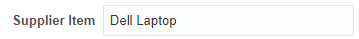

- In the delivery Section of the Enter Requisition Line screen, Click on the Requested Delivery Date field and type the requested delivery date in mm/dd/yy format, click on the date Icon and select the desired date or leave the contents of the field as is.

- In the Billing section of the Enter Requisition Line page, there should be a charge account that has been automatically added for you. Under no circumstances should this charge account be modified. The Charge Account is composed on several segments. The First Segment is the company segment and should be listed as 105. The second segment is the Location and should list 0102 for Corp-HQ. If you have changed the Deliver-to Location, the location segment will also change. The third segment is the Department segment and for all inventory purchases if should be listed as 0000. The fourth segment is the Account Segment and for expense requisitions it will be updated based on the Category Name once added to the Cart.

- In the same lines as the Charge Account, you will also see a few fields listed as Percentage, Quantity and Amount. These fields let the system know that 100% of the value of the requisition will be charged to the charge account listed previously.

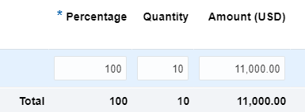

- Click the Add to Cart button to continue. An information message should appear briefly to let you know that the content has been added to the cart and the cart value should increase by 1
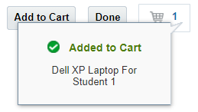

- Click the Shopping Cart icon to display the contents of cart.
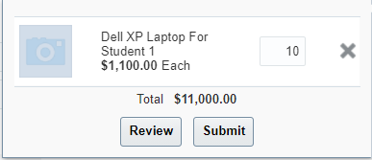

- Click the Review button to review the requisition for edits and to add a name to your requisition prior to submitting for approval. Upon clicking Review, the Edit Requisition page should open

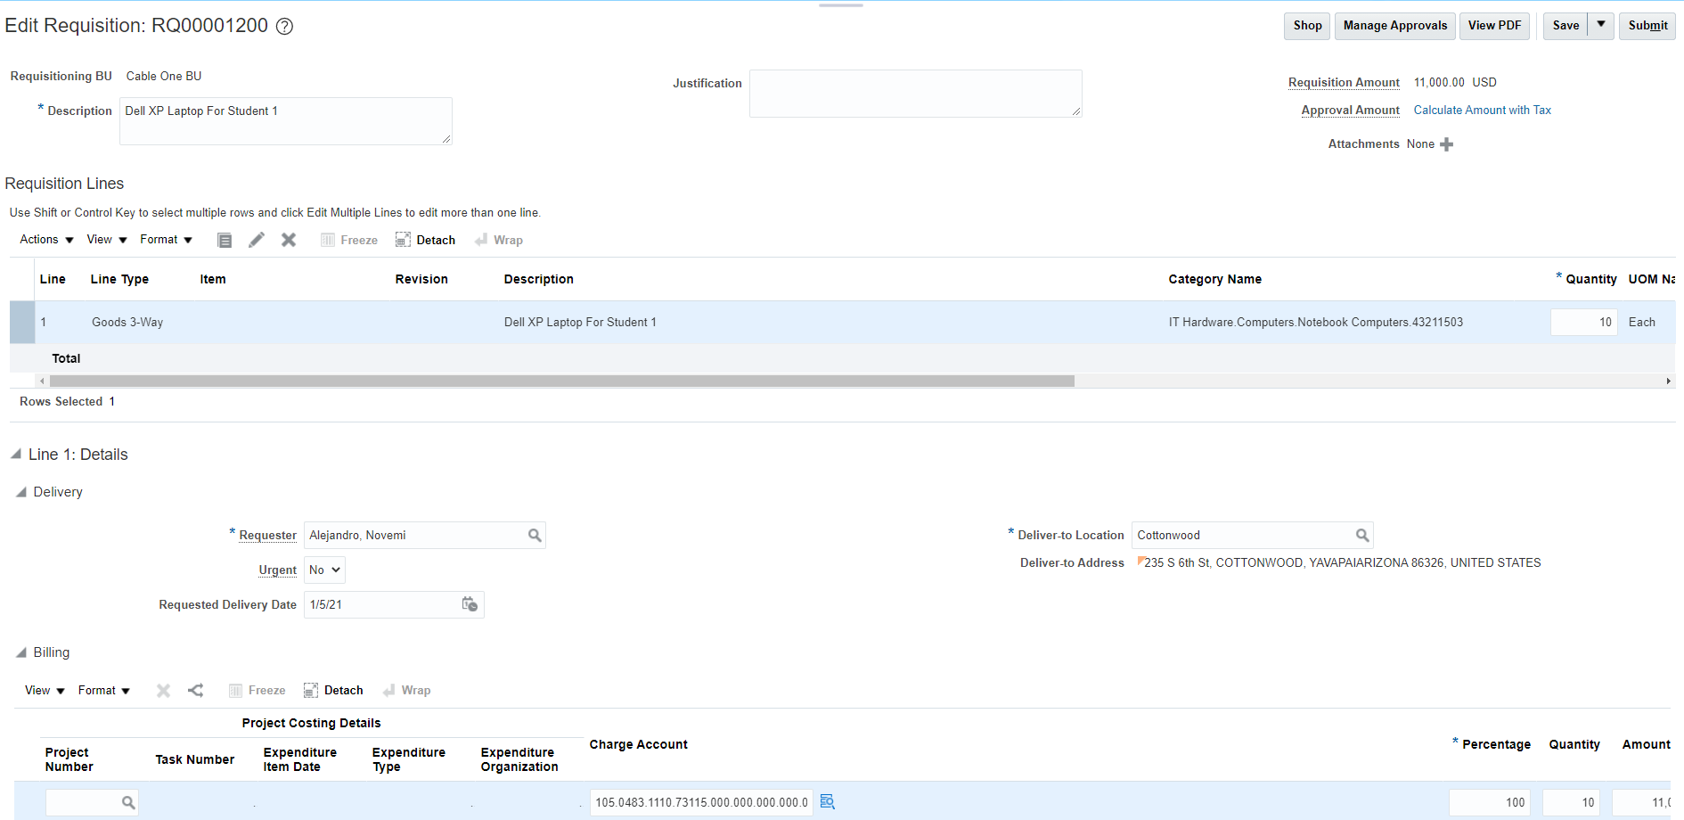

- Click on the Description field and replace the existing text (which by default will be the description of the first item added to your cart) with the text “My First Requisition as Preparer”

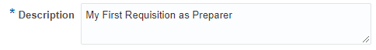

- Make any additional changes if needed.
- Click on the Save button. A date and time stamp should appear near the save button.

- If you have forgotten an item, you can always continue shopping by clicking on the Shop button. The shop button returns the item to the cart (but the requisition number remains assigned). If you must continue shopping, always remember to click save. For this exercise this will be our only item.

- Click the Submit button to submit your requisition. A confirmation message appears, Requisition XXXX was submitted , with the requisition number listed. The Edit Requisition page should close, and Oracle should return you back to the requisition page.

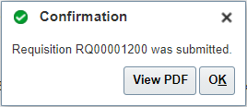

- Click on the PDF Button if you would like to see an electronic copy of the requisition. Click on the OK Button to close the confirmation message.

- The newly created requisition should be listed under the Recent Requisitions section of the Requisitions page. The status of the Requisition should also be listed and most likely will be listed as Pending Approval. User may return to check the status of the Requisition. Please note that the approvals will route via the fiscal approval flow for the requester (Alenjandro Novemi) and not the creator of the Requisition.

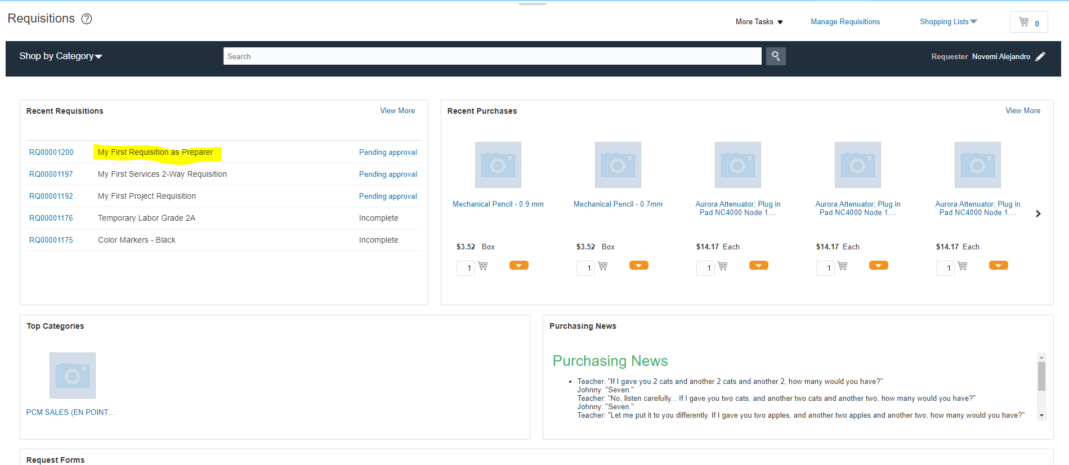

- You have completed the requisition. Return to this screen or to Manage Requisitions to follow up on your requisition status. It is recommended that the preparer of the requisition return to the Update Requisition Preferences and return the information back to his or her name and default Deliver-to Location. If you forget to do this, you will have issues in future requisitions.

Self Service Procurement:

What is Self Service Procurement
Oracle provides requisitioners and buyers with tools to automate or reduce the work involved in creating requisitions, processing requisitions and creating purchase orders. One of these tools is called Self Service Procurement which provides the ability to search for specific items (Project, Expense, or other Master Items) directly from locally or externally pre-created, content rich catalogs, and create requisitions from these catalogs. We also call this Catalog Based Buying or Guided Buying

Content rich catalogs describe lists that are pre-created and contained at least 9 of the key parameters needed to create a requisition and automate the order creation process: An Item number and/or Item Description, Category Name, Supplier, Supplier Item Number, Unit of Measure, Price and Supplier Agreement number. The Requester supplies the last piece of information which is the Quantity (only for 3-Way goods or services).

Although Catalog based buying speeds ups the requisition creation process, it also comes with some inherent restrictions. Because these catalogs have the key parameters already pre-defined, a requester or preparer will be limited on what changes can be made to an existing requisition or cart contents. The speed advantage in creating a requisition from a catalog over Enter Requisition Line make ups for potential limitations on changes.

Types of Catalog Based Buying

There are several types of catalog-based buying and some are more intricate than others. The most frequently used catalogs are the Shopping Lists, Local catalogs, Supplier Punchout Catalogs and Form Based Buying. The first 3 forms of catalog buying are explained in the following sections

Catalog Based Buying – Create a Requisition from a Shopping List:

Business Procedure Description:
Create a Requisition Line from a Shopping List and Submit the requisition for approval. A shopping list can be a Public or a Private Shopping list

Prerequisites:
A Shopping Cart must be available.
A Private Shopping List must be based on Existing Catalog based item
An Active project number must be available
All Subinventories must be active

Output/Next Steps:
Requisition is created and forwarded to the Requisition Approver for review and approval

Tips/Additional Information:

- Login into Oracle
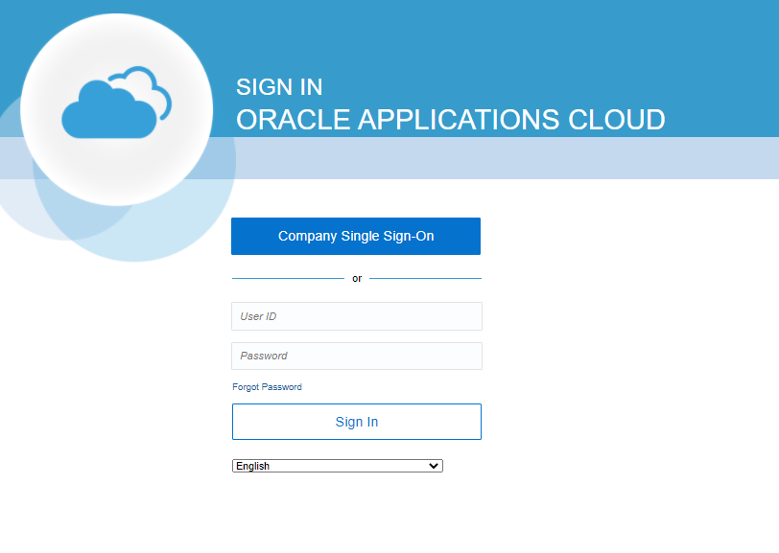

You should see the springboard navigation screen

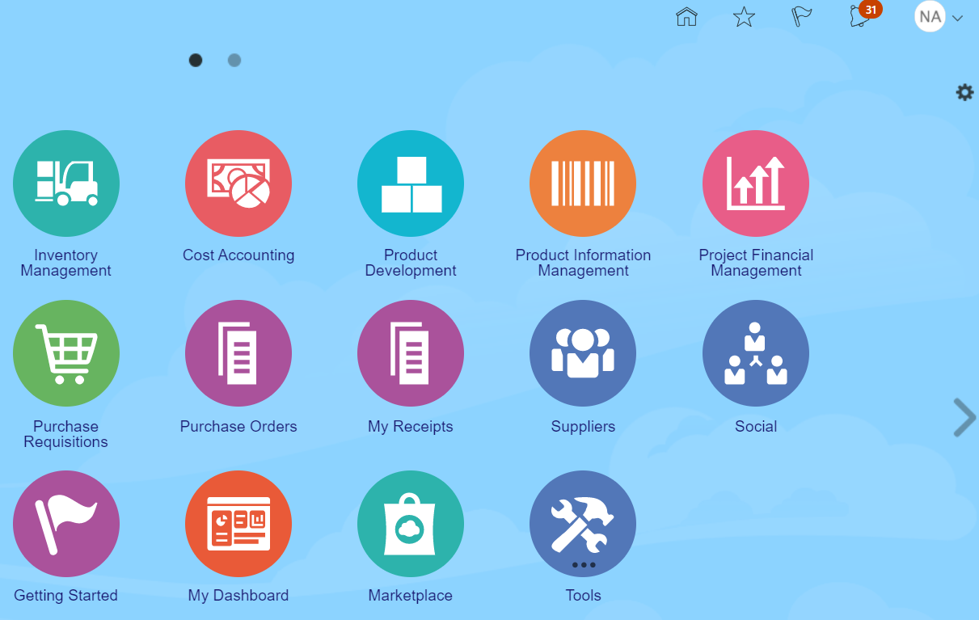

- Click the Purchase Requisitions icon to go to the Requisitions screen.

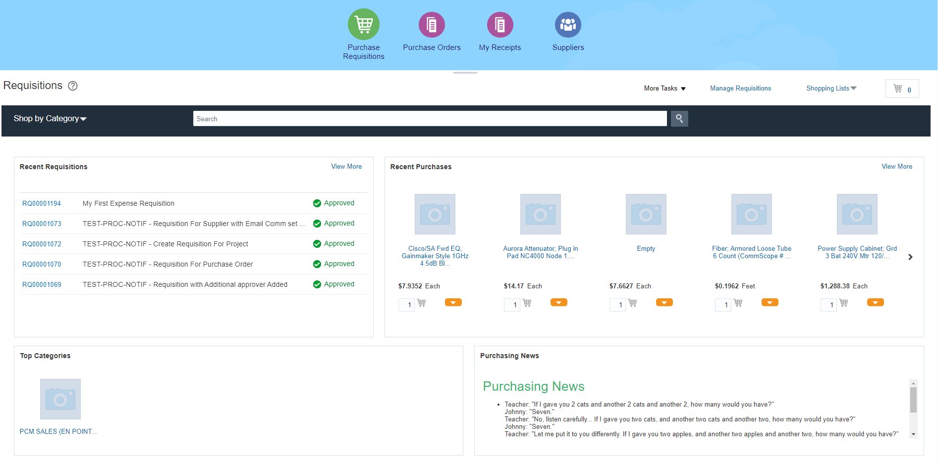

- Click on the Shopping List task drop down link on the top right of the screen. A listing of all the available Public and Private shopping lists should be visible. Public Shopping lists will be listed on the bottom half of the list and private shopping should lists on the top half. For clarity purposes we have name them Public and Private, but the names can be changed. Next to each name there is a box with a number, representing the number of items in the list.

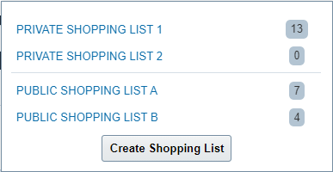
- Click on the link for PRIVATE SHOPPING LIST 1 ... The listing of items inside the Shopping list should appear in the shopping list.

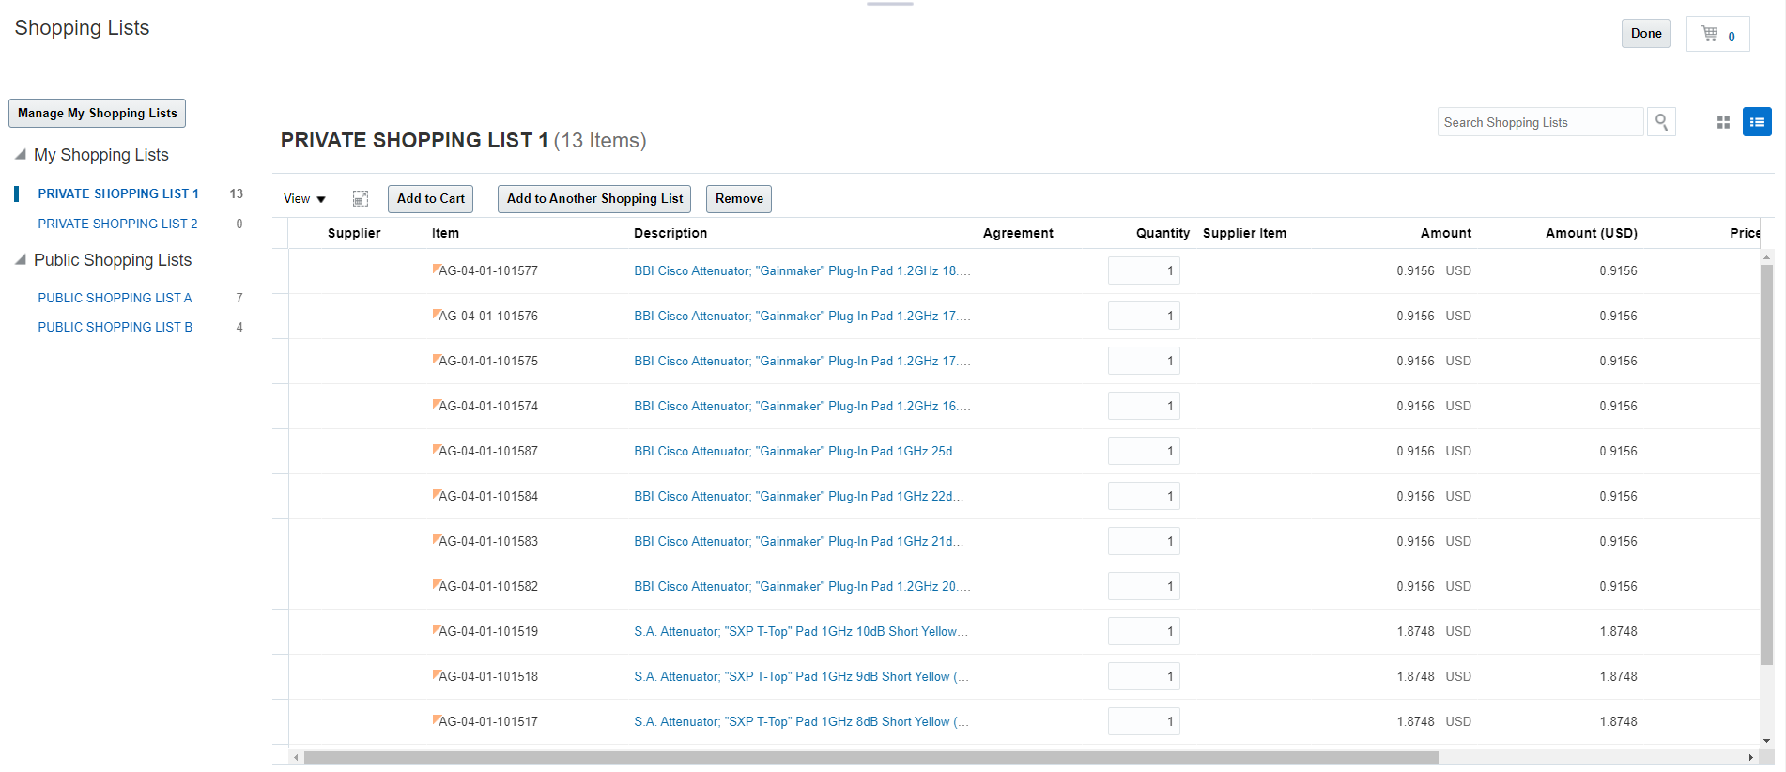

- This list is the typical format for all Internal Catalog lists. It contains the 9 Key Parameters needed to speed up requisitioning and automate purchase order creation. With this list, the user selects the items needed, highlights the rows and the adds all the rows highlighted to the cart and the same time. With the correct preparation this approach will work on project related needs.


- Sort the Item field column in ascending order by hoovering with your mouse over the field header and clicking on the up arrow icon

- In the row for Item AG-04-01-101516 click inside the quantity field.

- Change the value in the quantity field to 5.

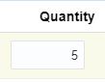

- Repeat the previous steps and change the quantity in the rows for AG-04-01-101517, AG-04-01-101518, AG-04-01-101519 to 5 as well.

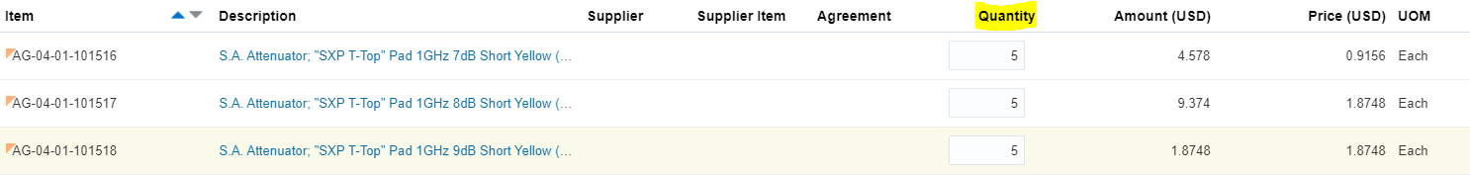

- Once of the desired rows have been change, click on each of the modified rows while holding the CTRL key. All the rows should be highlighted.

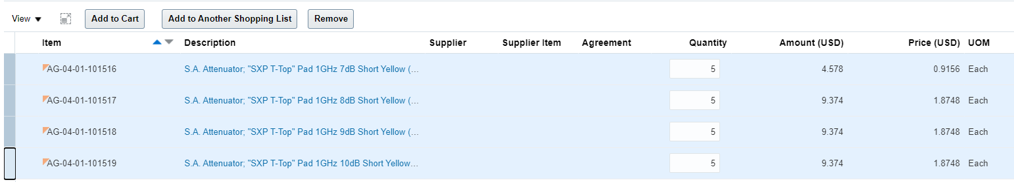

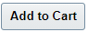
- Click on the Add to Cart Button to add the selected items to the Cart. A message confirming that the items have been added to the cart should appear and the Cart value should show 4 more items.

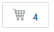
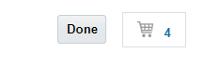
- Click on the Cart Icon . A listing of the cart options should appear.
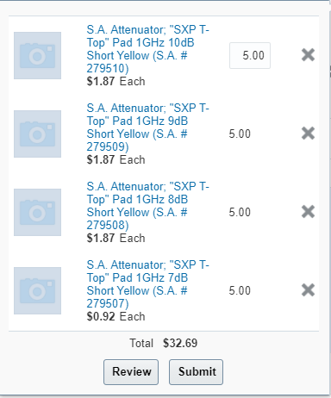

- Click on the review button to finish entering the required information such as Project information, Requisition Description, Destination Type, Requested Delivery Date, Notes to supplier and other information for each line. Please note that selecting Inventory Items using a shopping list requires the additions of Project information and a project related SubInventory (_PRJ) location. If you do not add this information, your Requisition will be automatically rejected.

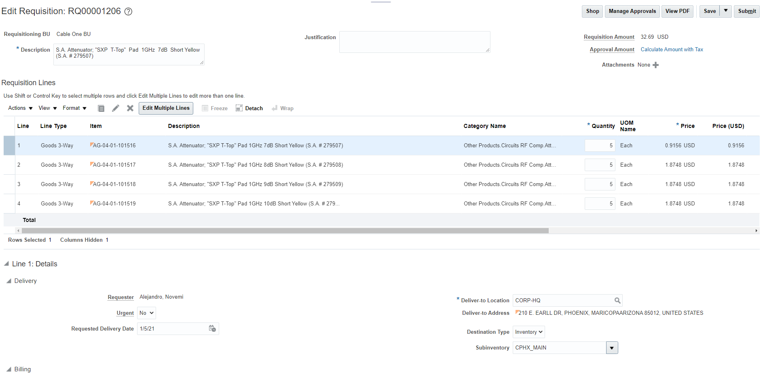

- Click on the *Description field and change the existing contents to “My First Shopping List Based Requisition”

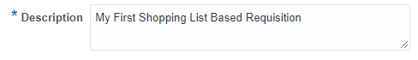

- Click on the line for Item AG-04-01-101516. The entire line should turn blue and now all the other fields that are changed will be for that selected item.
- In the delivery Section of the Enter Requisition Line screen, Click on the Requested Delivery Date field and type the requested delivery date in mm/dd/yy format, click on the date Icon and select the desired date or leave the contents of the field as is.

- Make sure that the Destination type is listed as Inventory and that the SubInventory field was set to CPHX_PRJ . Please note that if you are in another location, the 4 digit Inventory code should match the inventory Organization.

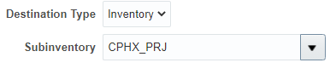

- In the Billing section of the Enter Requisition Line page you should see the Project Number field on the left side of the Project Costing Detail group. Please note that the remaining fields Task Number, Expenditure Item Date, Expenditure Item, Expenditure Type, and Expenditure Organization are not available for data entry.

- Click inside the Project Number field and enter the project number 102-HD105. When done, press the tab or the enter key.

- The Project Costing Details field that were locked should now be available for data entry. The Expenditure Item Date should default to whatever value you have entered in the Requested Delivery Date.
- Click on the Task Number dropdown arrow to see a list of available Tasks

- Select the 02-06 (Headend Equipment, ) task number option by clicking on that row of the option list. The Task Number should populate the field
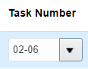
- Leave the Expenditure Item Date field as is. It is recommended that you always use the Requested Delivery Date to provide an indication of how early or how late you will want the products to be delivered.
- Click on the Expenditure Type field drop down arrow to see a list of all available options for the expenditure types.
- Select the Active Gear expenditure type option by clicking on the row
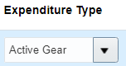
- Click on the Expenditure Organization field drop down to see or search for the available options
- Use the Corporate Office organization. If you see your Expenditure Organization, select it by clicking on the row. If you do not see your Expenditure Organization, then click on the search link to open the Search and Select: Expenditure Organization window.
- In the Value field enter the text Corporate and then press the Search button to display the possible results. Please note that Expenditure Organizations are different than Deliver-to or Inventory Organizations.

- Select the Corporate Office option by double-clicking on the selection or by clicking one to select the row and the pressing the OK button

- Repeat the above process and modify the three remaining lines. Highlight each line and change the Requested Delivery Date, Add the project information and then modify the Inventory Type and SubInventory.
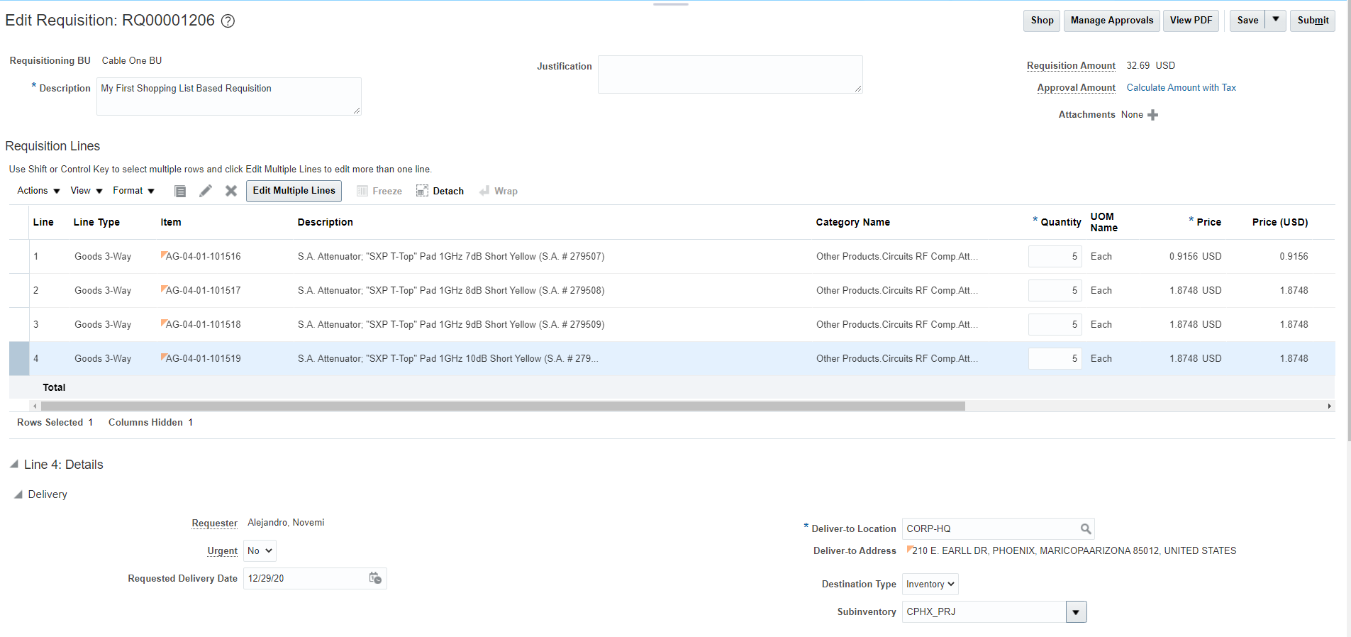
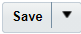
- Once you have finished updating all items, click on the Save Button .
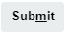
- Click on the Submit button to submit the requisition for approval. If the submission is successful a confirmation message will appear on the screen. Saying that the requisition was submitted
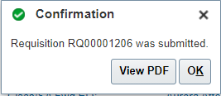
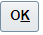
- Click on the OK button to close the confirmation message. You should return to the Requisitions page and the new requisition should be listed under the Recent Requisition section along with the status (Pending Approval)

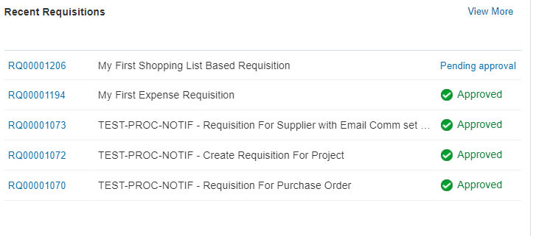
- The transaction is complete

Catalog Based Buying - Create a Requisition via a Punchout Catalog:

Business Procedure Description:
Use this process to create a requisition using a supplier punchout catalog.

Prerequisites:
Items must be available in self-service catalog
Punchout must be active and working
Category Mapping must be accurate and active

Output/Next Steps:
Requisition is created and forwarded to the Requisition Approver for review and approval

Tips/Additional Information:
Under certain circumstances, a punchout item will load improperly and the Category Name will not be listed. This will cause the requisition to fail if you try to submit as is. Remove the item from the Requisition and call procurement to add the Category Mapping to the punchout.

- Login into Oracle
You should see the springboard navigation screen

- Click the Purchase Requisitions icon to open the Requisitions screen show below.

- Click the Shop by Category drop-down arrow . A listing of Categories Hierarchy should appear.

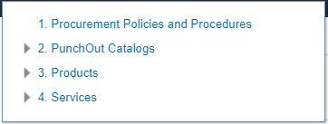
- Click on the arrow pointing right next to the Punchout Catalogs link . The Listing of available punchouts should appear below the Punchout Catalogs Category. If you do not click on the arrow portion but you click on the word link itself, a new screen with the punchout list should appear.

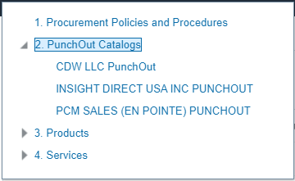

- Click on the CDW LLC Punchout link to open the punchout site. The Site should open

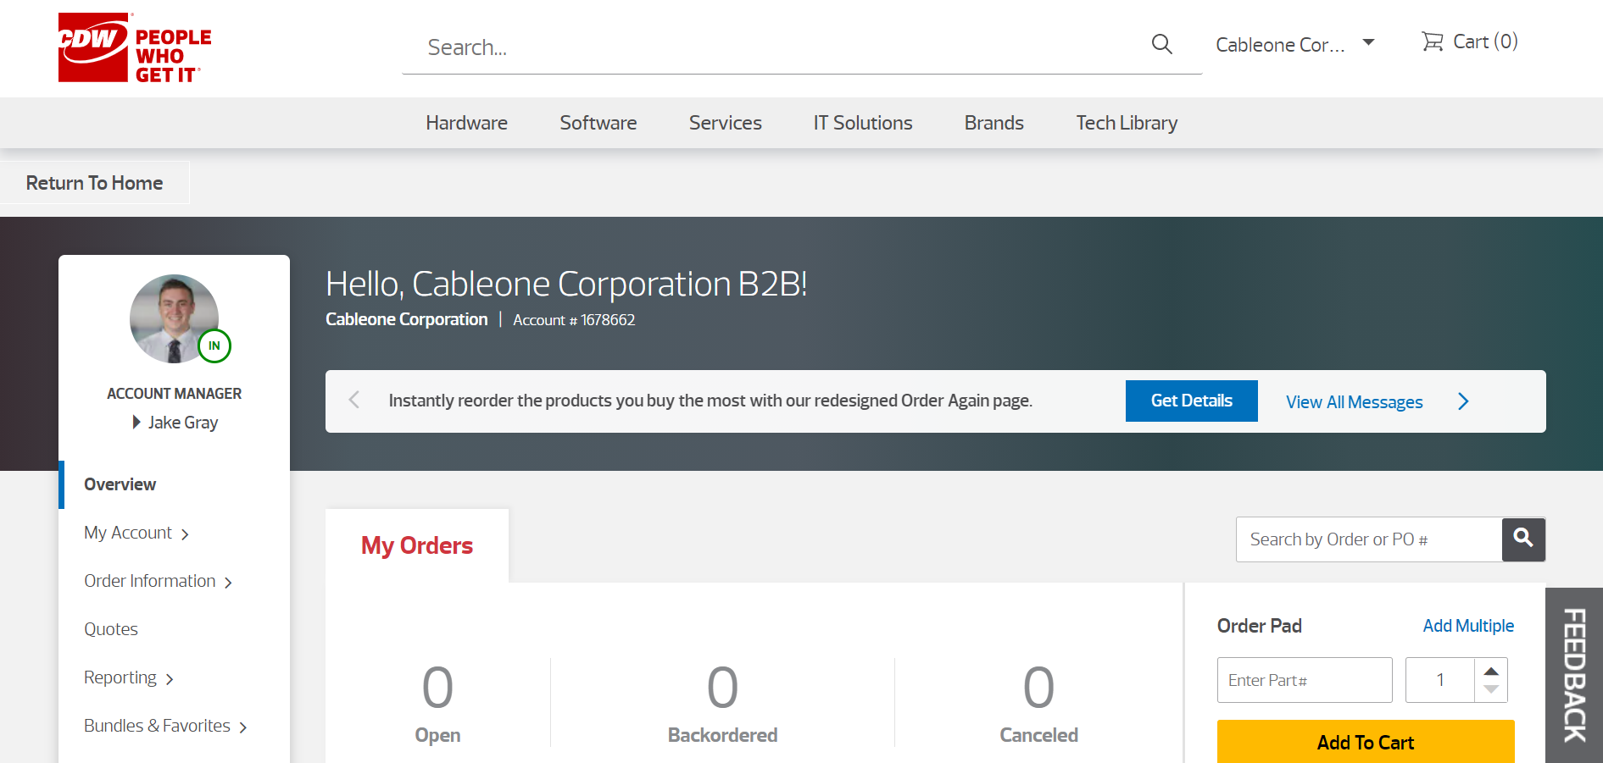

- As you look around the CDW site keep in mind that each suppliers punchout site will be different but should have 6 similar activities that will allow you to use the site to the fullest. Each Site should have:
  - A way to search for items
  - A shopping cart to put selected items in
  - An Add-to-Cart Button to add items to the Cart
  - A way to get out of the Cart
  - A Checkout process to finalize your steps
  - A way back to the CABO oracle program (could be automatic or could be by a link)

- Search for an item by typing the description of it. For Example, type Laptop in the search box.


- Press the Magnifying glass to initiate the search. Keep in mind that in other sites you may see similar icons or a search button like Oracle. After clicking the search icon you should see a listing of Laptop options.

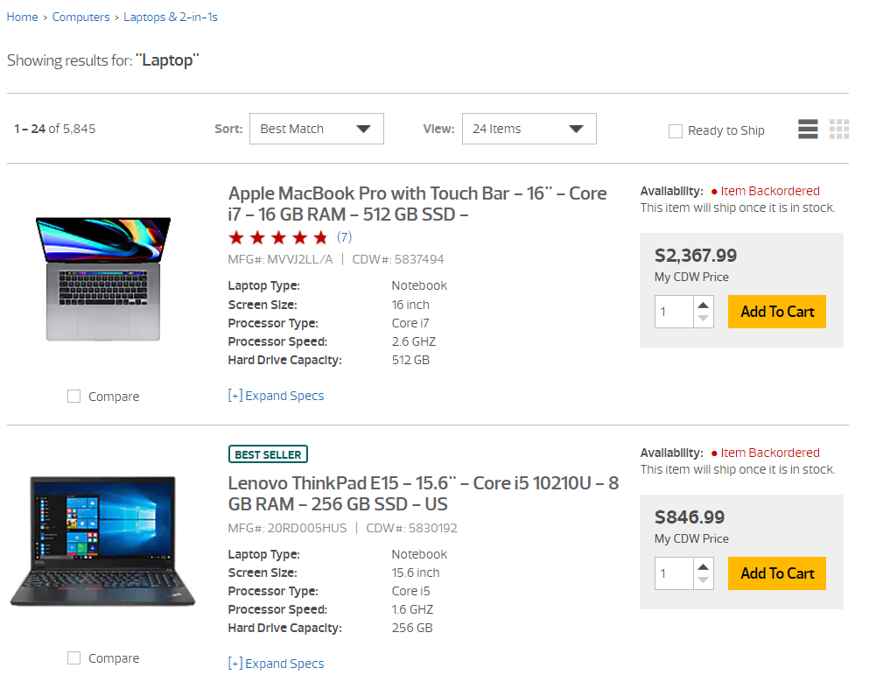

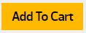
- Select one the of Laptops and then click on the Add To Cart button. In the CDW site, when you click on the Add To Cart button, it will take to the Cart listing the recently added laptop. Some punchouts, like Oracle, will add the item to the cart and you can search around for additional items.

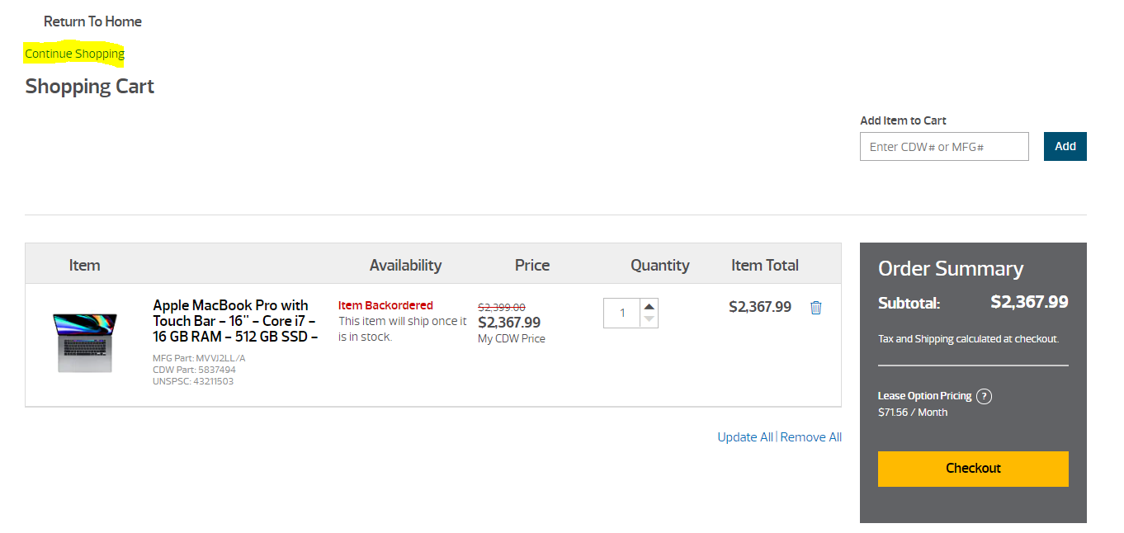


- Click on the Checkout Button. The CDW Punchout site will provide a link to return to the Oracle Requisition.

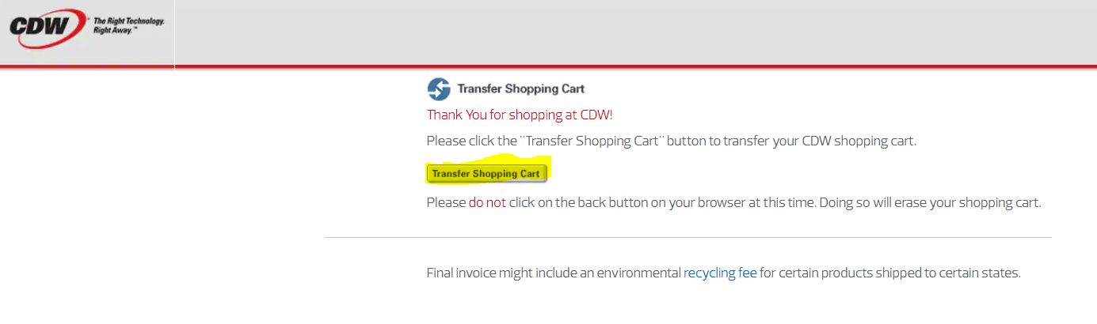

- Click on the Transfer Shopping Cart button. Please note that this process to return to the Oracle Site is very different from supplier to supplier. The Oracle Edit Requisition Page should open. The step that was just performed is equivalent to clicking the Oracle Review button.
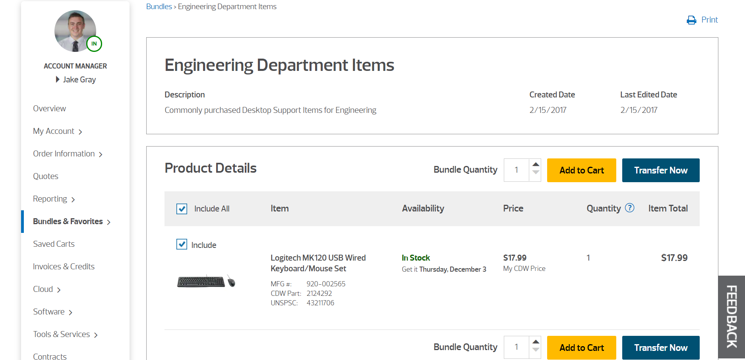

- Click the Transfer Now button 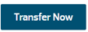 to continue.

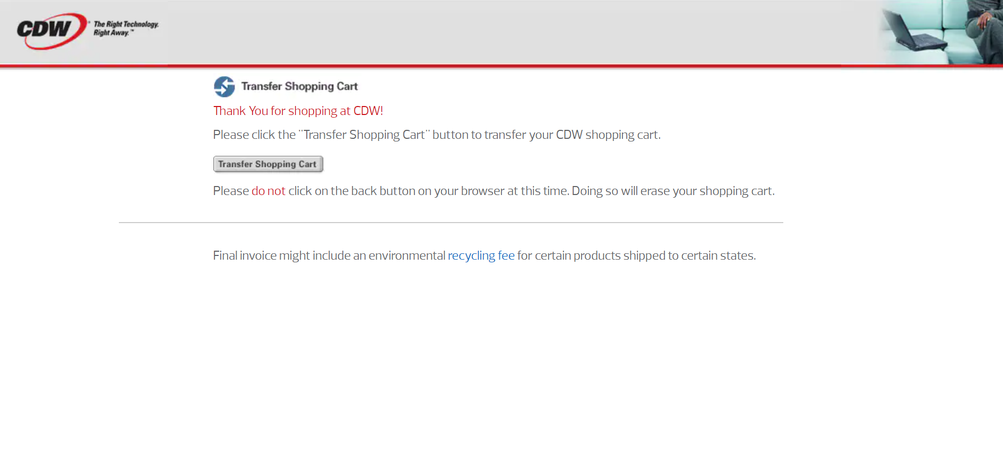
- Click the Transfer Shopping Cart button to go to the Edit Requisition: XXXX screen in Oracle.

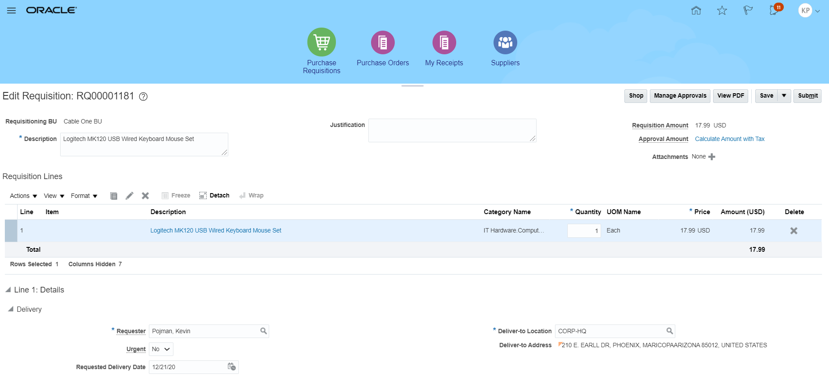

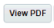
- Review the requisition. Make any changes as needed and click the Submit button to submit your requisition and display the Confirmation window. If you make changes you must click the Save button to save updates prior to submitting. If needed, you can view a PDF version of the requisition by clicking the View PDF button.

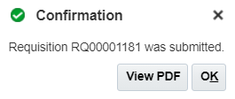
- The system displays the message: Requisition XXXX was submitted. If necessary, you can view a PDF version of the requisition that has been submitted by clicking the View PDF button in the Confirmation window.
- Click the OK button to return to the Requisitions screen.

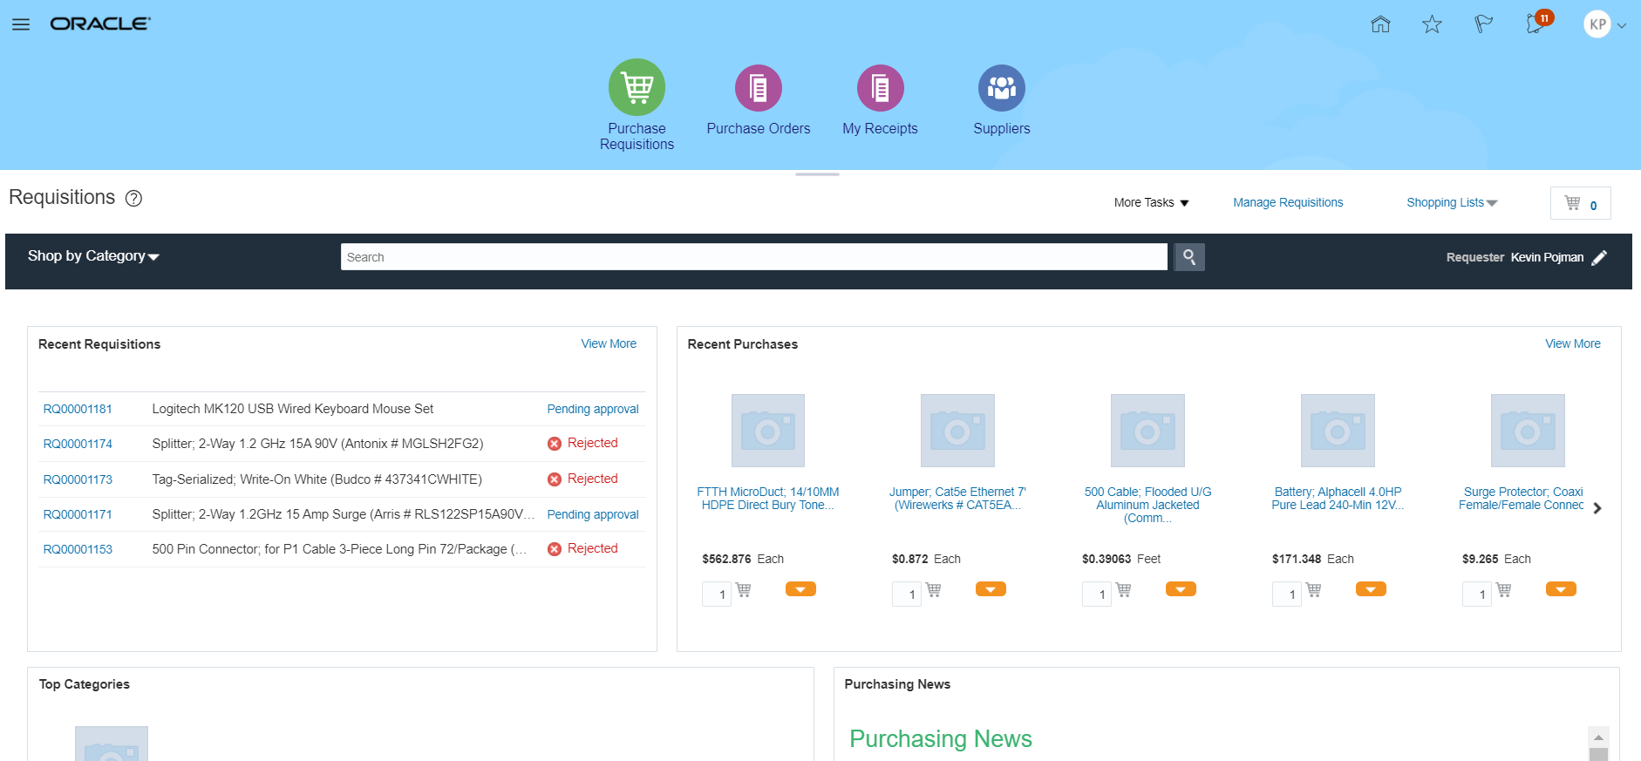

- You have completed this transaction.

Create a Requisition Line via Shop by Category or Search:

Business Procedure Description:
Create a Requisition Line using the shop by category or search functionality and submit the requisition for approval. Requester will search for items to add to a requisition vie the Browsing Categories listed in Shop by Category

Prerequisites:
Items must be available in self-service catalog
Browsing Categories Must be created.
Browsing Categories must be link to items.

Output/Next Steps:
Requisition is created and forwarded to the Requisition Approver for review and approval

Tips/Additional Information:

- Login into Oracle

You should see the springboard navigation screen

- Click the Purchase Requisitions icon to open the Requisitions screen show below.

- You can use the Shop by Category or the Search box to add items to your cart.

  - Click the Shop by Category drop-down arrow . A listing of Categories Hierarchy should appear.

  - Click on the arrow pointing right, next to the Products link. A listing of available sub-categories or browsing groups should appear. If you do not click on the arrow portion to open the next level, but you click on the word link itself, a new screen with all the items listed in the master or in supplier agreements that match the category will show up.

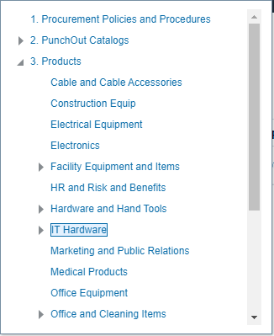
  - Click on the IT Hardware Link to list any item that is attached to Categories that belong to IT hardware. Do not click on the arrow itself. Click on the word link. A listing of all items matching either from Item Master or from Supplier Agreements should be listed

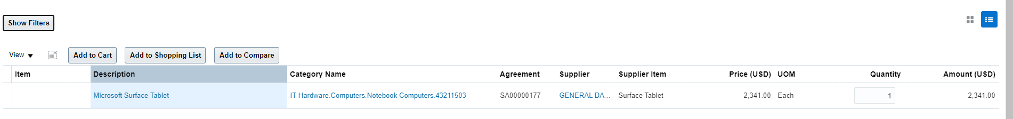

- The Search method allows you a more specific search, but the number of results could be larger. Inside the Search box, type the text “IT Hardware”


- Press the Search Icon. You will get a very large list of items

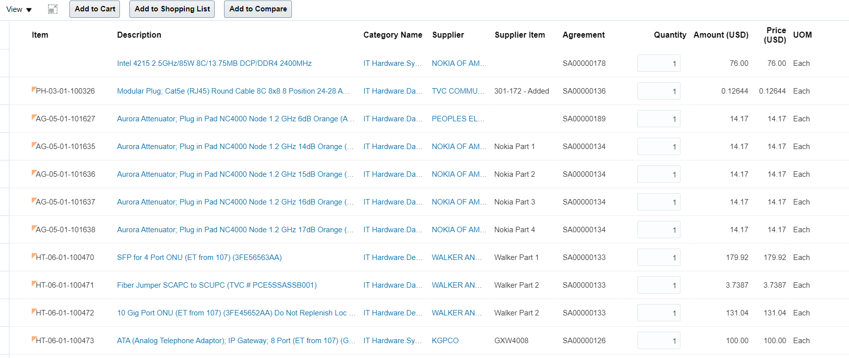
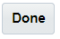
- Clear the content of the search box by clicking the Done button next to the cart icon.
- In the search box, enter the text “Notebook”

- Press the Search Icon. You will get a smaller and targeted list of items

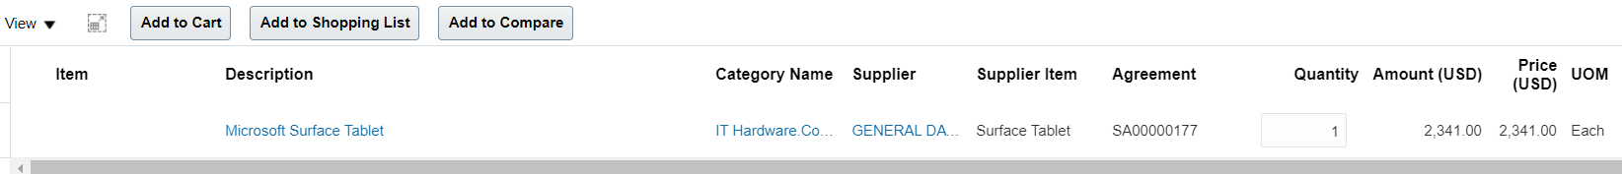

- Using either method, click inside the quantity field of the Microsoft Surface Tablet row and change the existing value to 5

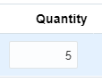
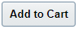
- Click the Add to Cart button to add the item and the selected quantity to the Cart.

- A Notification message saying that the item has been added to the card appears for a few seconds and then disappears.

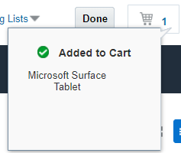

- Click on the Cart Icon to show the contents of the Cart. A small window listing all the items show appear.

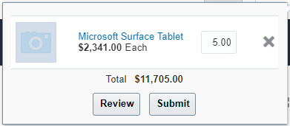

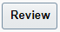
- Click on the Review Button to review and make changes to the requisition. The Edit Requisition page should appear listing all the pertaining information

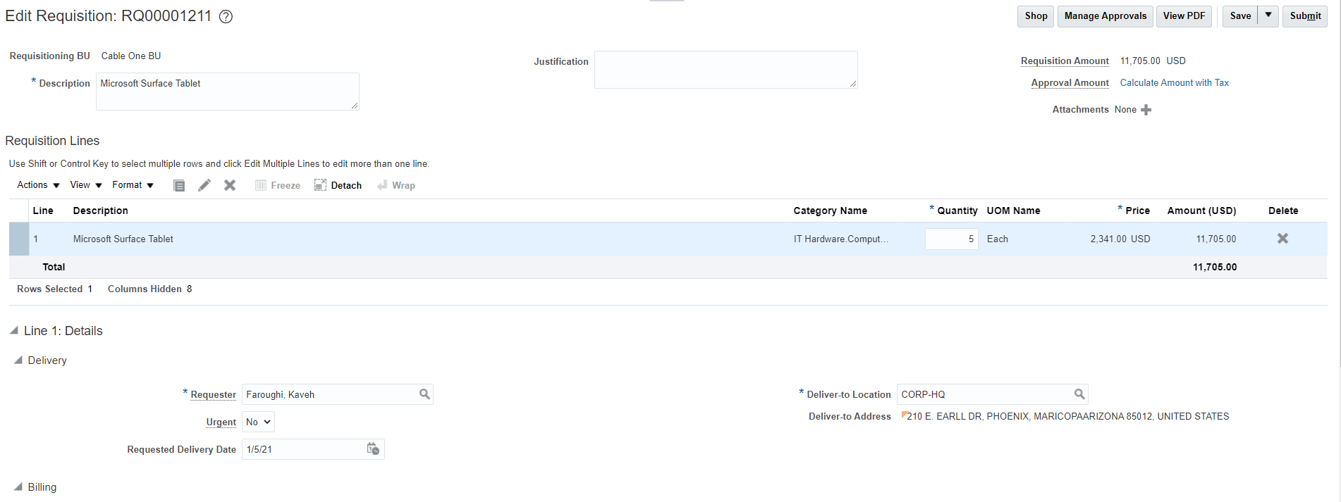

- In the *Description field, change the existing test to “My First Shop by Category Requisition”.

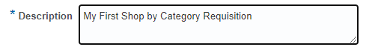
- Check the Charge Account to make sure that it is populated for all 4 initial segments.

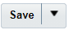
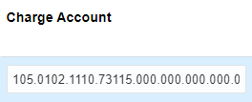
- Click on the Save button. A timestamp should appear once saved.

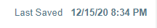
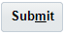
- Click on the Submit button to submit the requisition for approval. Once submitted, a confirmation message should appear information that the Requisition has been submitted for approval,

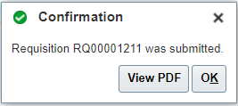
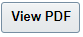
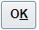
- User may click on the view PDF button to download a copy of the Requisition or you may just click on the OK button to close the confirmation message. Once closed, user should see the requisition screen again.

- The Requisition should be listed in the Recent Requisitions area and should be in Status Pending Approval.
- The Requester can click on the Pending Approval link to find the routing of approvals that the requisition will follow. The user will not be able to change the routing.

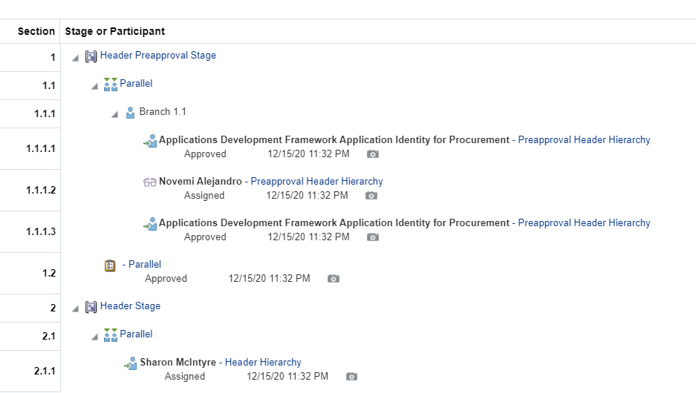

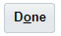
- Click on the Done Button to close the approval information screen.

- You have completed the exercise

Create a New Requisition Via Duplicate:

Business Procedure Description:
The activity describes how to create a new requisition from an existing one and the restrictions this process has on the new requisition

Prerequisites:
Requisition must exist in Oracle
An existing requisition in Incomplete, Pending Approval or Approved status is needed to copy from.
Requested dates be updated for the new requisition if copying from older ones.

Output/Next Steps:
New requisition is created.

Tips/Additional Information:

- Login into Oracle

You should see the springboard navigation screen

- Click the Purchase Requisition Icon to open the Requisitions screen.

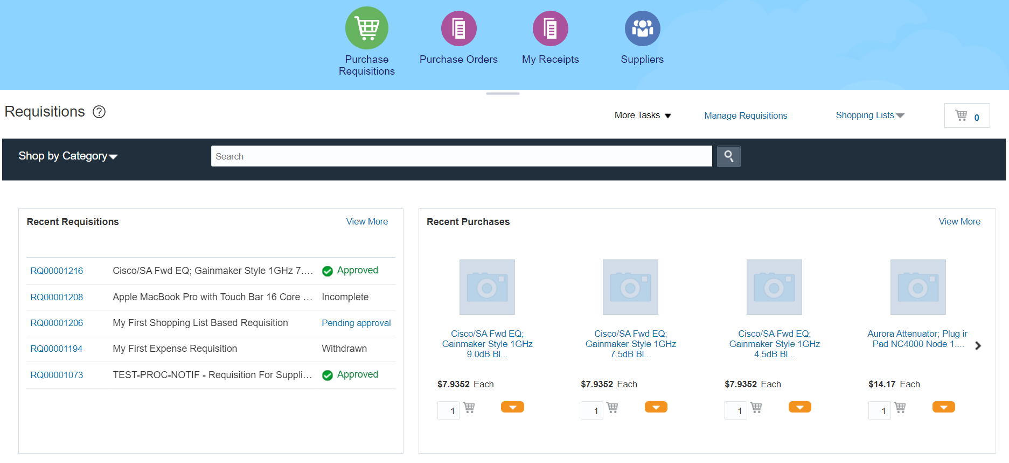

- Click on the Manage Requisition link, to open the manage requisition task. The Manage Requisition task screen consists of a requisition search area and a search results area.

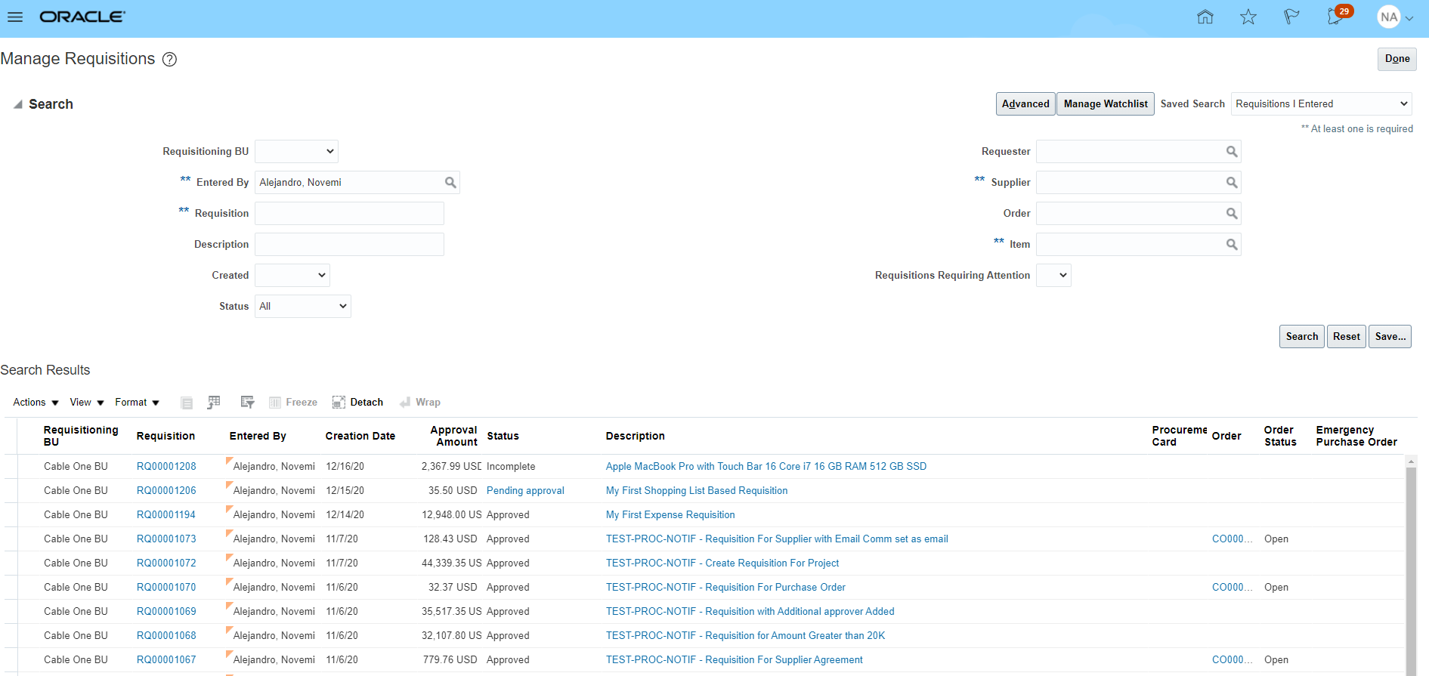

- In the Search portion of the screen, make sure that your name is listed in the Entered By field. Please note that if there are any fields that have 2 asterixis (**) next to them, it means that at least one of those fields must be filled for the search to be able to be performed at all

- Click on the Status field drop down arrow to see a list of available statuses

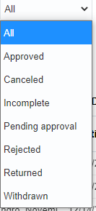
- Select the Status Incomplete (or withdrawn depending on your need)

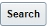
- Click on the Search button.


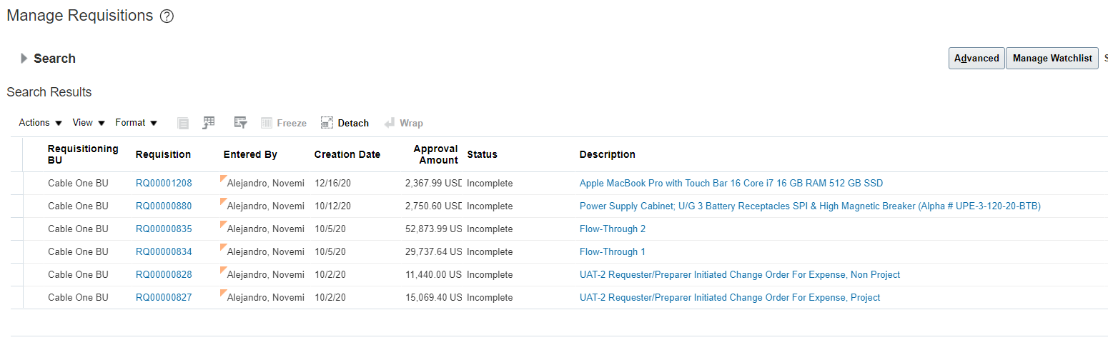
- If the Search portion of the screen is no longer visible click on the search link to open it up again. Please note that only Requisitions with the status listed as Incomplete should be showing in the search results.

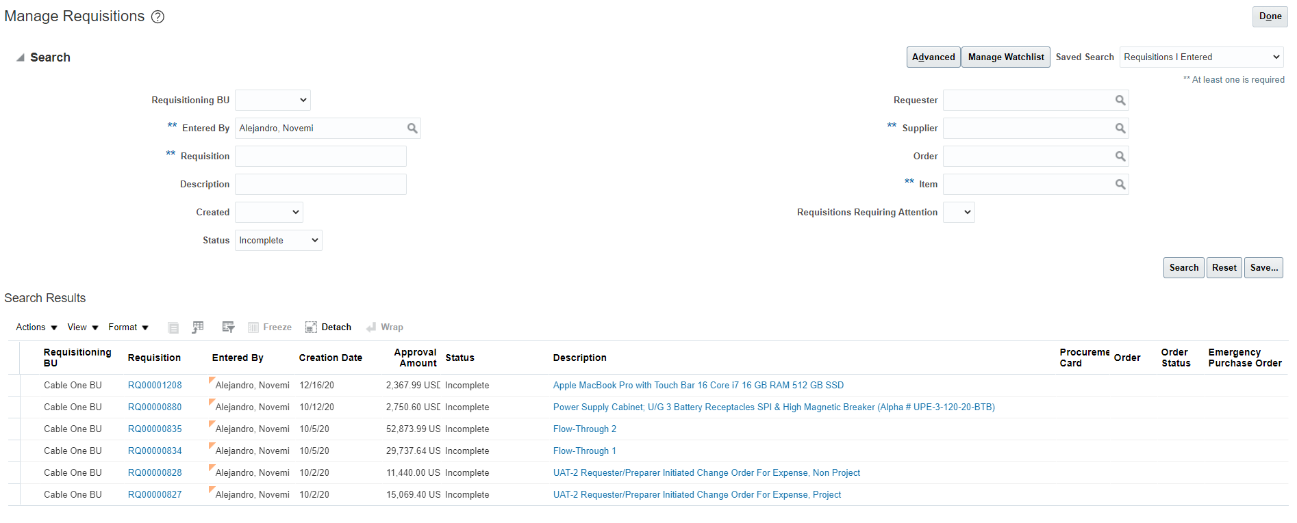
- Click on the Requisition number link of any of the requisitions listed. The Requisition screen should open
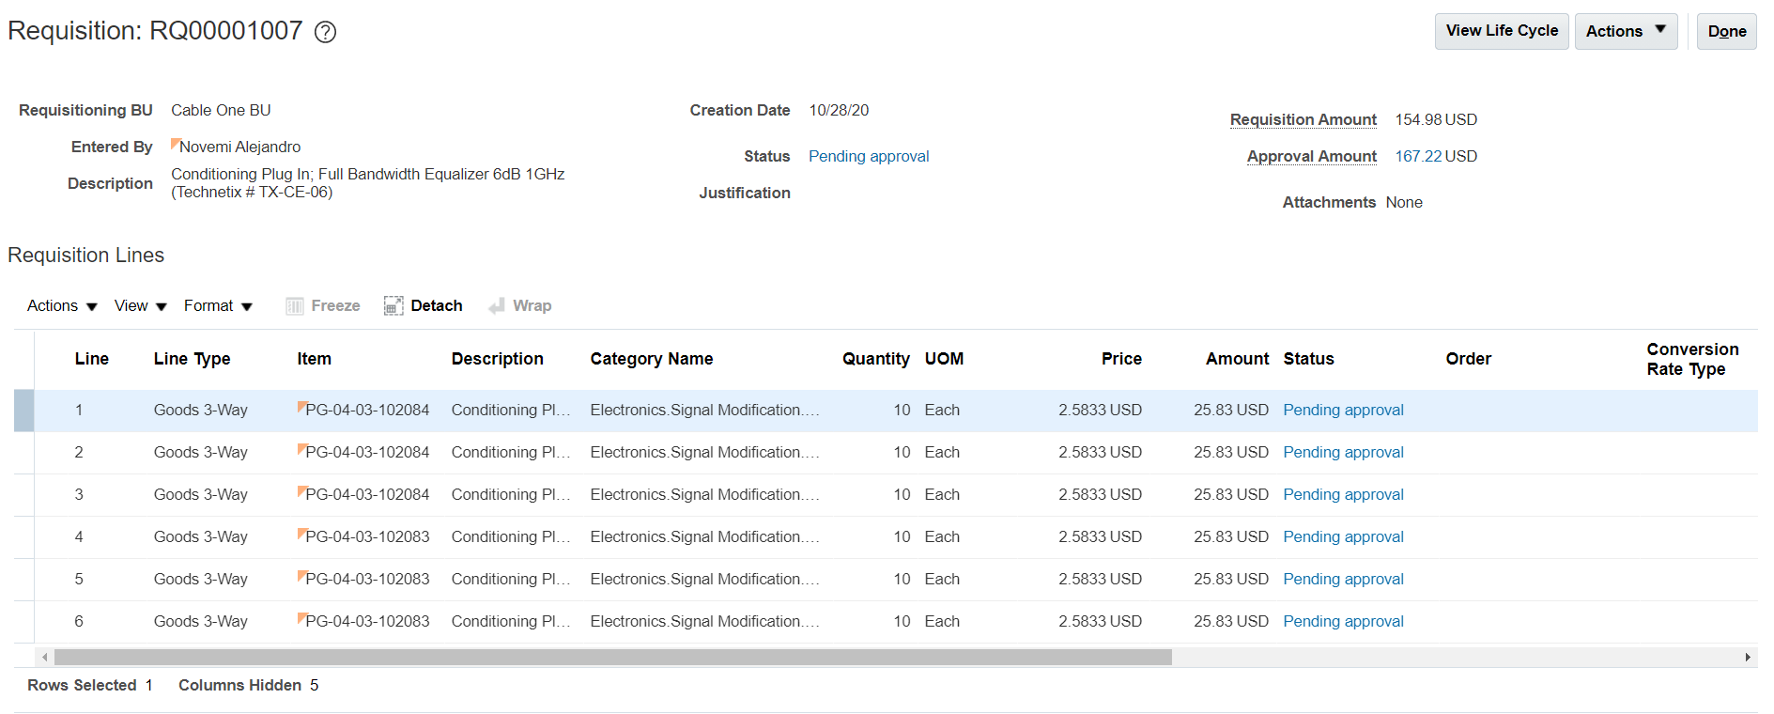
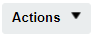
- For a requisition in incomplete (or Withdrawn) status, editing can be initiated by clicking on the Actions drop down button on the top right of the Requisition screen. Click on the Actions button to see the options

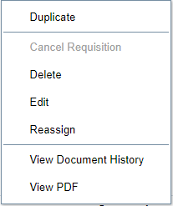

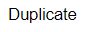
- Click on the Duplicate option. The System will process the request and will open the Edit Requisition page with a replica of the selected requisition and all the information. You will also see that a new requisition number has been assigned to the duplicate. At this stage

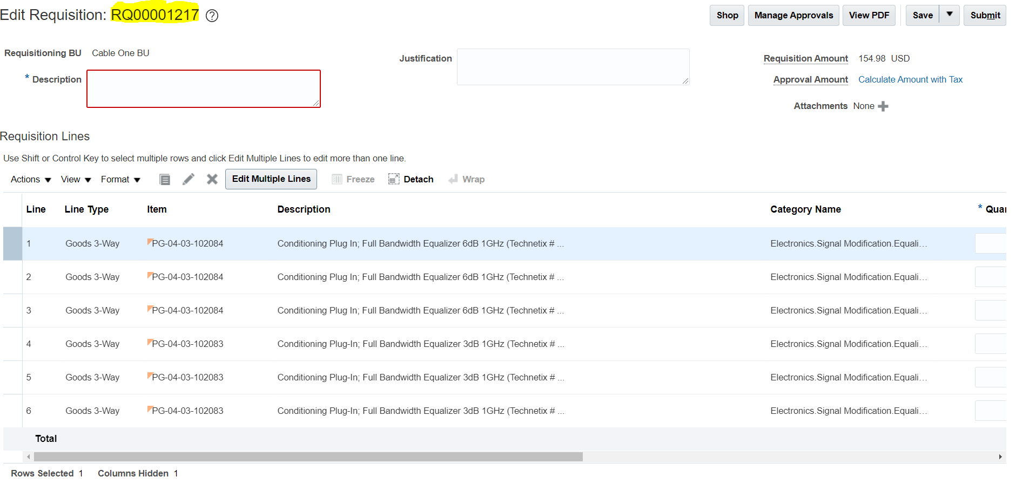

- In the *Description field Enter the Text “This is my first requisition created from duplicate”

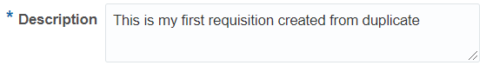
- Scroll down through each requisition line and modify the quantity field and the information in the delivery and billing information if needed. Please remember that the data is being copied completely and therefore any errors (such as old dates, wrong Subinventories, wrong project number, etc) may move with it. Oracle should create a new Requested date for each line, but you must verify this.
- Click on the Save button. A timestamp should appear once saved.

- Click on the Submit button to submit the requisition for approval. Once submitted, a confirmation message should appear information that the Requisition has been submitted for approval,

- User may click on the view PDF button to download a copy of the Requisition or you may just click on the OK button to close the confirmation message. Once closed, user should see the requisition screen again.

- The Requisition should be listed in the Recent Requisitions area and should be in Status Pending Approval.
- The Requester can click on the Pending Approval link to find the routing of approvals that the requisition will follow. The user will not be able to change the routing.

- You have completed this activity.

Search for a Requisition:

Business Procedure Description:
Use this process to search for a requisition as needed.

Prerequisites:
Requisition must exist in Oracle
Search criteria is required to find a requisition (e.g.: requester name, requisition number, etc.)

Output/Next Steps:
Requisition is displayed

Tips/Additional Information:

- Login into Oracle

You should see the springboard navigation screen

- Click the Purchase Requisition Icon to open the Requisitions screen.

- Click on the Manage Requisition link, to open the manage requisition task. The Manage Requisition task screen consists of a requisition search area and a search results area.

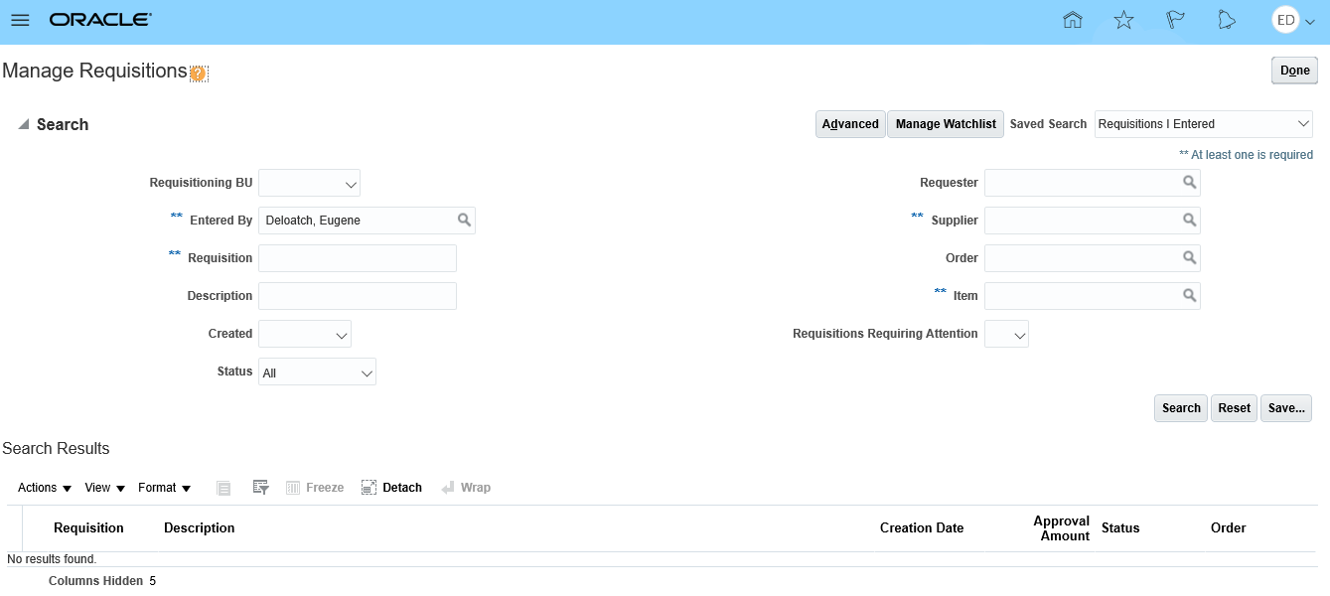
- Any field listed with 2 Asterixis (**) next to the field name, means that at least one of those fields must be filled for the search to be performed.

Field Name | Required/Optional/Conditional | Description
Requisitioning BU | Optional | Business Unit that created the requisition
Entered By | Conditional | Name of the person that created the requisition
Requisition | Conditional | Requisition Number
Description | Optional | Requisition Description
Created | Optional | Date range the requisition was created
Status | Optional | Current status of the requisition (e.g.: Approved, canceled, etc.)
Requester | Optional | Name of the person that requested the requisition
Supplier | Conditional | Name of the supplier fulfilling the requisition
Order | Optional | Order Number
Item | Conditional | Item Number
Requisitions Requiring Attention | Optional | Option to display requisitions that need further review/resolution

- Enter data in the required fields. Please note the Entered By field is filled by default with your name

- Click the Search button to continue. You should see a list of requisitions matching the criteria you used in the search header field.
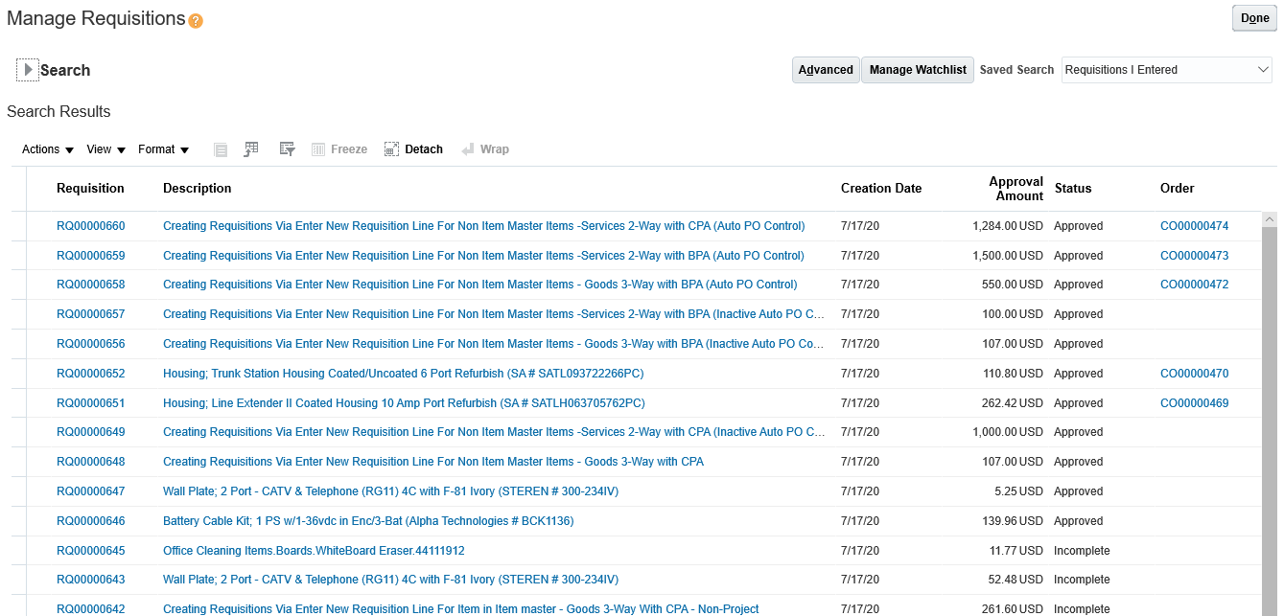

- To process or view additional information for a specific requisition, just click on the requisition number link.

- Click on the Search arrow to unhide the search field if they are hidden

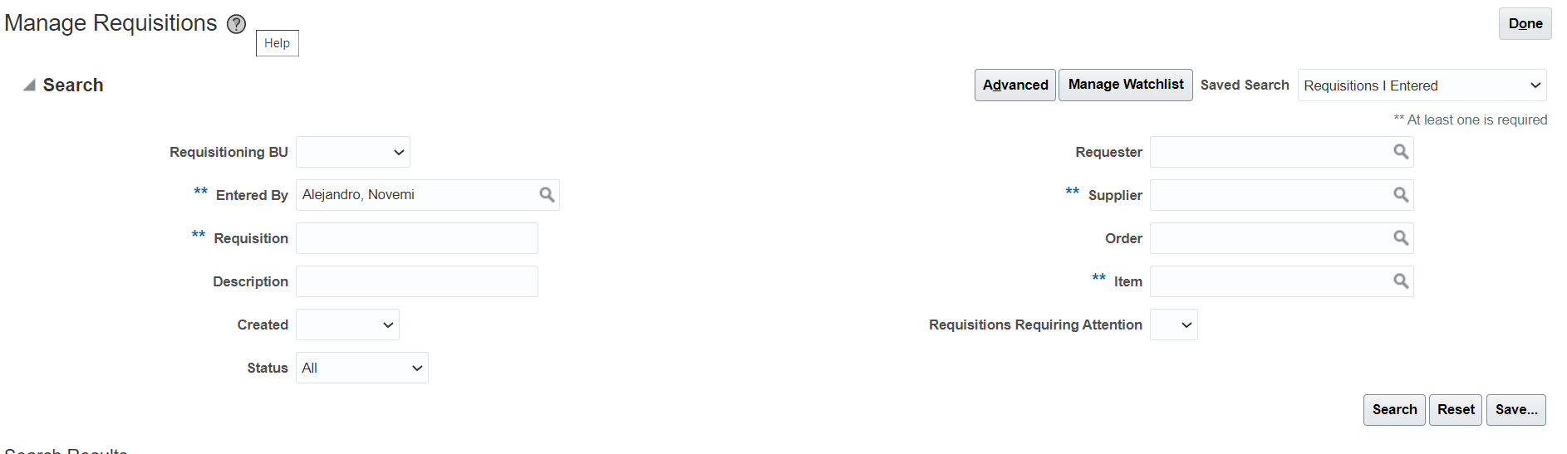
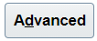
- Click on the Advance button to see additional search criteria that can be used.

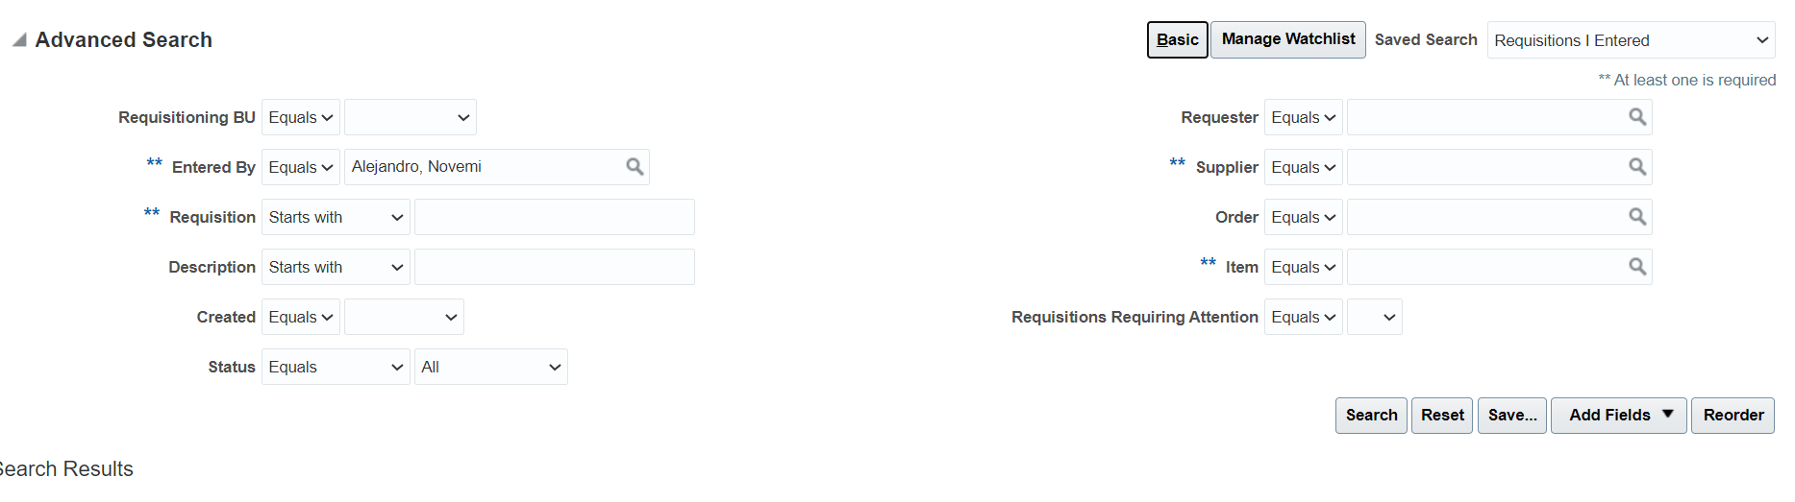

- Note that next to each field you will see an operator (if you hover over the operator you will see the name of the operator) and this operator is used to change the logic of the search. Not all operators will have the same options available.

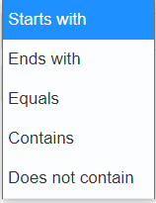

- You can change the operator to facilitate the type of search you want to perform or to resolve an issue related to lack of complete information.

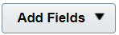
- The fields available in the search section are those that are most used but not the only ones available. On the right middle section of the Manage Requisitions screen, you will see a button called Add Fields. Click on the Add Field drop down button to see the entire list of fields you can search by. Please note that in some cases they may be some duplicated additional fields.

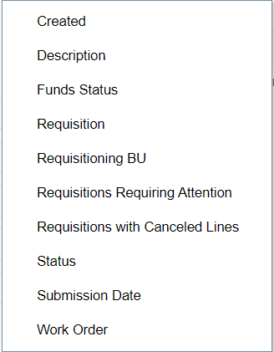
- To select one of the fields to add to the search, just click on the option in the list. The Option will be added to the search.

- The Search Results section of the Manage Requisition page also has some customizations you can perform to make the experience easier.

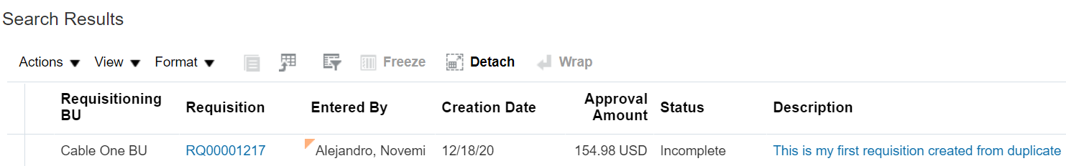

- On top of the results column headers there are some drop down menus and icons that we will review

  - The View drop down button allow the user to add or remove fields from the search results. It also allows the order to organize in a specific way, each one of the columns.

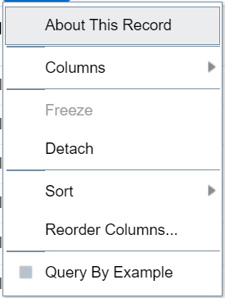

  - Click on the Columns option to see all the columns that can be viewed in the search results

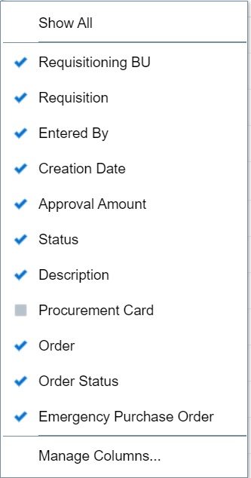

  - Check or uncheck the selections you want or don’t want to be visible. Unfortunately, this is a one by one change and you will be going back and forth to view and back to the list. Instead, you can use the manage columns option which allow you to select and move fields from a Hidden column to a Show column.

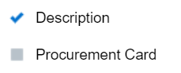

  - Click on the Filter by Icon. An additional row will be shown between the Menus and the column headers. On top of most column headers you should see a blank space.

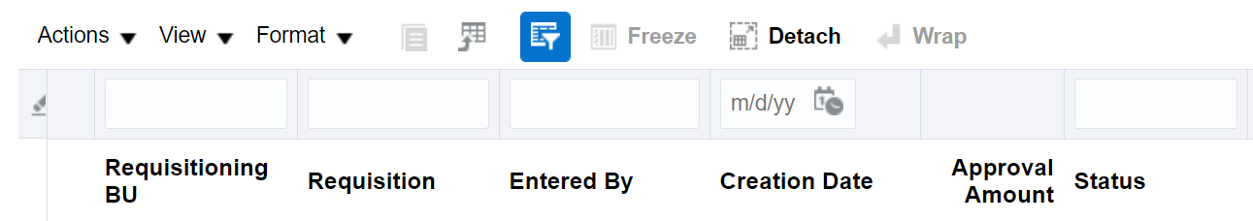

  - You can type text or numbers inside to narrow down the search results based on some sort of character filter (all requisitions that created on 11/10/20, or all requisitions with Requisition number containing 107). You can use wild card to find exact match or partial match such as the example below %107% which means, contains 107.

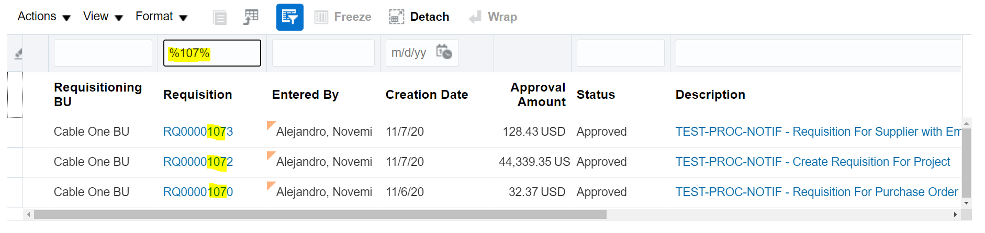
- You have completed this activity. You may explore more on your own.

Requisition Management - Edit a Requisition in Incomplete or Withdrawn Status:

Business Procedure Description:
This activity describes how to edit a requisition which is incomplete status (Has not been submitted for approval)

Prerequisites:
Only the person that entered the requisition will be able to make changes to the requisition lines.

Requisition created via Enter Requisition Line or via Self Service Procurement
Requisition in Incomplete Status

Output/Next Steps:
Change Order is created and forwarded to the Approver for review and approval

Tips/Additional Information:
In Edit Requisition, you may not add new items to a requisition via edit Requisition. The only way to add items is to put the contents of the requisition back into the cart.

- Login into Oracle

You should see the springboard navigation screen

- Click the Purchase Requisition Icon to open the Requisitions screen.

- Click on the Manage Requisition link, to open the manage requisition task. The Manage Requisition task screen consists of a requisition search area and a search results area.

- In the Search portion of the screen, make sure that your name is listed in the Entered By field. Please note that if there are any fields that have 2 asterixis (**) next to them, it means that at least one of those fields must be filled for the search to be able to be performed at all
- Click on the Status field drop down arrow to see a list of available statuses

- Select the Status Incomplete (or withdrawn depending on your need)

- Click on the Search button.

- If the Search portion of the screen is no longer visible click on the search link to open it up again. Please note that only Requisitions with the status listed as Incomplete should be showing in the search results.

- Click on the Requisition number link of any of the requisitions listed. The Requisition screen should open
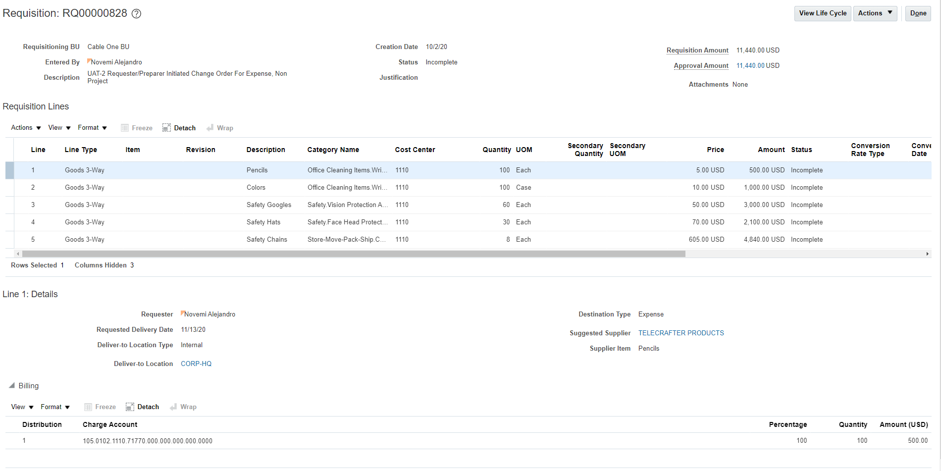
- For a requisition in incomplete (or Withdrawn) status, editing can be initiated by clicking on the Actions drop down button on the top right of the Requisition screen. Click on the button to see the options

- For a Requisition in incomplete (or Withdrawn) status, the available actions to take are limited. You can Delete the requisition, Edit it or Reassign it to someone else. You can also use the requisition to create a new one, but this does not change the requisition. Click on the Edit option to Enter the Edit Requisition screen.
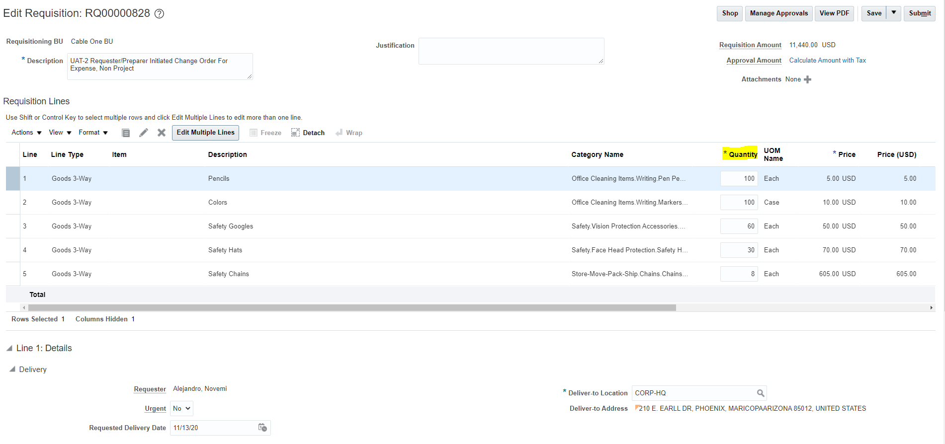

- Depending on whether the requisition was created using Enter Requisition Line task or using one of the Catalog Based Buying tools, the scope of changes allowed by the user to the contents will be limited. If you do not remember how you created the requisition line, there is a simple way to find out. Just Remember that limitations are based on the Requisition Line not the entire requisition. Select a Requisition Line by clicking on the line row. The Line should now be highlighted.

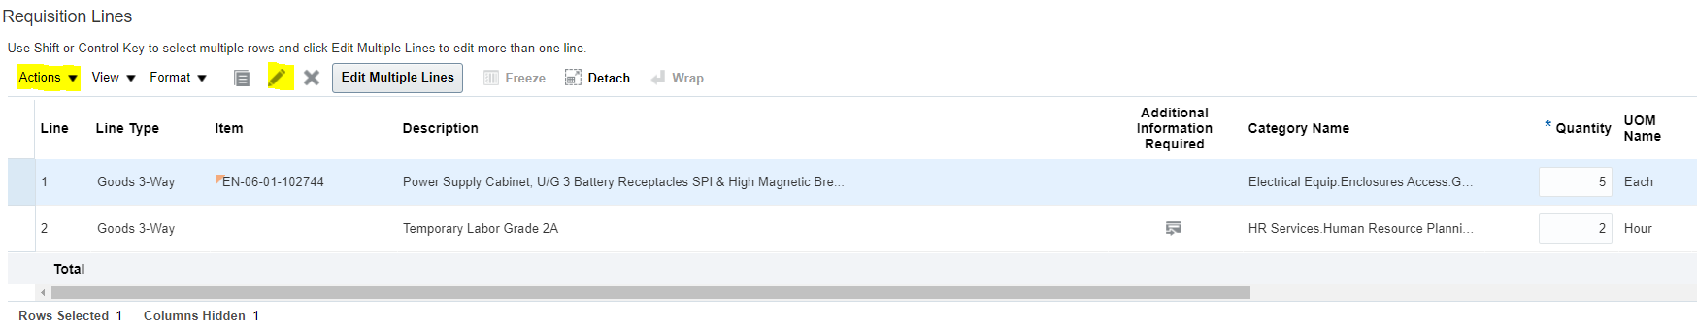

- Try editing the line. There are two different ways to initiate editing on a line.

  - Method 1 is to click on the Edit icon (the pencil Icon).
  - Method 2 is to click on the Actions task drop down arrow and this action will bring up a list of additional options you can perform on that line

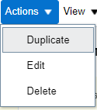

  - Click on the Edit task option.

- If the above actions result in an error message appearing in the screen, and the message says that You Can’t edit punchout items or lines added from a catalog, then the requisition line you are trying to edit is a Catalog Based Buying requisition line. The only change that can be made in the Requisition Line item key parameters is to the Quantity field.

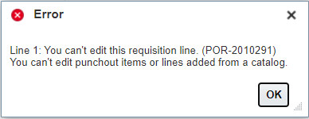

- If the result of initiating a line edit is the appearance of the Edit Line:X window (the X represents the line number being edited), then you will be allowed to change specific fields (the fields permitted to be change also depend on other process steps such as the use of an item or the use of a supplier agreement)

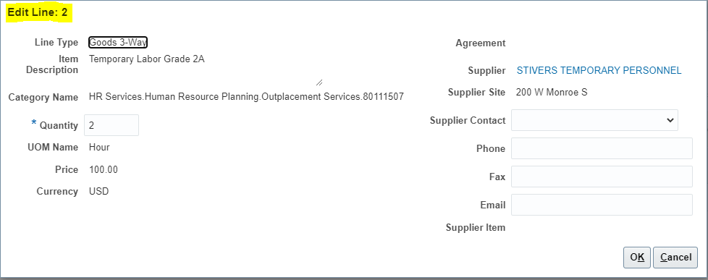

- Please note that the Delivery, Billing and the Notes and Attachments sections which also are specific to each line, can always be modified in a requisition that was in incomplete status. The source section cannot be modified.

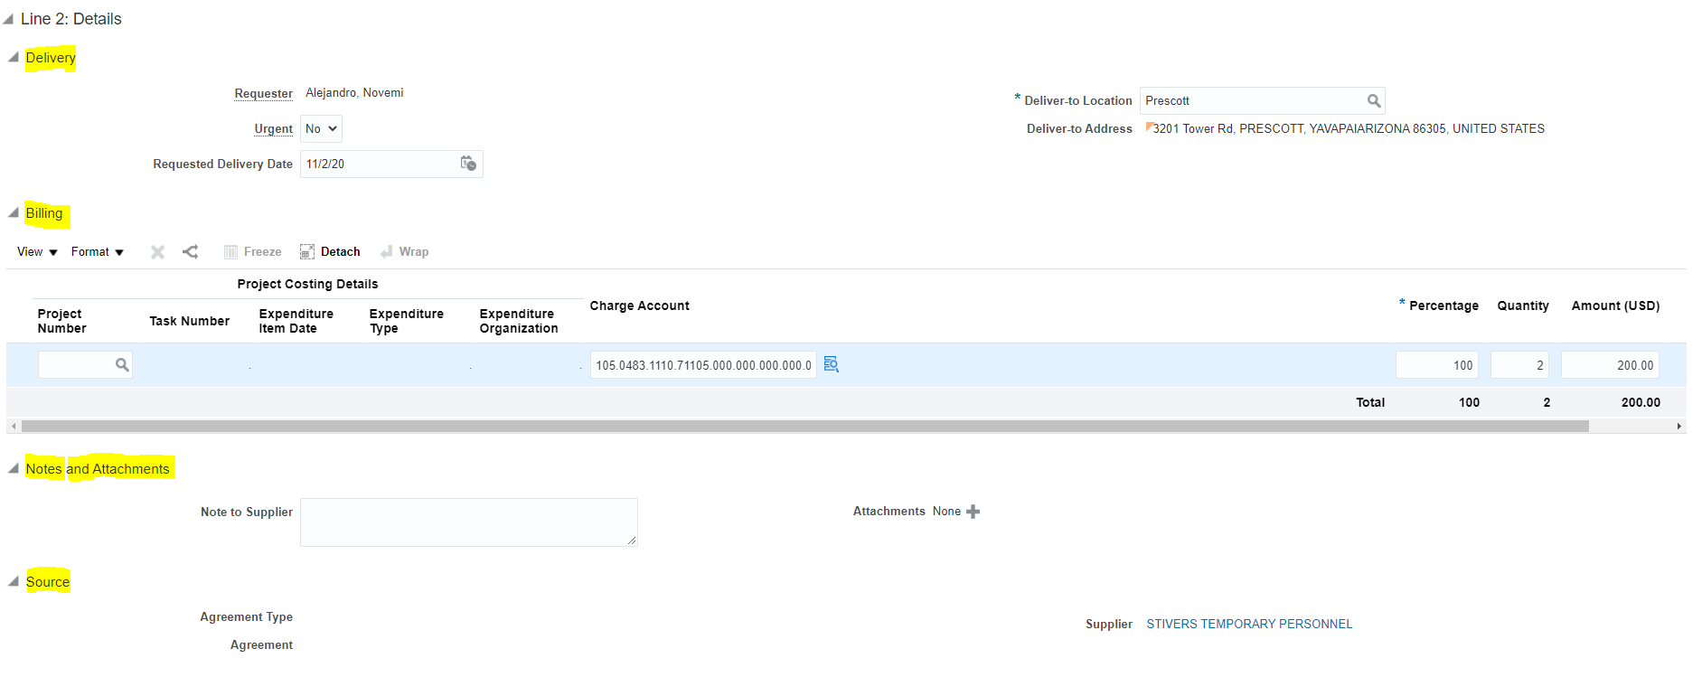

- In your Requisition Line, click on the Quantity field and change the existing amount to a different value. In a requisition line created via Catalog Based Buying, make the change to the quantity in the Requisition Line itself.

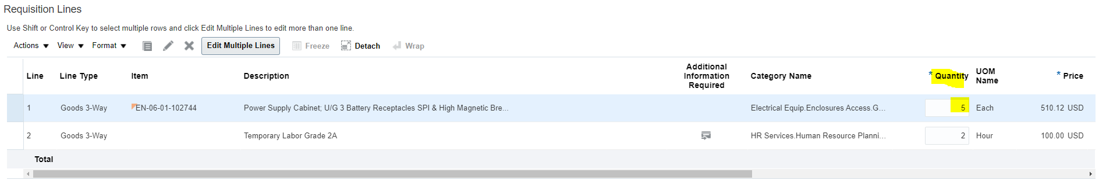

- For a Requisition Line that was created using Enter Requisition Line you may change the quantity in the same way or via the Edit Line window described previously

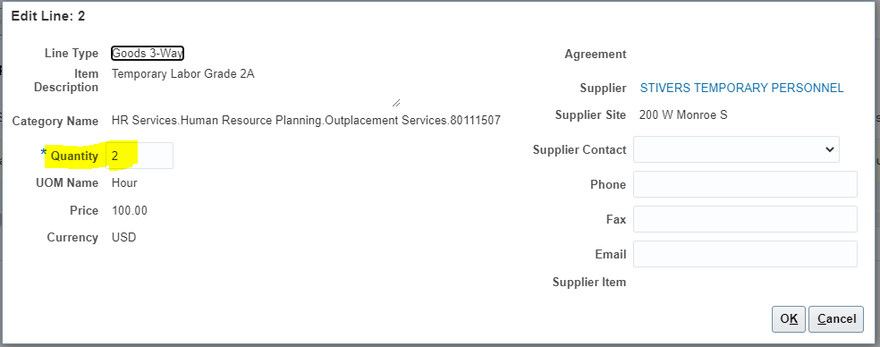
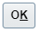
- If you opened the Edit Line window, close it by clicking the OK button.

- While the requisition line is highlighted, click on the Requested Delivery Date and Change the Value to 1/29/21
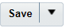
- Click on the save button.

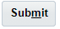
- Click on the Submit button again to re-submit the Requisition modified. A Confirmation Message should appear confirming that the requisition has been submitted for approval.

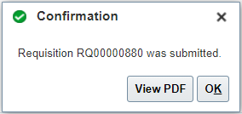

- You have completed a change to a requisition in incomplete status.

Requisition Management – Edit Requisition in Pending Approval or Approved Status but With Out A Purchase Order Assigned to A Line

Business Procedure Description:
Edit a Requisition Line that is in approved status but for which a purchase order has not yet been created.

Prerequisites:
Only the person that entered the requisition will be able to make changes to the requisition lines.
Requisition created via Enter Requisition Line or via Self Service Procurement
Requisition in Pending Approval Status or Requisition Line in Approved status but without an order assigned to it.

Output/Next Steps:
Change Order is created and forwarded to the Approver for review and approval

Tips/Additional Information:
When determining if an order has been placed against an approved requisition line, always open the requisition to view each line.

- Login into Oracle

You should see the navigation springboard.

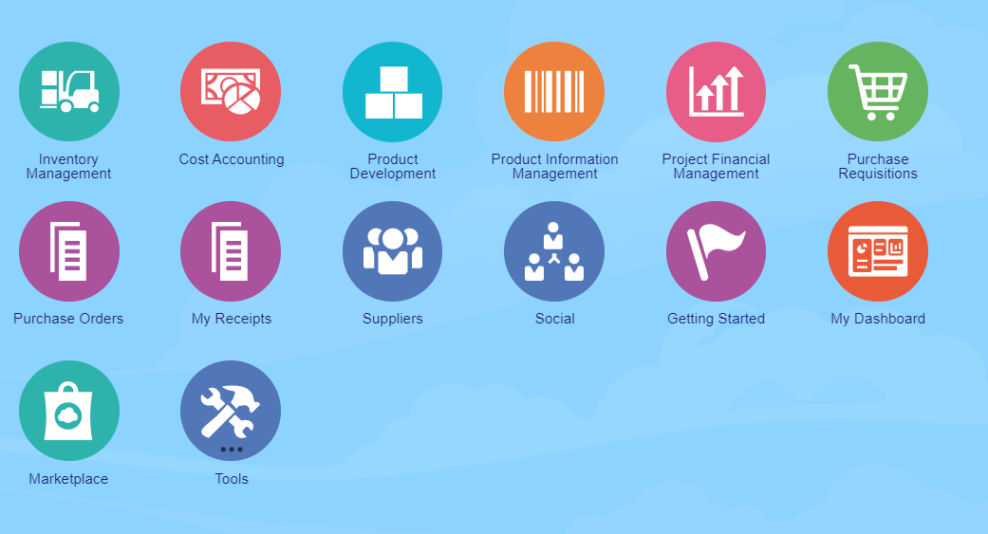
- Click the Purchase Requisition Icon to open the Requisitions screen.

- Click on the Manage Requisition link, to open the manage requisition task. The Manage Requisition task screen consists of a requisition search area and a search results area.

- In the Search portion of the screen, make sure that your name is listed in the Entered By field. Please note that if there are any fields that have 2 asterixis (**) next to them, it means that at least one of those fields must be filled for the search to be able to be performed at all
- Click on the Status field drop down arrow to see a list of available statuses
- Select the Status Pending Approval

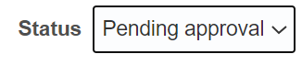
- Click on the Search button.

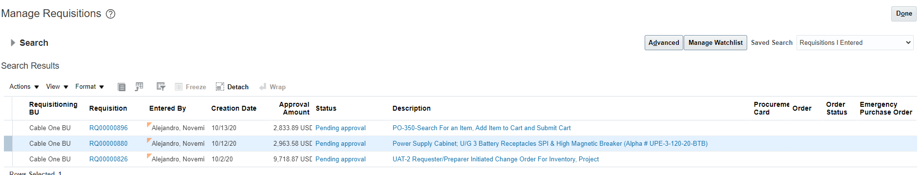
- If the Search portion of the screen is no longer visible click on the search link to open it up again. Please note that only Requisitions with the status listed as Incomplete should be showing in the search results.

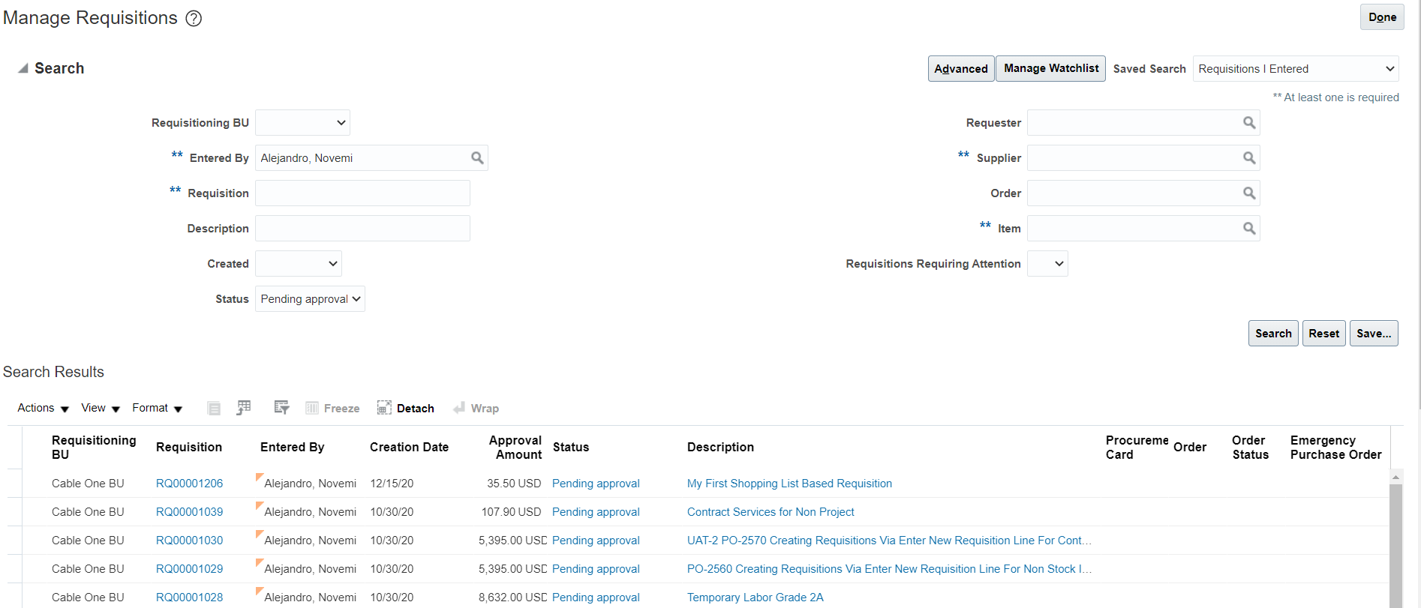

- Click on the Requisition number link of any of the requisitions listed. The Requisition screen should open for that requisition number. At this moment you are in view only mode and unable to edit the requisition. Requisitions that have been submitted for approval, but not yet approved, can only be recalled by withdrawing the requisition.

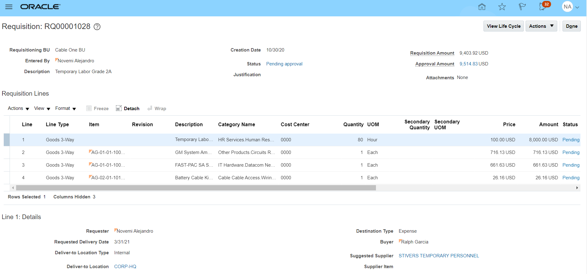
- For a requisition in Pending Approval status to be edited, the requisition must be withdrawn. There are two methods for withdrawing a requisition prior to editing. Both accomplish the same result of withdrawing the Requisition from the approval flow, although one allows you to edit it right away while the other just removes it from the approval flow if there are no orders against it.
  - In the Withdraw and Edit method, click on the Actions drop down button located on the top right of the Requisitions: RQXXXXXXX screen to see the options available.

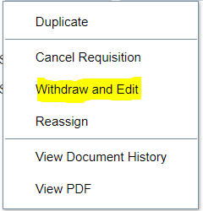

  - For a Requisition in Pending Approval status, the available actions to take Cancel Requisition, Withdraw and Edit or Reassign it to someone else. You can also use the requisition to create a new one (Duplicate), but this does not change the requisition. Click on the Withdraw and Edit option to remove the Requisition from the approval flow.

  - A warning message will appear letting you know that the Requisition is currently in either approved or Pending Approval and that if you continue, it will be removed from the approval flow.
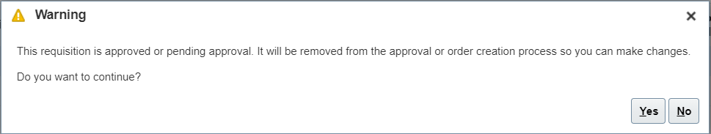
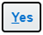
  - Click on the Yes Button to continue withdrawing the requisition. The Edit Requisition page should appear.

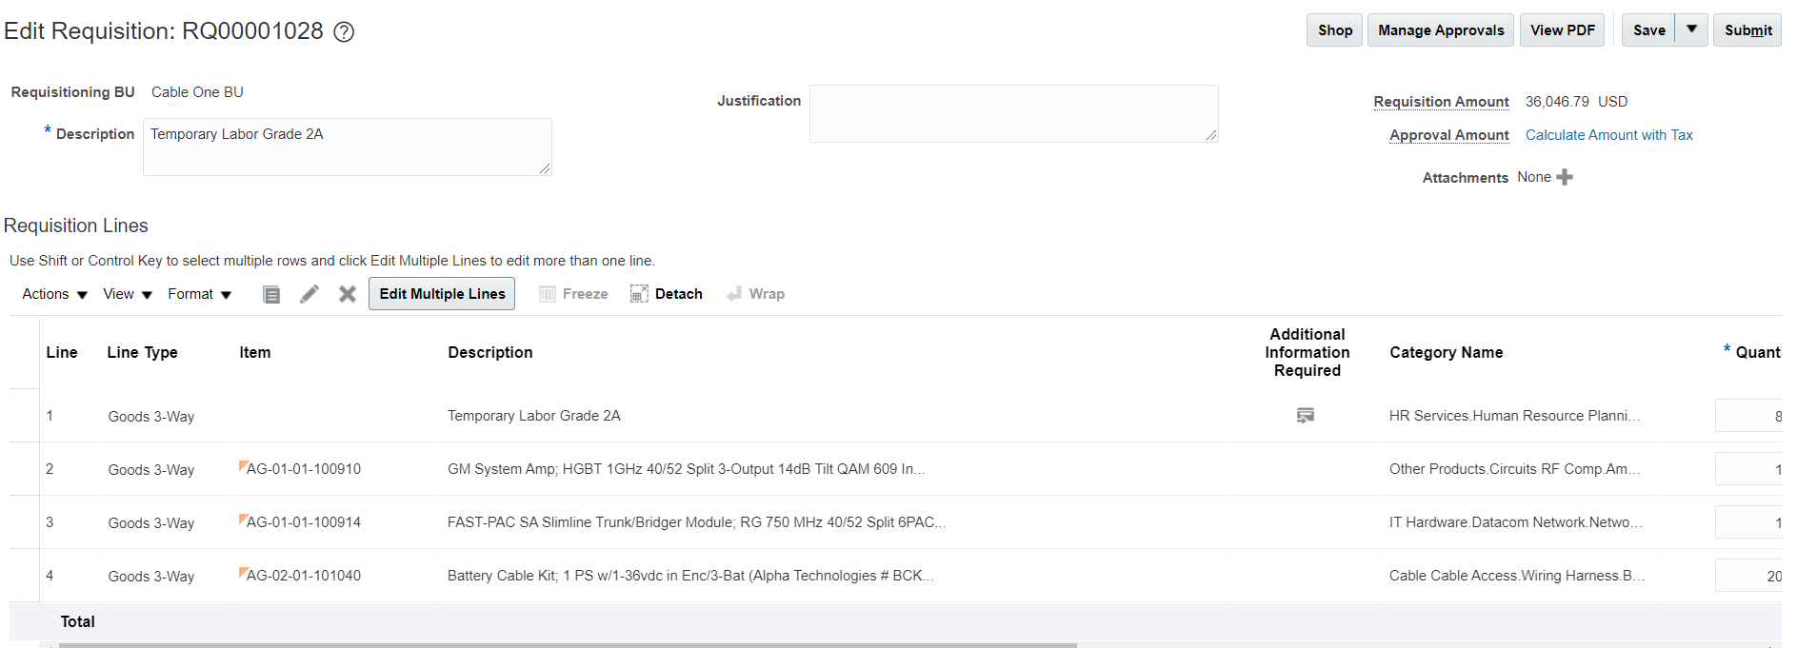

- In the Withdraw Only method, you are given the opportunity to be able to withdraw a requisition line that happens to be part of a requisition which does have lines with assigned orders. To edit these, you must first select the requisition line by clicking on the row.

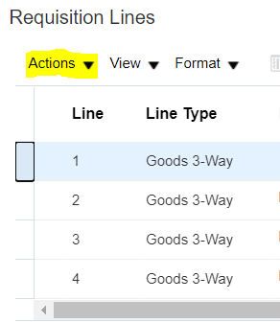
- Click on the Actions drop down button just below the Requisitions Lines section. Once you press the drop down button you will see a few available options

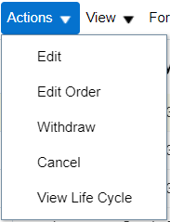
- Click on the withdraw option. If no lines have orders against them, then a warning message will appear stating that if you withdraw a line, then all lines will be withdrawn. If you happen to select a line item that is not assigned to an order, but the requisition does have other lines assign to orders, you will not see the message below and the line will be withdrawn without questions.

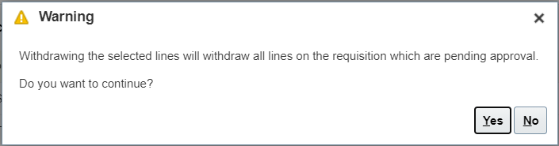

- Click on the Yes Button to continue withdrawing the requisition. The Requisition Page will continue open but now the Requisition Status should have changed to withdrawn and a blue circle should be visible next to the status and next to each line.


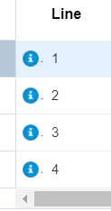

- To begin editing you will have to click on the Actions drop down option and then select the Edit option. If you do not plan on making modifications just yet, you can click the Done Button to exit the screen. Later, you can search for the requisition and follow the process Requisition Management - Edit a Requisition in Incomplete or Withdrawn Status.

- Assuming we continue with the Withdraw and Edit method, depending on whether the requisition was created using Enter Requisition Line task or using one of the Catalog Based Buying tools, the scope of changes permitted to the user will be limited. If you do not remember how you created the requisition line, there is a simple way to find out. Just Remember that limitations are placed on individual Lines and not the entire requisition. Select a Requisition Line by clicking on the line row. The Line should now be highlighted.

- Try editing the line. There are two different ways to initiate editing on a line.
  - Method 1 is to click on the Edit icon (the pencil Icon).

  - Method 2 is to click on the Actions task drop down arrow and this action will bring up a list of additional options you can perform on that line

  - Click on the Edit task option.

- If the above actions result in an error message appearing in the screen, and the message says that You Can’t edit punchout items or lines added from a catalog, then the requisition line is a Catalog Based Buying requisition line. The only change that can be made to the Requisition Line’s key parameters is to the Quantity field.

- If the result of initiating a line edit is the appearance of the Edit Line:X window (the X represents the line number being edited), then you will be allowed to change specific fields (the editable fields also depend on other process steps such as the use of an item or the use of a supplier agreement).

- Please note that the Delivery, Billing and the Notes and Attachments sections which also are specific to each line, can always be modified in a requisition that was in incomplete status. The source section cannot be modified.

- In your Requisition Line, click on the Quantity field and change the existing amount to a different value. In a requisition line created via Catalog Based Buying, make the change to the quantity in the Requisition Line itself.

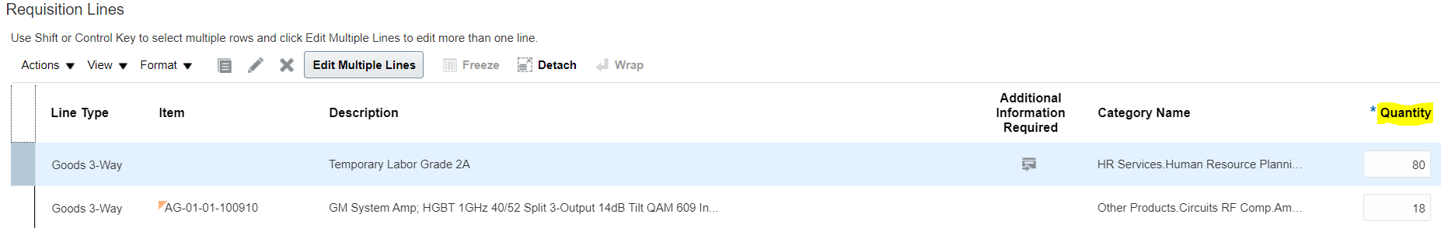

- For a Requisition Line that was created using Enter Requisition Line you may change the quantity in the same way or via the Edit Line window described previously

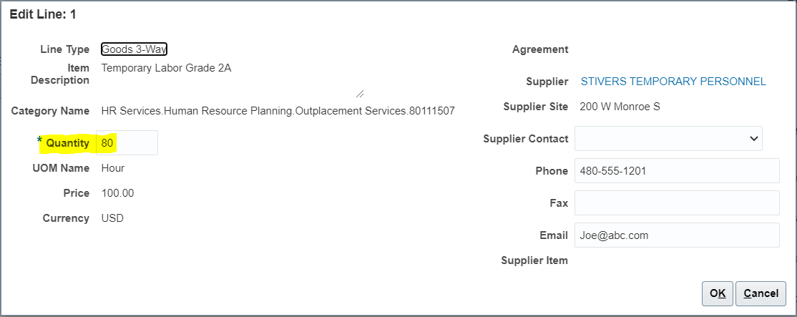
- If you opened the Edit Line window, close it by clicking the OK button to return to Edit Requisition.

- While the requisition line is highlighted, click on the Requested Delivery Date and Change the Value to 1/29/21
- Click on the save button.

- Click on the Submit button again to re-submit the Requisition modified. A Confirmation Message should appear confirming that the requisition has been submitted for approval.

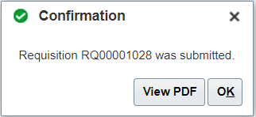

- You have completed a change to a requisition in Pending Approval.

Requisition Management – Methods for Starting Requester Initiated Change Orders.

Business Procedure Description:
This activity describes the various methods in which a Requester can initiate a change to a requisition or a requisition line for which an order has been created. This activity provides the process to address changes requested on a requisition with a single or multiple order assigned to the Requisition. This activity will stop short of entering the change order itself.

Prerequisites:
Requisition must be in approved status and at least one line item must have an order attached

Output/Next Steps:
Change Order is created and forwarded to the Approver for review and approval

Tips/Additional Information:
When determining if an order has been placed against a requisition, you must check each individual line and not just the requisition header.

- Login into Oracle

You should see the navigation springboard.

- Click the Purchase Requisition Icon to open the Requisitions screen.

- Click on the Manage Requisition link, to open the manage requisition task. The Manage Requisition task screen consists of a requisition search area and a search results area.

- In the Search portion of the screen, make sure that your name is listed in the Entered By field. Please note that if there are any fields that have 2 asterixis (**) next to them, it means that at least one of those fields must be filled for the search to be able to be performed at all
- Click on the Status field drop down arrow to see a list of available statuses
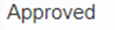
- Select the Status Approved by clicking on the Approved option.

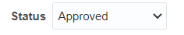

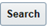
- Press on the Search Button to see the search results. The search results provide header level information and change orders must be managed while reviewing Requisition Line information.
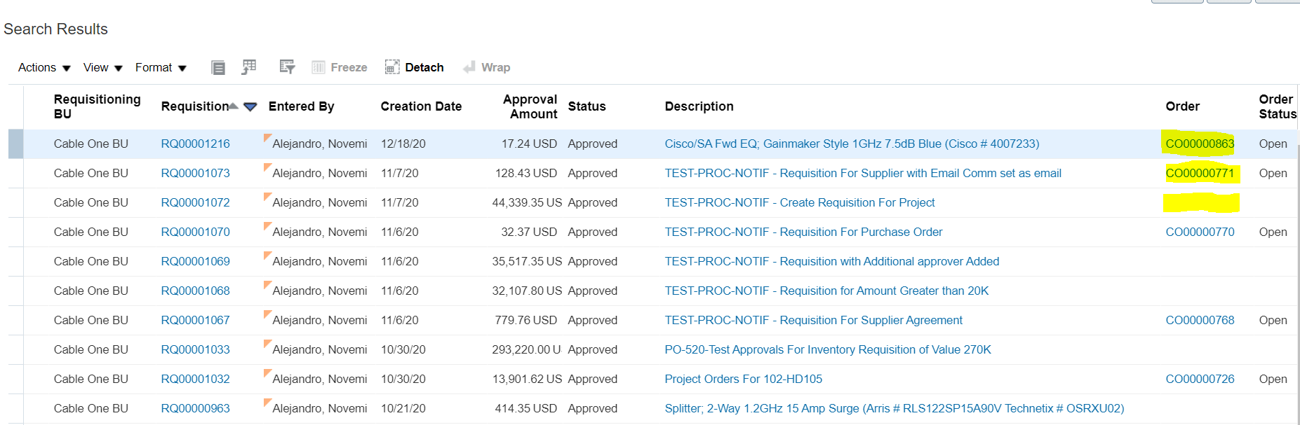

- A requester-initiated change to a requisition line that has an order created against it, triggers a Change Order. Because a purchase order exists and this type of document is a legally binding document between the company and the supplier, any changes to it must be managed, approved and tracked. In order to ensure process and fiscal control, a requester can only initiate a change order that is tied to one of its own requisitions.

- An approved requisition may have several requisition lines. Each requisition line could have a different order against it, or all the requisition lines could be on the same order. Initiating a change order will make all items in the order subject to a potential change by the requester.
You could also have a situation where only some lines have a purchase order attached. Each one of these situations causes the initiation of the change order to be slightly different.

  - In the case where a requisition has only one line and that line has an order against it such as in the example below

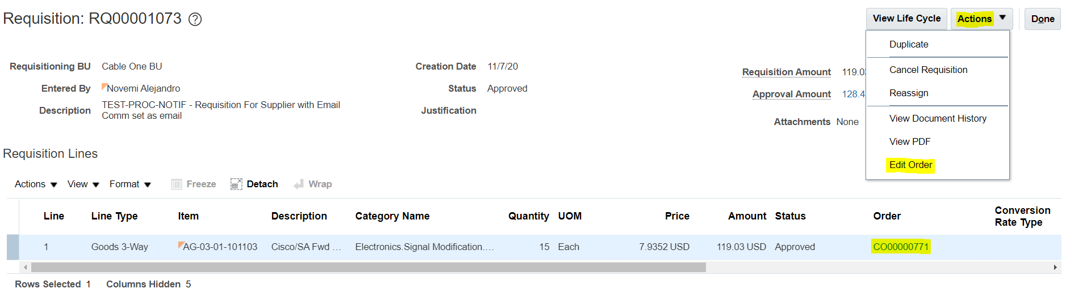

or in the case where a requisition has multiple lines and all lines have the same order against them like in the example below

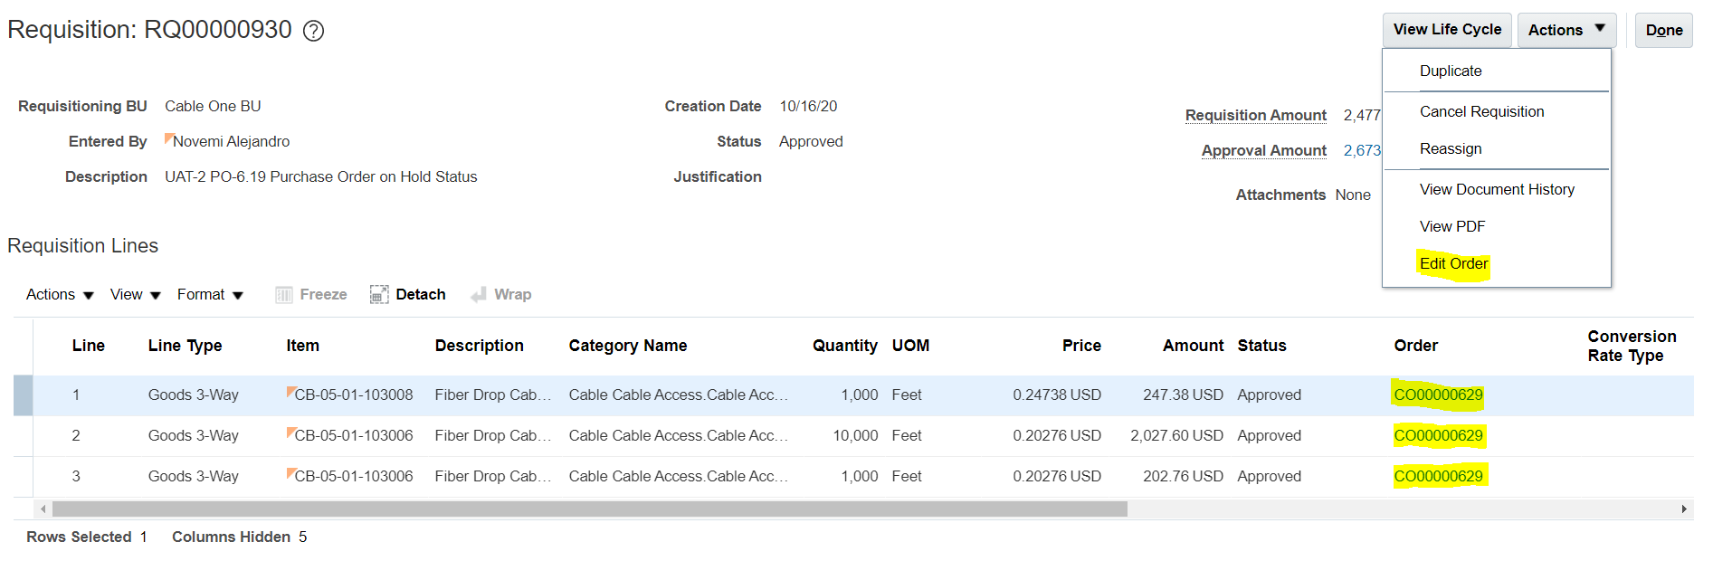
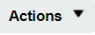
The requester will initiate the change by clicking the Actions button on the top right of the requisition.

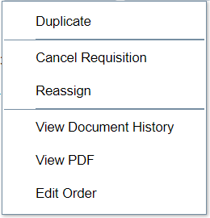

  - The requester then selects the Edit order option. If there is no change order already active for the order in question, the user should see a warning message stating that the action will create a change order to the document and asks the user if they want to continue.

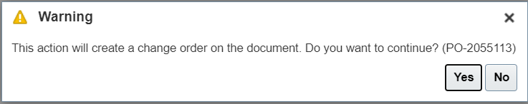
  - Click the yes button to proceed. The Edit Change Order Screen Should appear.

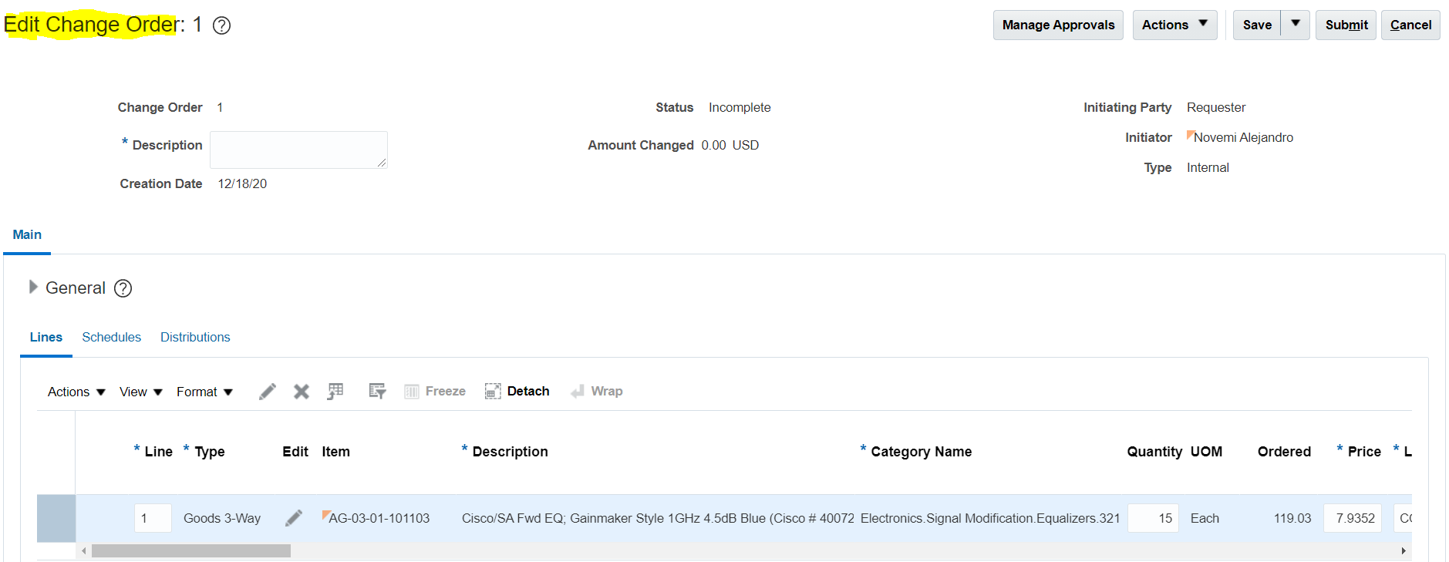

- In the case where a requisition has multiple lines and lines have been assigned to different orders like the example below,

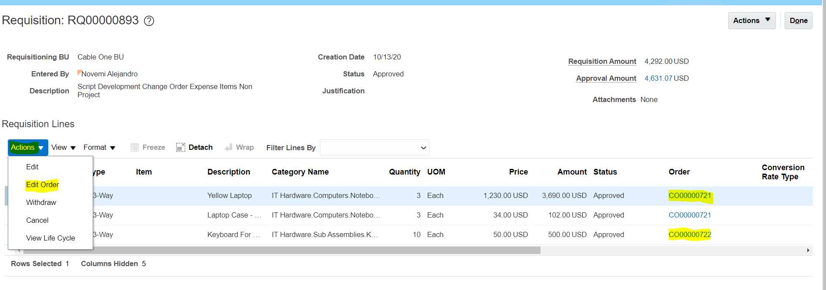

or the requisition has lines with and without orders assign to them like in the example below

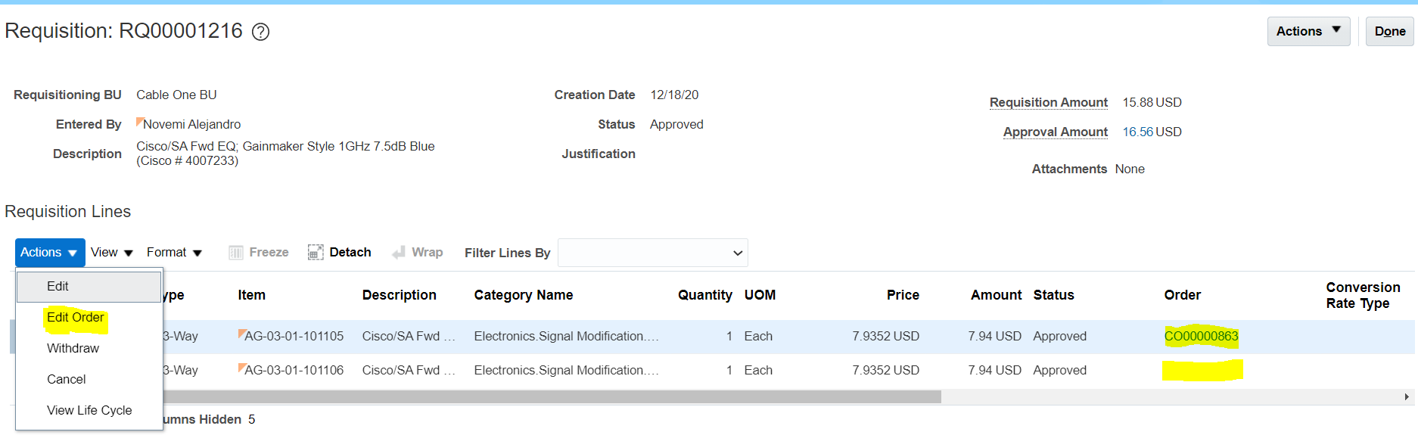

Then the user will have to initiate the change order directly from the requisition lines actions.

- Select the Requisition line to modify by clicking on the row and highlighting it.

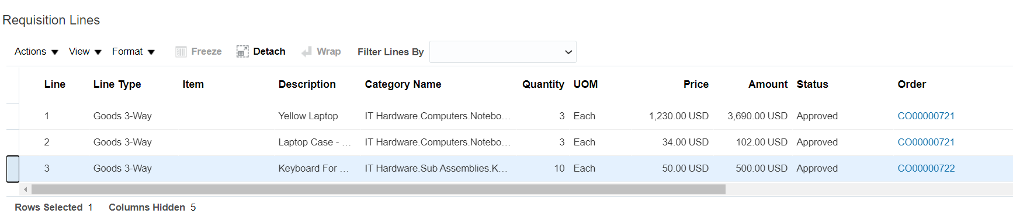
- Click on the Requisition Lines Action drop down link. A listing of available options should appear.

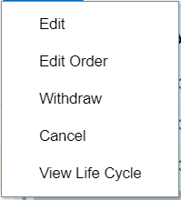
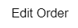
- Click on the Edit Order option to initiate the change order process.

- The requester then selects the Edit order option. If there is no change order already active for the order in question, the user should see a warning message stating that the action will create a change order to the document and asks the user if they want to continue.

- Click the yes button to proceed. The Edit Change Order Screen Should appear.

- From this point on, the process of completing a change order is the same with only variations related to the approval process for a change order. Review the remaining change order activities to learn how to execute and submit a change order.

Create a Change Order

Business Procedure Description:
This activity describes the steps that need to be taken in order to complete and submit a requester-initiated change order and explains the different approval requirements based on the nature of the change

Prerequisites:
Only the person that entered the requisition will be able to make changes to the requisition lines.
Requisition created via Enter Requisition Line or via Self Service Procurement in approved status with an order attached to the line
Not having an initiated or pending change order against the order

Output/Next Steps:
Change Order is created and forwarded to the Approver for review and approval
Approval flow is based on the nature of the change and the impact that the change has on the individual line amounts. modifications than result in a change greater than 1% in the line amount require fiscal approval as well as procurement approval. Changes than result in a change of less than 1% in the line amount or change certain non-critical parameters require only the approval of procurement.

Tips/Additional Information:

- Login into Oracle

You should see the navigation springboard.

- Click the Purchase Requisition Icon to open the Requisitions screen.

- Click on the Manage Requisition link, to open the manage requisition task. The Manage Requisition task screen consists of a requisition search area and a search results area.

- In the Search portion of the screen, make sure that your name is listed in the Entered By field. Please note that if there are any fields that have 2 asterixis (**) next to them, it means that at least one of those fields must be filled for the search to be able to be performed at all
- Click on the Status field drop down arrow to see a list of available statuses
- Select the Status Approved by clicking on the Approved option.

- Press on the Search Button to see the search results. The search results provide header level information and change orders must be managed while reviewing Requisition Line information.

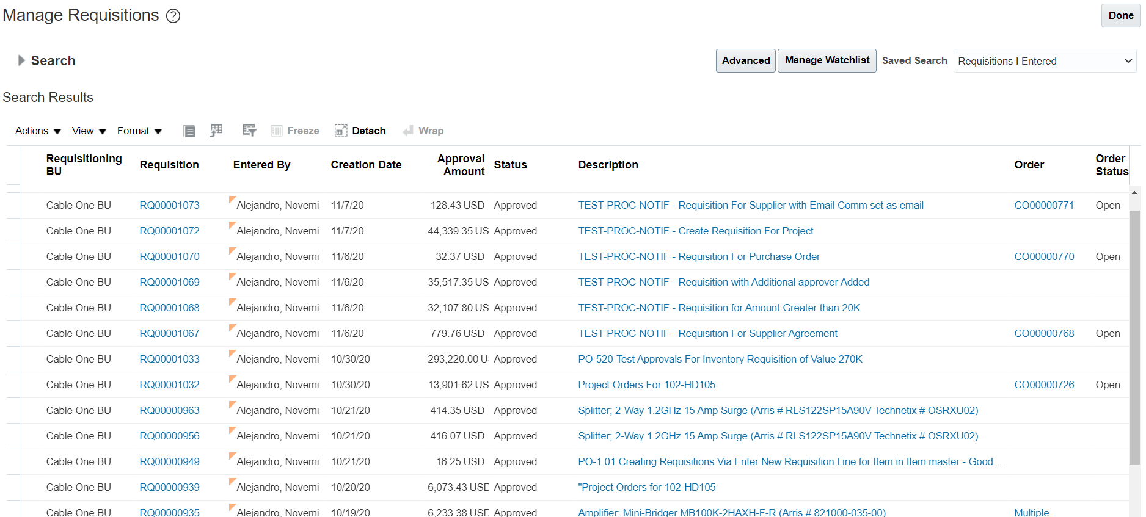

- For this exercise look for a requisition that has a value populated in the order field. It can be an order number starting to CO or it could be one with the word multiple populated in the field.

- Click on the requisition number (number links are listed in the Requisition column). The requisition page should appear.

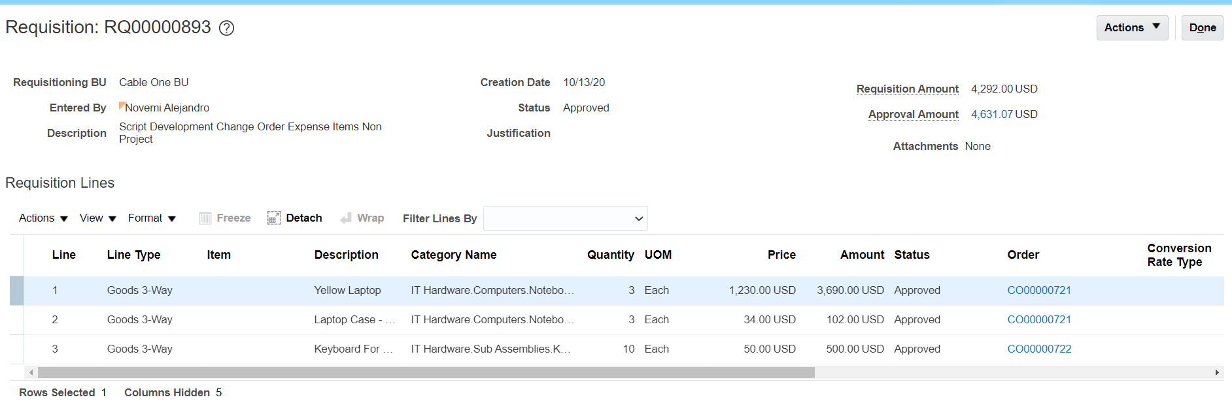

- Highlight the desired Requisition line you would like to change by clicking on the desired row.

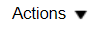
- Click on the Requisition Lines Action drop down link. A listing of available options should appear.

- Click on the Edit Order option to initiate the change order process.

- The requester then selects the Edit order option. If there is no change order already active for the order in question, the user should see a warning message stating that the action will create a change order to the document and asks the user if they want to continue.

- Click the yes button to proceed. The Edit Change Order Screen Should appear.

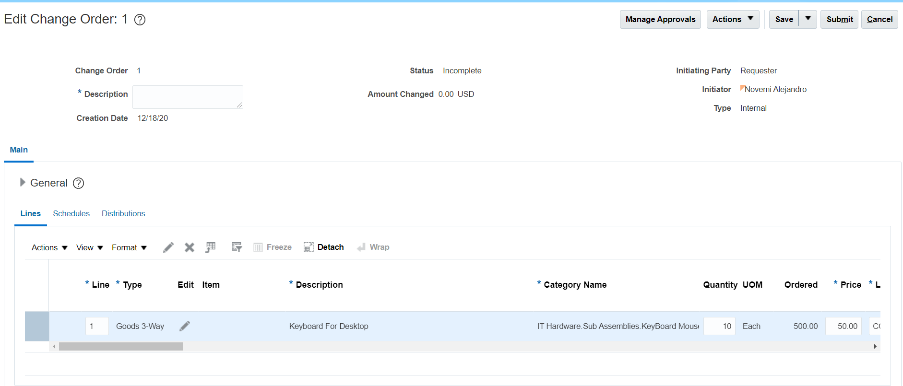

- Note that the header information of the change order has 8 fields that you and the buyer will be using to ensure correct processing of the change order.

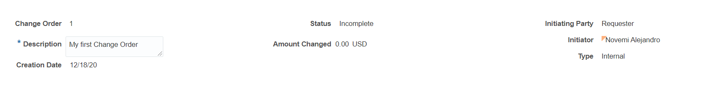
Change Order | Sequential number of changes orders created on the order
Description | Description of the change order
Status | Status of the change order
Creation Date | Date the Change Order Was Created
Amount Changed | Value of the change processed
Initiated Party | Role of the person initiating the change order (Requester or buyer)
Initiator | The user’s name
Type | Internal or external (initiated by internal employee or by supplier)

- Click on the *Description field and type “My first Change Order” in the field. Please note that this field is a required field. You will not be able to submit the change order without it.

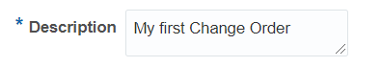

- IN the General section of the Change order, you will note a lot of similarities with the requisition screen listing the Requisition lines. However, there are two additional tabs call Schedules and Distributions.

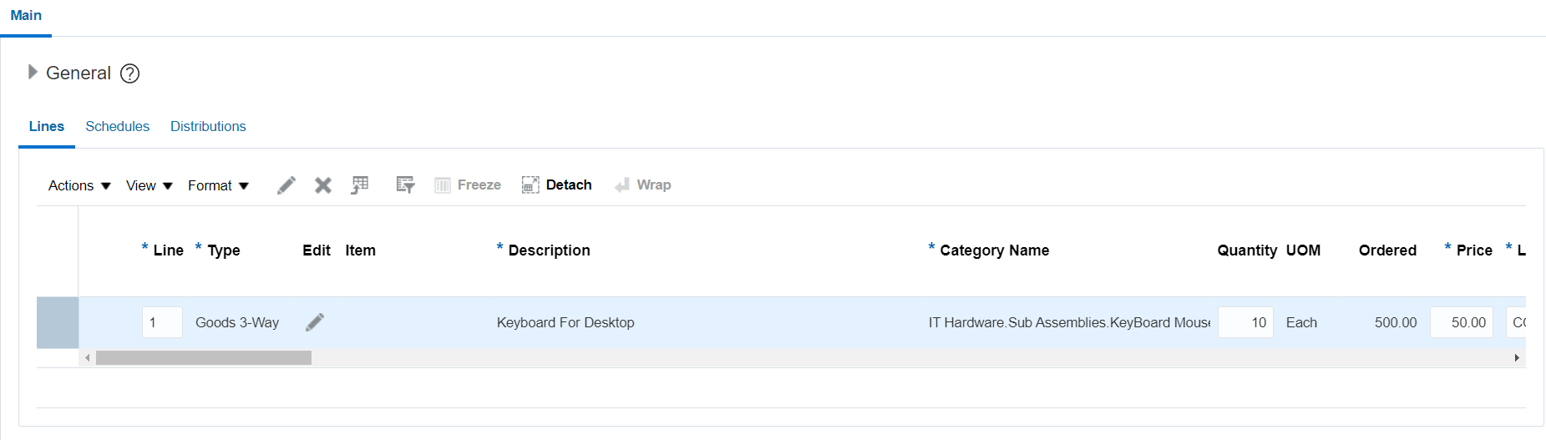

- Scroll to the right of the line information to see the additional fields available

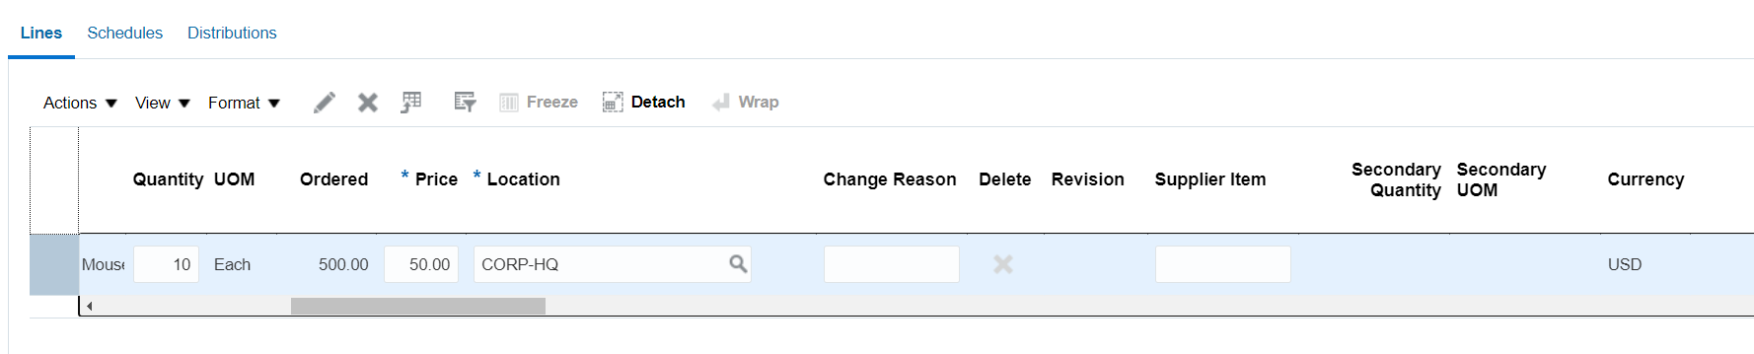

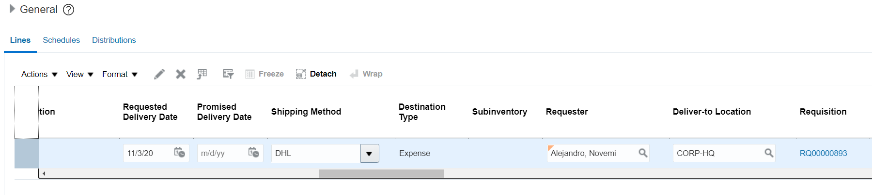

- Alternatively, and easier on the eyes, make sure that the line is highlighted and click on the Edit Icon ( Pencil Icon)

- The Edit Line Screen should appear listing a variety of fields, some which you may modify some you cannot.

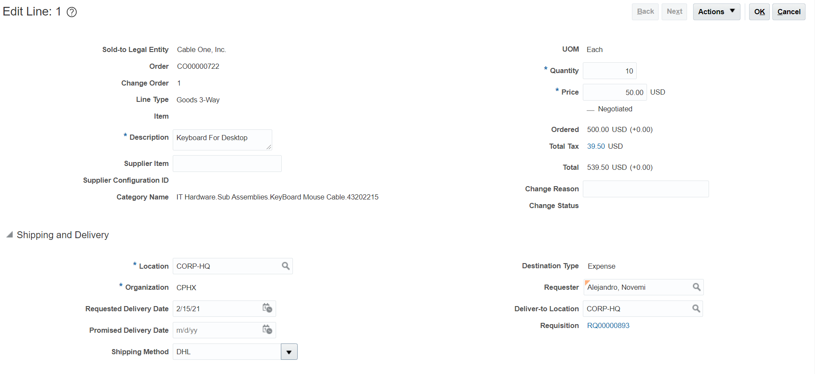

- Change the value in the quantity field

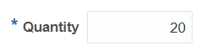

- Change the value of the price field if allowed to do so.

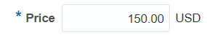

- Change the Requested Delivery Date field to 2/15/21

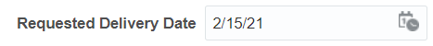

- In the change reason field enter the text, “Incorrect quotation from Supplier”

- Please note that the Ordered field and the Total field have additional information describing the line amount impact. This information will be important in case you want to know whether fiscal approvers will have to approve.

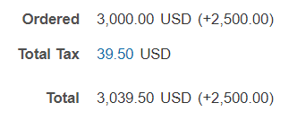

- Scroll down the screen to familiarize yourself with the additional information you could potentially change.

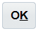
- Once you are done, click on the OK Icon on the top right of the screen. You should return to the Edit Change order screen. The Amount Change field should be updated

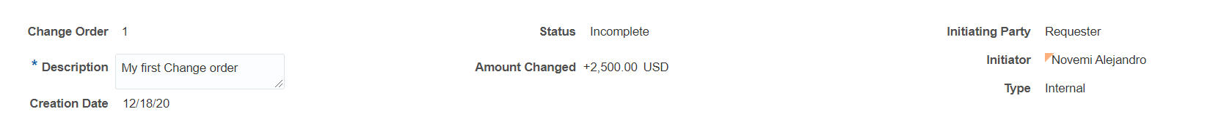

- You will also notice that the fields you changed have been updated.
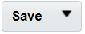
- Click on the Save Button. A date and time stamp should appear

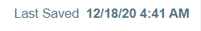
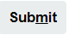
- Click on the Submit Button. A confirmation message should appear, confirming that the change order has been submitted for approval.

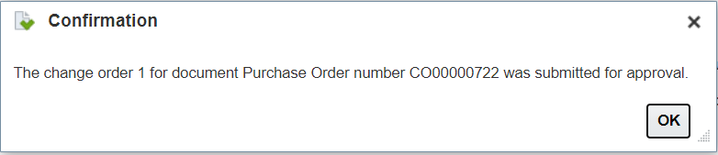
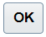
- Click on the OK button to close the confirmation message. You should return to the Requisition page of the requisition you initiated the change order from.

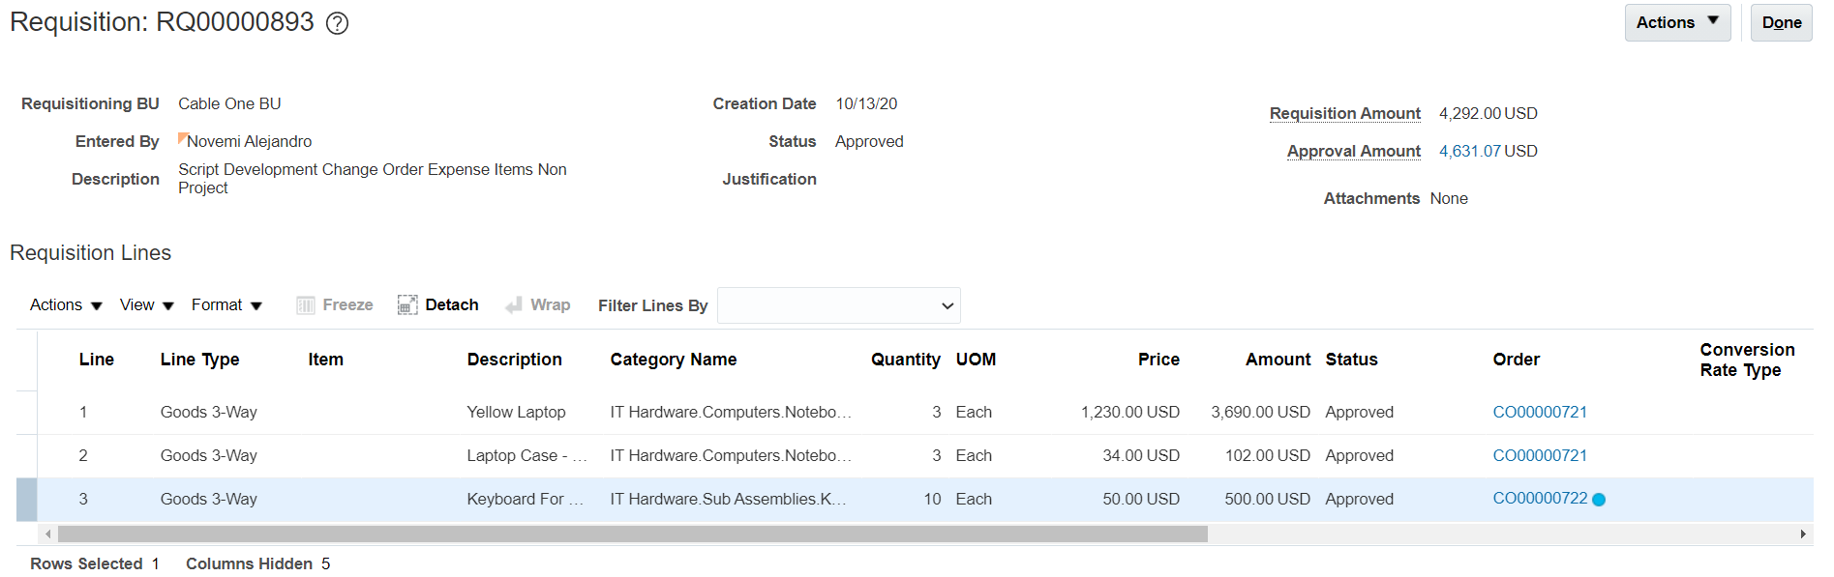

- Note that a blue circle next to the Order number for the requisition line you modified. If you do not see the blue circle, search for that requisition again, to refresh the information.

- With your mouse, hover over the blue circle. You should see a comment appear saying that the Order has pending changes.

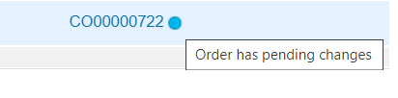
- Click on the Order number link. The Change Order screen for the pending change order should appear. The Status field should list the change order in Pending Approval status. Also note that the Ordered and Total fields have a blue circle next to them. If you scroll lower down the screen, the changed line with also have a blue circle next to it.

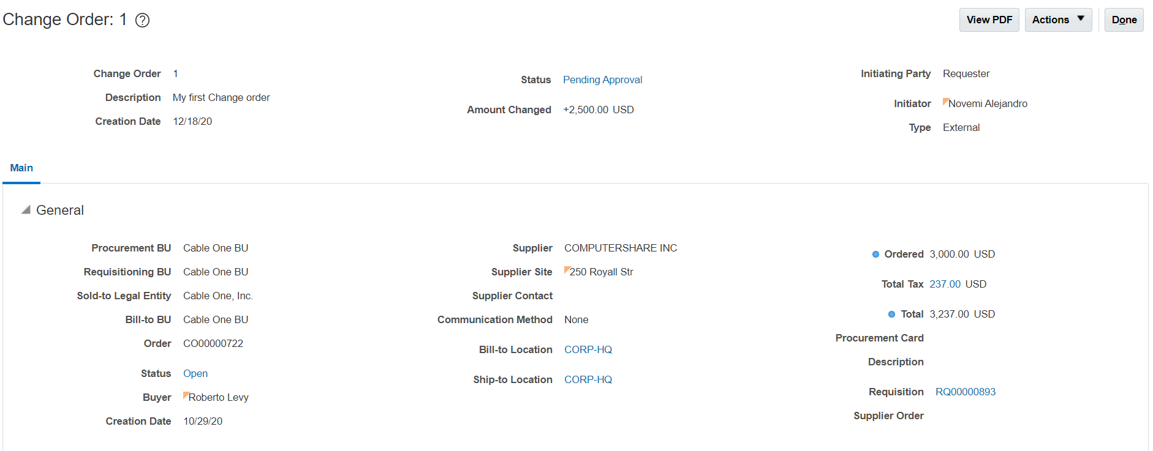

- Click on the Pending Approval link. The Change Order Action Detail screen should appear. This screen provides the user with the flow of approvals for the requisition. All Change orders must be approved by a person in the procurement team before the approval can continue to the fiscal approvers.

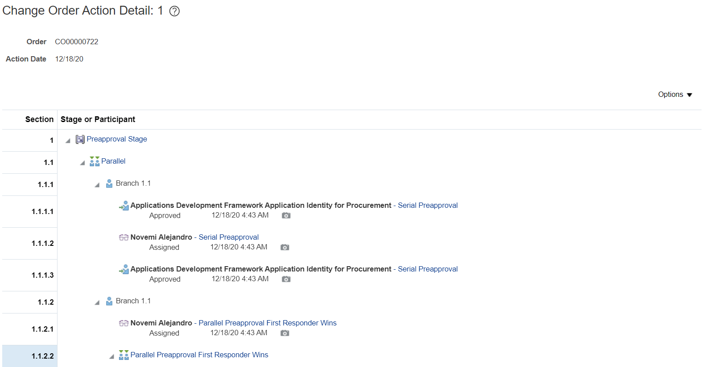

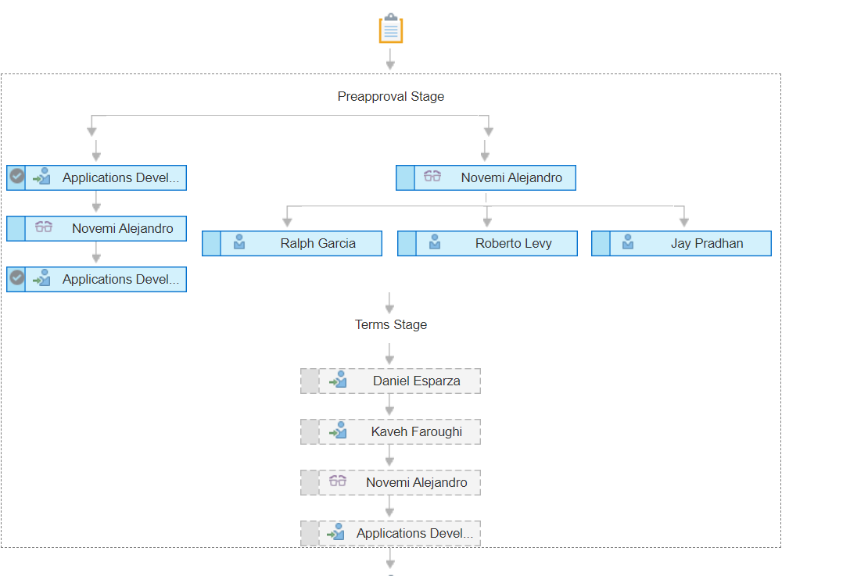

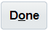
- Click on the Done button to return to the Requisitions screen.

- You have completed the Create Change Order exercise

Cancel a Requisition in Pending Approval or Approved Status without An Order Assigned to The Requisition Lines:

Business Procedure Description:
Use this process to cancel a requisition prior to approval by the requisition approver as needed.

Prerequisites:
Requisition must exist in Oracle
Search criteria is required to find a requisition (e.g.: requester name, requisition number, etc.)
Requisition must be in a “Pending Approval” status or may be in Approved status but no order can be assigned to a requisition line.
You can only cancel requisitions that you created

Output/Next Steps:
Requisition is canceled

Tips/Additional Information:

- Login into Oracle

You should see the navigation springboard.

- Click the Purchase Requisition Icon to open the Requisitions screen.

- Click on the Manage Requisition link, to open the manage requisition task. The Manage Requisition task screen consists of a requisition search area and a search results area.

- In the Search portion of the screen, make sure that your name is listed in the Entered By field. Please note that if there are any fields that have 2 asterixis (**) next to them, it means that at least one of those fields must be filled for the search to be able to be performed at all
- Click on the Status field drop down arrow to see a list of available statuses
- Select the Status Pending Approval by clicking on the Pending Approval option.

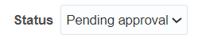

- Press on the Search Button to see the search results. The search results provide header level information and change orders must be managed while reviewing Requisition Line information.

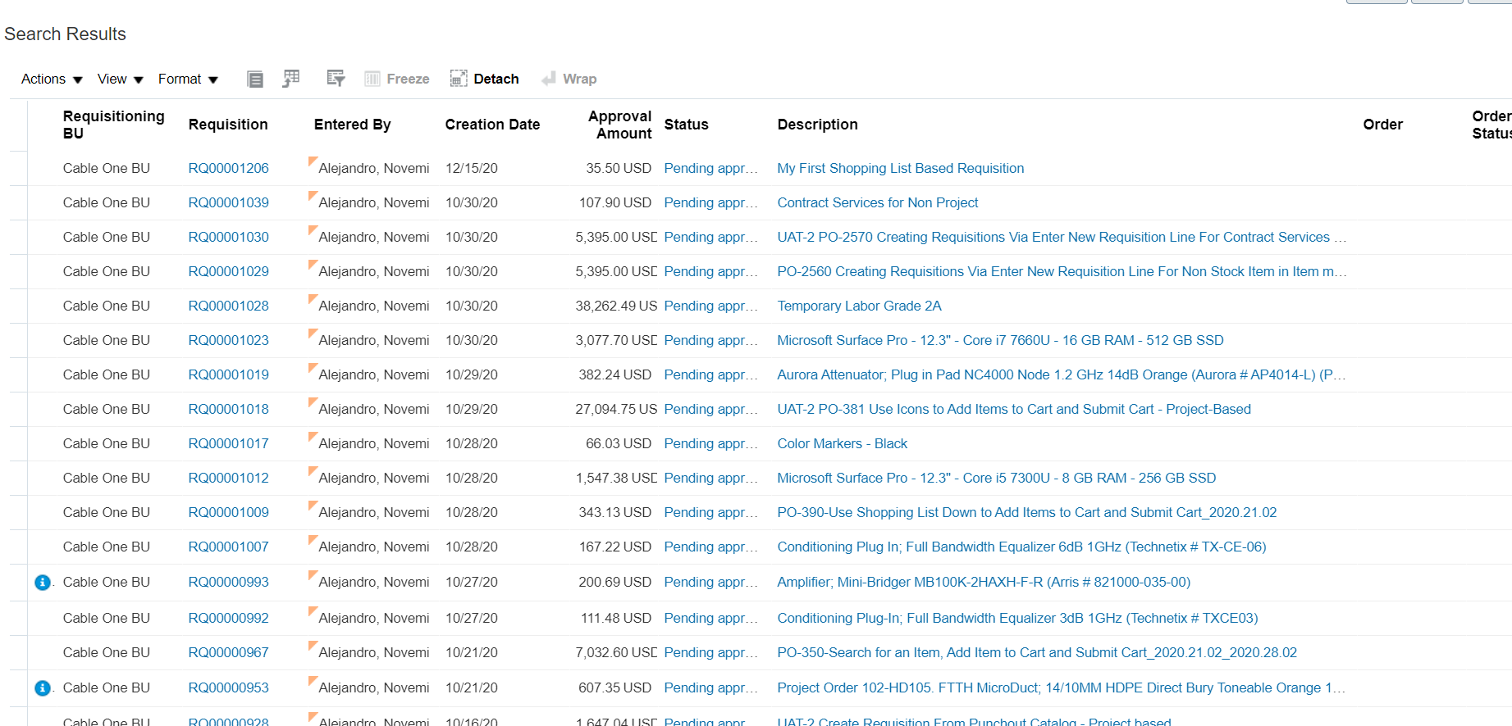
- Click on a requisition number to open the Requisition screen and review

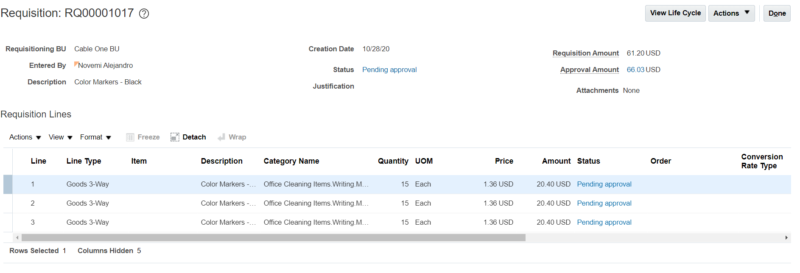
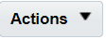
- Click on the Actions Button of the top right of the screen and review the available options

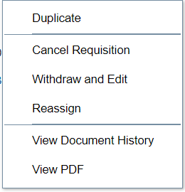
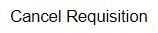
- Select the option Cancel Requisition from the option list. The Cancel Requisition window should appear.

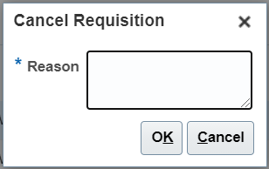

- In the reason field enter “Color Markers No longer needed and no purchase order assigned yet”
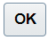
- Click on the OK Button to close the Cancel Requisition window. A confirmation message should appear saying that “The requisition lines were cancelled or cancellation requests were submitted for the lines.

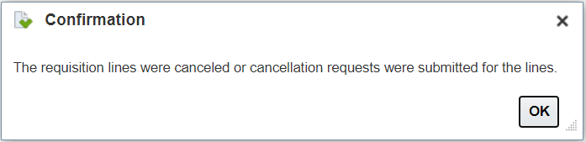
- Click on the OK Button to close the confirmation message. The requisition Page should be visible now and you will not a cancellation symbol on each one of the lines. The Requisition header lists the Requisition status as Cancelled and the Requisition Lines statuses also are listed as Cancelled.

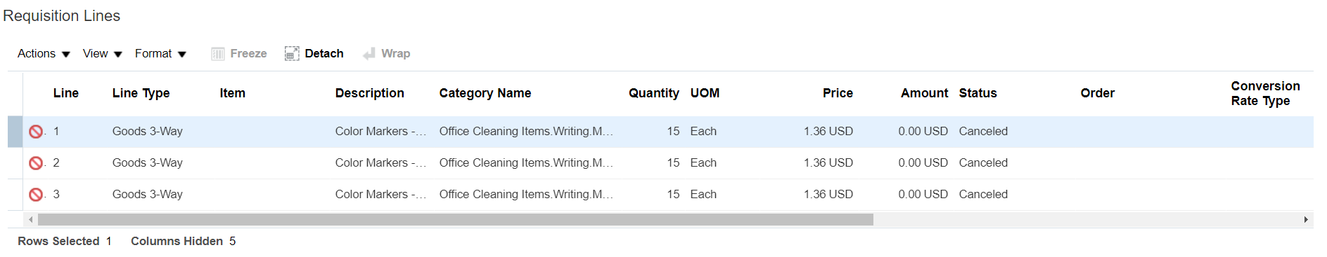

- You have completed the activity.

Cancel a Requisition in an Approved Status with a PO Created:

Business Procedure Description:
Use this process to cancel a requisition after it has been approved and a purchase order has been created. Requesting a cancellation creates a change order than must go through the respective approval process.

Prerequisites:
Procurement setups must be completed
Requisition must be in an approved status with an existing purchase order created
Canceling the requisition cancels the purchase order automatically or the open portion remaining
You can only cancel requisitions that you created
Pending Change Order should not exist

Output/Next Steps:
Requisition is canceled

Tips/Additional Information:

- Login into Oracle

- Click the Purchase Requisition Icon to open the Requisitions screen.

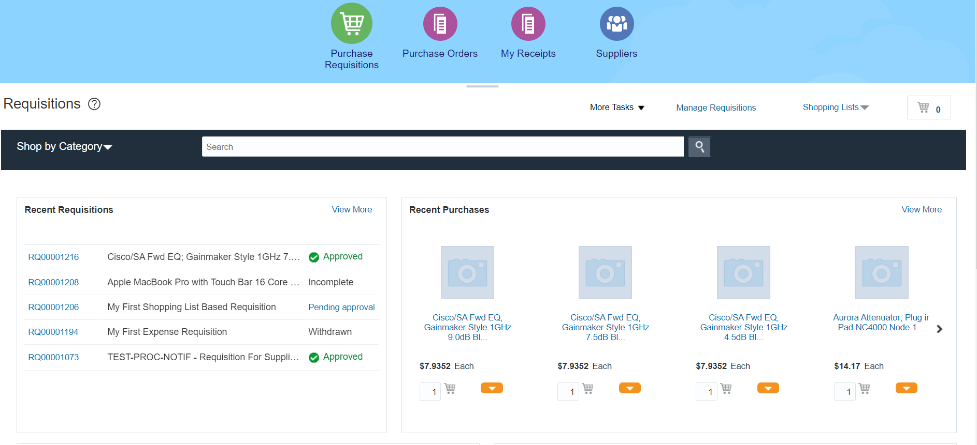
- Click on the Manage Requisition link, to open the manage requisition task. The Manage Requisition task screen consists of a requisition search area and a search results area.

- In the Search portion of the screen, make sure that your name is listed in the Entered By field. Please note that if there are any fields that have 2 asterixis (**) next to them, it means that at least one of those fields must be filled for the search to be able to be performed at all
- Click on the Status field drop down arrow to see a list of available statuses
- Select the Status Approved by clicking on the Approved option.

- Press on the Search Button to see the search results. The search results provide header level information and change orders must be managed while reviewing Requisition Line information.

- For this exercise look for a requisition that has a value populated in the order field. It can be an order number starting to CO or it could be one with the word multiple populated in the field.

- Click on the requisition number (number links are listed in the Requisition column). The requisition page should appear.

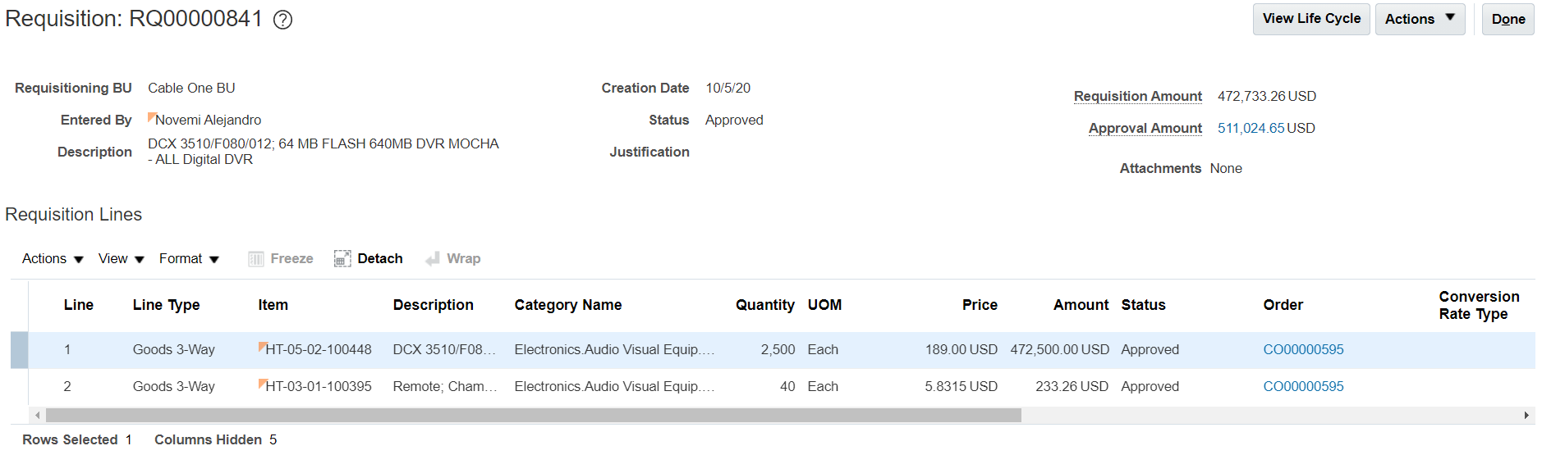

- Highlight the desired Requisition line you would like to change by clicking on the desired row.

- Click on the Requisition Lines Action drop down link. A listing of available options should appear.

- The requester then selects the Cancel option. The Cancel window should appear.

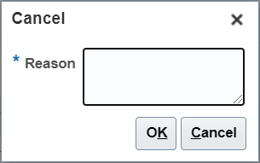

- In the reason field enter “No longer needed”
- Click on the OK Button to close the Cancel Requisition window. A confirmation message should appear saying that “The requisition lines were cancelled or cancellation requests were submitted for the lines.

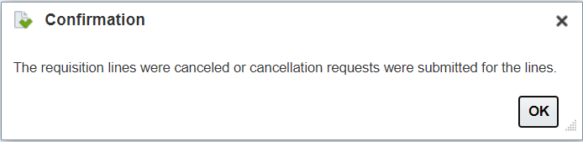
- Click on the OK Button to close the Confirmation message. The Requisition Page should reappear. Please note that the Requisition line that was selected now has a blue circle next to the order number. If there were multiple lines assigned to the same order number, then each line will have the blue circle. A requester may not cancel a requisition with open or closed orders assigned to it until the buyer has approved the cancellation. Therefore, this type of cancellation creates a request to cancel change order. Please note that any other requisition lines that were assigned to a different PO number are not included in the change order. If the user has requested a cancellation at the header level all available and permissible orders would have been includes in the cancellation request.

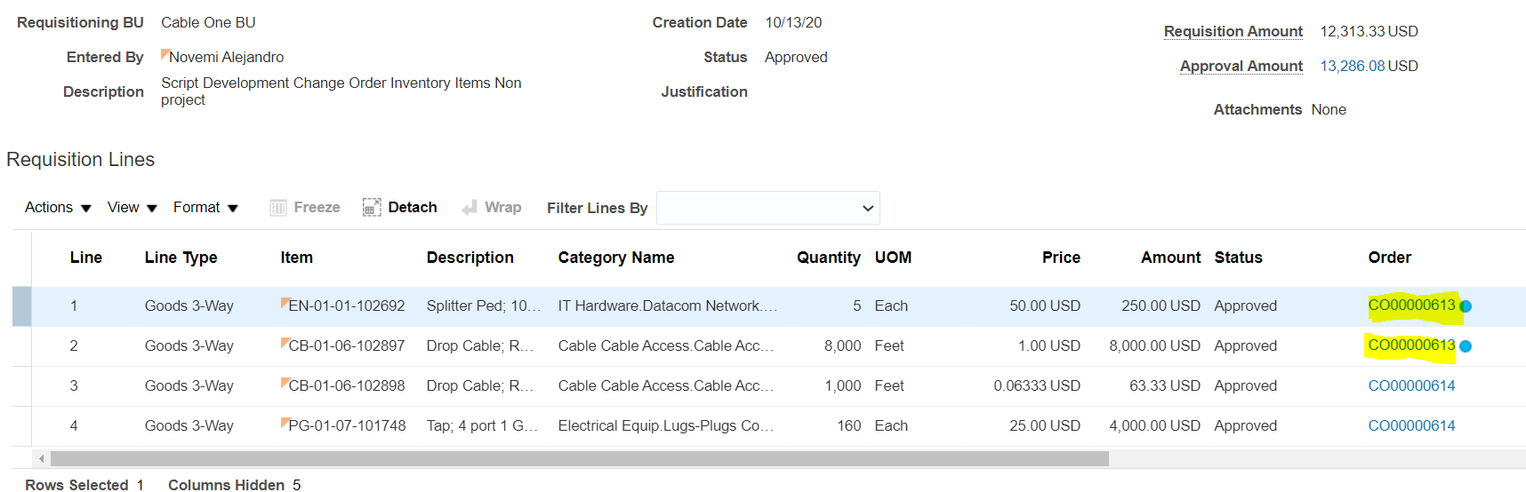
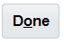
- Click on the Done button to return to the Manage Requisitions. If you do not see the done button, you may already be in the Manage Requisitions screen or you will have to click on the Manage requisition task link

- This time try finding a requisition that has several requisition lines assign to at least 2 orders.

- Click on the Requisition number link to open the Requisition page for that requisition number
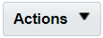
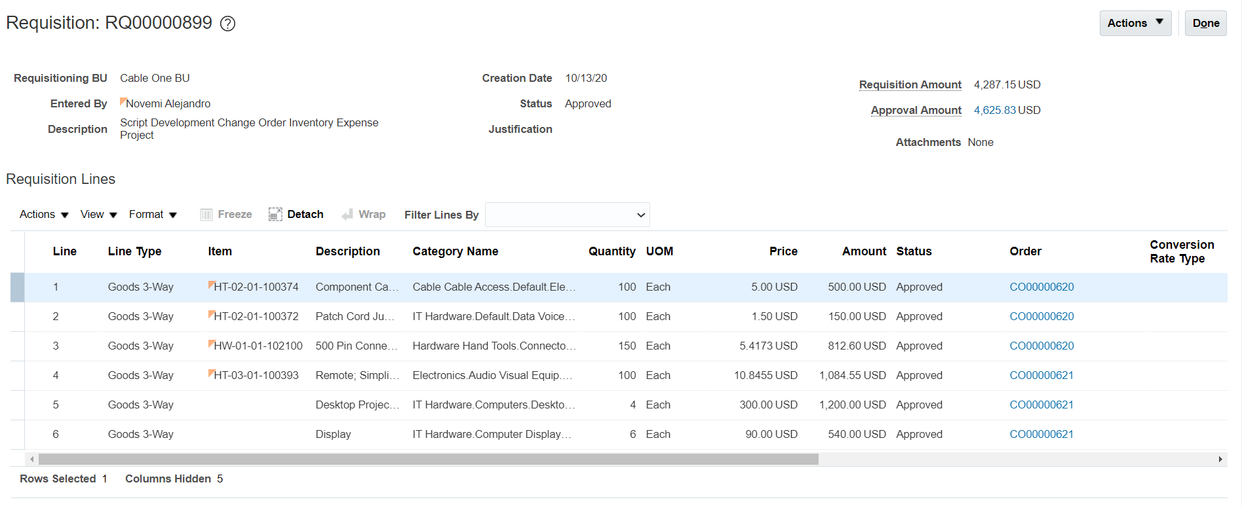
- Click on the Action button to see the options available to take on the entire requisition.

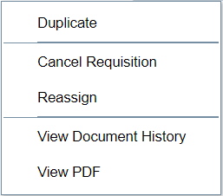

- Click on the Cancel Requisition option. The Cancel Requisition window should open up

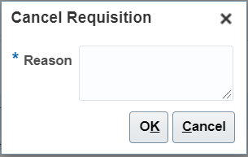

- In the Reason Field, enter the Text “Cancel All Requisition Lines”.

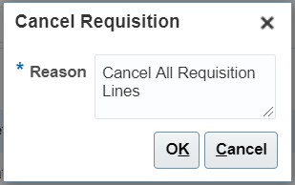
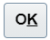
- Press the OK Button to process the cancellation. A confirmation message saying that the cancellation request has been submitted should appear

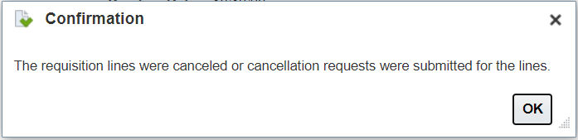

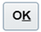
- Click on the OK button to close the confirmation message. You should see the requisition lines with a blue circle next to them, which tags all the lines as pending change order. Please keep in mind, the buyer would have to address a change order for each Purchase order and not just one for the entire requisition.

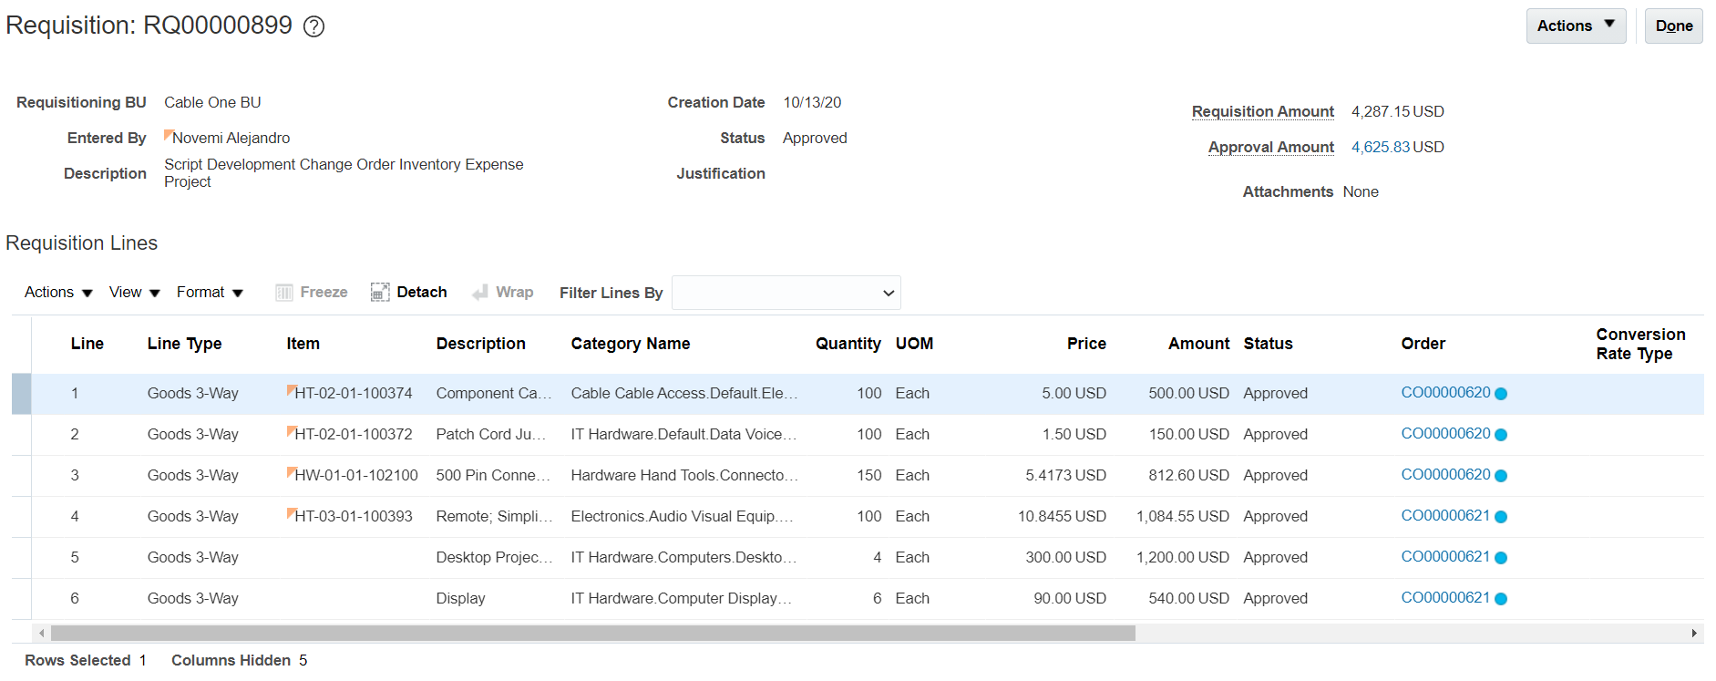
- You have completed this activity

Create a Private Shopping List:

Business Procedure Description:
This activity explains the steps needed to create a Private Shopping list. A private shopping list is available only to you and can be used for a variety of things including facilitating ordering, facilitating the BOM process for projects and other possible benefits.

Prerequisites:
Items must be available to be added to the Private Shopping List and must be available in the Search by Category or Search self service capabilities.

Output/Next Steps:
A private shopping list

Tips/Additional Information:

- Login into Oracle

- Click the Purchase Requisition Icon to open the Requisitions screen.

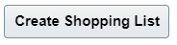
- There are two ways to create a Private Shopping list. The first is the On-The-Fly method, in which you select items you want and then you create the shopping list and automatically add the selected items to a new list. The second method is to click the Shopping List drop down link and then clicking on the Create Shopping List button

- To use the On-The-Fly method, in the Search box, enter TAPS%


- Press the search icon on the right side of the search box (Magnifying Icon). A listing of all the items that either have TAPS in their name or in the Category name should appear.

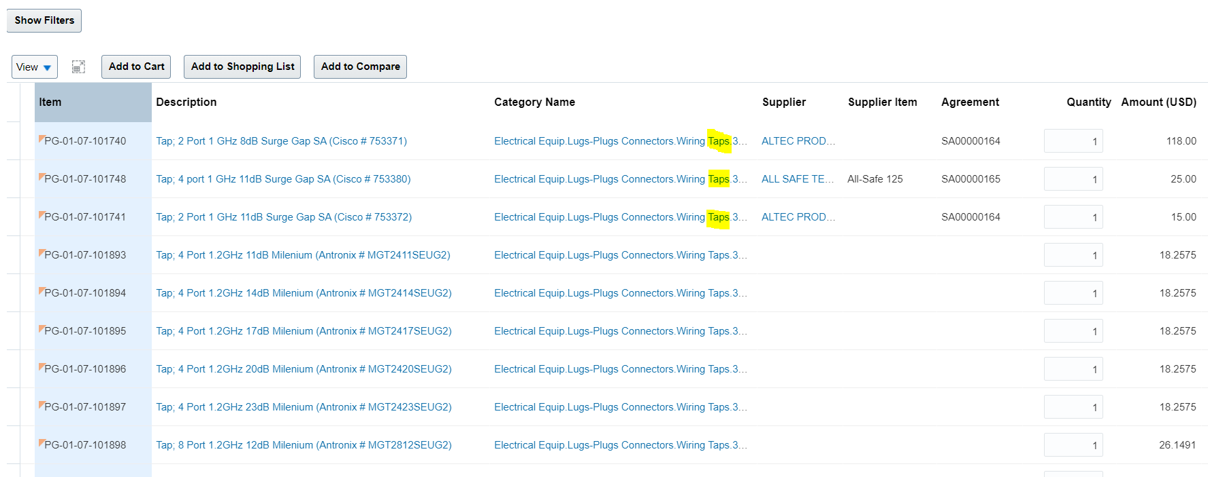

- Select 4 or 5 rows of items. Do so by pressing the CTRL key on your keyboard and while pressed, click on the desired rows in the list. Once complete, all the rows should be highlighted in blue.

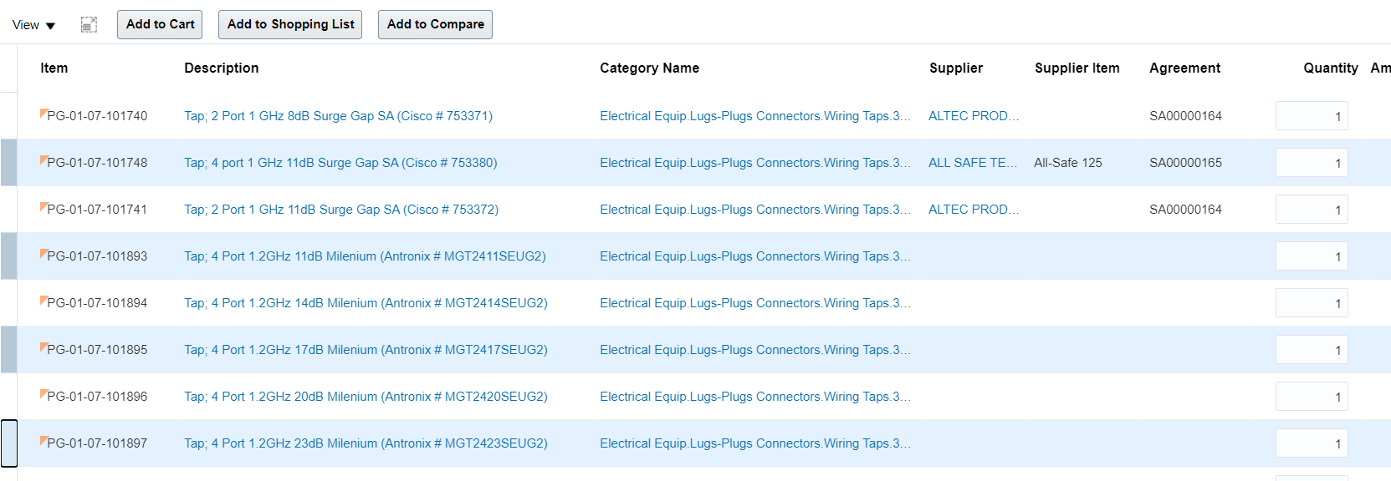

- As opposed to when wanted to place items to a cart, there is no need to change quantities as the shopping list will default all to 1 or based on the unit of measure.

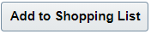
- Click on the Add to Shopping list Button. The Add to Shopping List window should appear. Please note that for both creating a new shopping list or adding items to an existing one, you need to select at least 1 row.

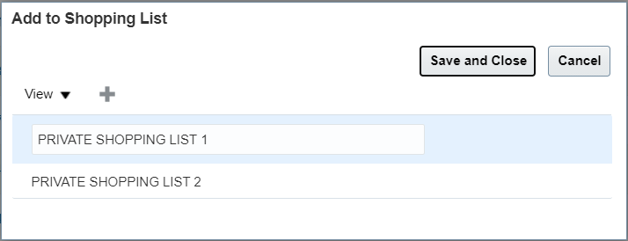

To create a new Private Shopping List, click on the plus icon. On top of the existing shopping lists you should see a new space to name your shopping lists

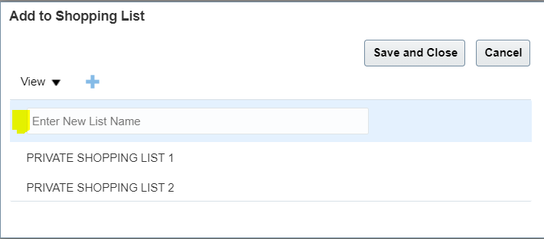

- Click on the Enter New List Name field and type the following text “My First Private Shopping List”

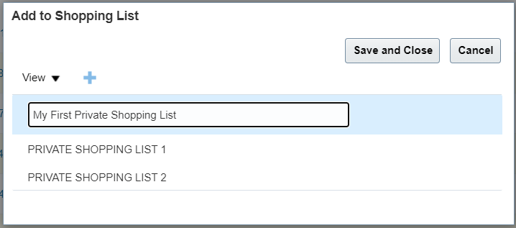
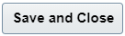
- Click on the Save and Close Button. Small message should appear temporarily to let you know that you have added the rows to your Shopping List.

- To verify that your Shopping list is created and populated, click on the Shopping Lists drop down link. Your new shopping list should be visible in the top half of the option list and should list the number of items inside the list.

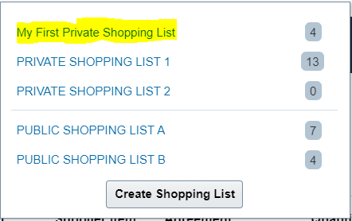

- The Only difference between the two methods of creating the private shopping list is that of the order of adding the items and the ability of the user to remove a shopping list in the Create Shopping List method.

- You have completed this activity.

Approvals:

Purpose of Approvals
The purpose of approvals, especially in a public company, is to ensure that the proper controls are in place for the approval to spend or make sure of the company’s capital. Approvals in Oracle have been implemented across the procurement process to ensure that the right people are providing their permission to spend money for our various needs. Approvals at Cable One are based on a combination of the type of expenditure, the amount of the expenditure and the level of the person requesting the expenditure. The following requisition related activities must follow approval process
- Approvals for Requisitions
  - Requisitions for inventory related materials must be approved by procurement fiscal approvers
  - Requisitions for inventory related materials for projects must be approved by project fiscal approvers
  - Requisitions for Expense items for projects must be approved by project fiscal approvers
  - Requisitions for Expense items for non-project needs must be approved by requester fiscal approver
  - Requisitions created by a preparer must be approved by the requester’s fiscal approvers.
- Approvals of Requisition Changes
  - All approved requisitions that are withdrawn and modified prior to order creation must be re-approved by the same logic as approvals for requisitions
- Approvals of Change orders
  - All change orders must be approved by Procurement. If a change order impacts an order line amount by a magnitude greater than 1% then the approval by the requester’s fiscal approvers or by Project approvers will be needed
  - All order cancellation requests must be approved by procurement.

Approval Types
All users will have the ability to see what the approval flow is for either a requisition being created, or a change order being implemented. The approval flow has two dimensions. The first dimension is the order of the approval which means who approved first and who approves next. The order starts with the requester’s immediately manager level supervisor and then continues “up the chain” of command. The second dimension is related to functional approvals (group approvals). For example, in a group approval, you can have the entire group required to approve a document or you can have a first approver only. In first approver only, whoever approves the document has approved for the entire group and the approval flow continues to the next step

Adding Approvers
All users will have the ability to add a user to the approval flow, either as an approver or just for information. If another user is added as an approver, the user will need to determine where in the hierarchy of the approval that user must approve (at the beginning, before or after someone else, etc.). Under no circumstances will a requester be able to remove an existing approver. Those approvers are based on programmed roles and responsibilities and are the minimum requirements

Approving Combined Requisitions
In our implementation of Oracle, we do not have separate rules for combined requisitions. For Example, if a requester combined project and non-project line items in a requisition, the approval will require everyone in the approval logic for project and non-project items to approve the entire requisition. If you mix project with non-project requisition lines your requisition approval could be delayed because it must complete two different approval flows.

